

This annual report provides information about the Queensland Police Service’s financial and non-financial performance for 2018-19. It has been prepared in accordance with the Financial Accountability Act 2009, the Financial and Performance Management Standard 2009 and the Annual report requirements for Queensland Government agencies.
Enquiries and further information
Telephone No.: (07) 3364 3616
Visit: www.police.qld.gov.au
Email: QPS.Reporting@police.qld.gov.au
This annual report can be obtained in paper form by calling 13 QGOV (13 7468) or online at www.police.qld.gov.au/corporatedocs/reportsPublications/annualReport/default.htm.
Feedback
Feedback on the annual report can be provided through the Get Involved website:
www.qld.gov.au/annualreportfeedback
Other languages and formats
The Queensland Government is committed to providing accessible services to Queenslanders from all cultural and linguistic backgrounds. If you have difficulty understanding this publication and need a translator, please call the Translating and Interpreting Service (TIS National) on telephone number 131 450 and an interpreter will be arranged to communicate the report to you.

Queensland Police Service
 | www.mypolice.qld.gov.au |  | www.youtube.com/QueenslandPolice
 | www.facebook.com.au/QueenslandPolice |  | www.instagram.com/qpsmedia/
 | www.twitter.com/QPSmedia |  | www.pintrest.com/qldpolice

Copyright
© The State of Queensland, Queensland Police Service 2019.
Licence
This annual report is licensed by the State of Queensland, Queensland Police Service under a Create Commons Attribution (CC BY) 4.0 Australian licence.
CC BY Licence Summary Statement
In essence, you are free to copy, communicate and adapt this annual report, as long as you attribute the work to the State of Queensland, Queensland Police Service. To view a copy of this licence, visit:
www.creativecommons.org/licenses/by/3.0/au/deed.en
Attribution
Content from this annual report should be attributed as: The State of Queensland, Queensland Police Service Annual Report 2018-19.
ISSN:
Online: 1837-235X
Print: 1837-2341

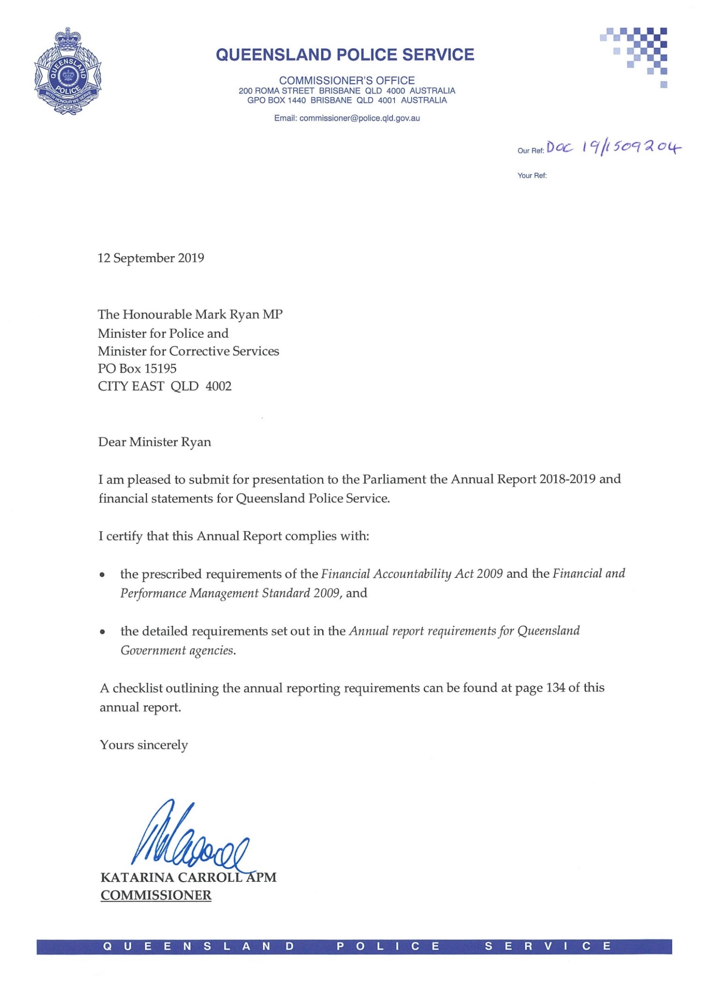
Letter of compliance

Table of contents
Letter of compliance 2
Table of Contents 3
Commissioner’s Message 4
2018-19 at a glance 6
About Us 8
Organisational structure 19
QPS Regional Map 21
Financial Summary 23
Summary of financial performance 23
Summary of financial position 24
Performance 26
Key performance measures 26
2018-19 Highlights 32
Governance 68
Executive management 68
Board and committees 72
Government bodies 79
Ethics and code of conduct 79
Risk management and accountability 80
Human resources 87
Financial Statements 93
Appendices 127
Government bodies 127
Acronyms 132
Compliance checklist 134
Contacts and key locations 136

Information about consultancies, overseas travel and the Queensland Language Services Policy is available at the Queensland Government Open Data website (www.data.qld.gov.au/).


Commissioner’s message
During 2018-19, the Queensland Police Service (QPS) continued to deliver world-class frontline policing services for the people of Queensland. I feel very proud of the QPS’ ability to meet the many challenges and complexities of a constantly evolving policing environment. In 2018-19 we continued to pursue technologies, strategies and initiatives to support our ongoing commitment to keep communities safe.
Our success as an organisation is attributed to the hard work, skills, courage and commitment of our more than 15,000 members and I take this opportunity to thank each member for their service to the Queensland community.
During 2018-19, the QPS had many achievements that showcase the outstanding work and dedication of our members. Highlights for the year included:
- the launch of a dedicated Major Events Planning Unit in Brisbane Region in May 2019 which provides planning support across the region with a strong focus on the City, Valley and Riverside patrol groups, delivering enhanced major event planning
- continuing to embrace technology advancements including a new laser scanner to record critical evidence and capture every aspect of a crime scene in accurate detail, trialling a Remotely Pilot Aircraft to map traffic scenes to reduce road closure times, and trialling on-water drug testing and enforcement to create a safer environment for Queensland waterways
- rolling out a fleet of new Kia Stingers across the state
- celebrating 125 years of photographic services in the QPS and the strong evolution of police photography since the nineteenth century
- unveiling a new permanent police memorial in Brisbane City Botanic Gardens which will serve as an important tribute to those QPS officers who have made the ultimate sacrifice in the line of duty, and provide a solemn site for reflection and remembrance
- the Commonwealth Games Group receiving national accolades, including the Gold Award in the prestigious Prime Minister’s Award for Excellence in Public Sector Management, for its handling of security, with all planned outcomes achieved on time and under budget, and a Collaboration Award for demonstrating effective integration across multiple agencies at all levels of government
- ongoing high visibility road safety operations, focussing on the ‘Fatal Five’ high risk road user behaviours to ensure the safety of all Queenslanders on our roads
- continuing to support inclusion and diversity through the Our People Matter Strategy, Senior Women’s Collective group and participating in LGBTI activities.
We farewelled former Deputy Commissioner Bob Gee and Assistant Commissioner Paul Stewart. Former Deputy Commissioner Bob Gee was appointed as the Director-General for the newly created Department of Youth Justice, after a long and distinguished career in the QPS spanning more than 32 years. Former Assistant Commissioner Paul Stewart was appointed to the role of Deputy Commissioner in Queensland Corrective Services, after a long and distinguished career in the QPS spanning more than 35 years. Both officers have made significant contributions to the QPS and the Queensland community, and I wish both Bob and Paul well in their new roles.
I announced my retirement from the Service in February 2019, following a career spanning more than 45 years. I am honoured and privlidged to have served as the Queensland Police Commissioner for the last six years. I wish my successor, Commissioner Carroll all the best for the future.

As always, I was honoured to lead the QPS during the year. I would like to thank the QPS Executive Leadership Team and our 15,000 members for their dedication to those we serve by delivering safe and secure communities across our great State.

IAN STEWART APM
COMMISSIONER

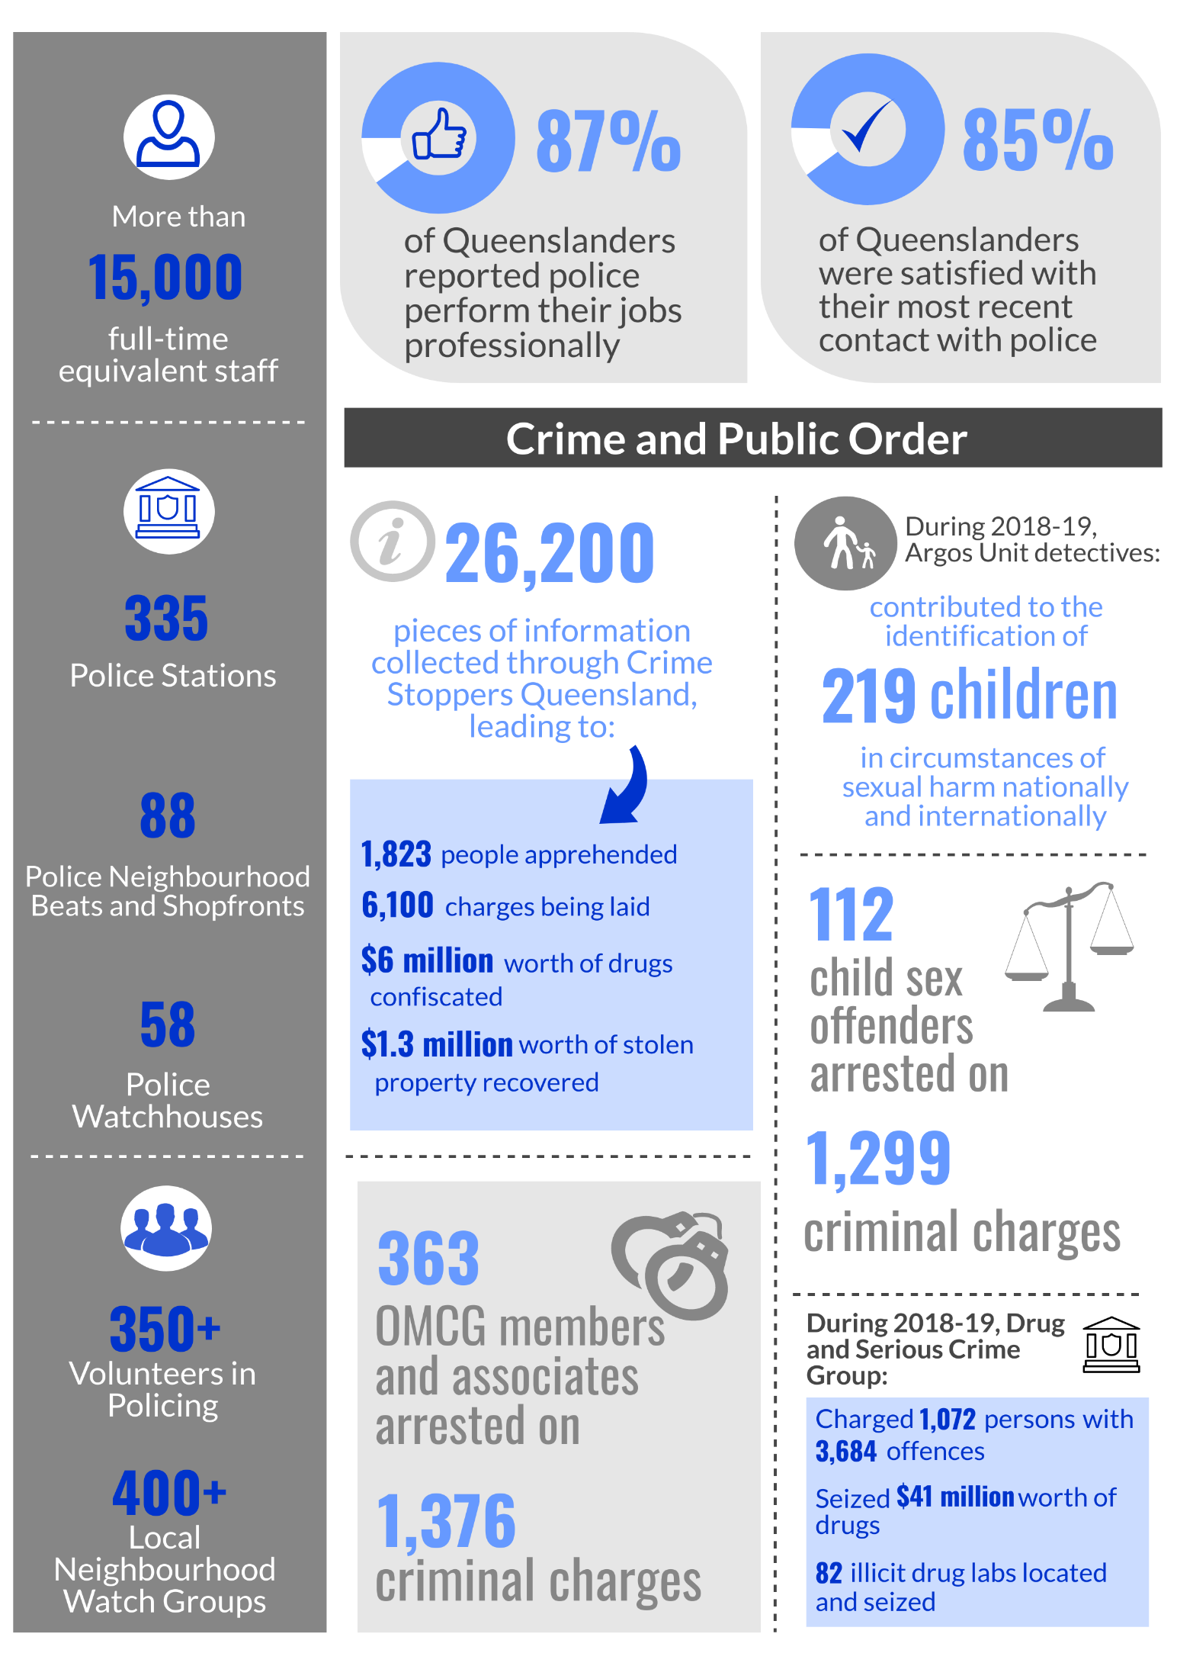
2018-19 at a glance
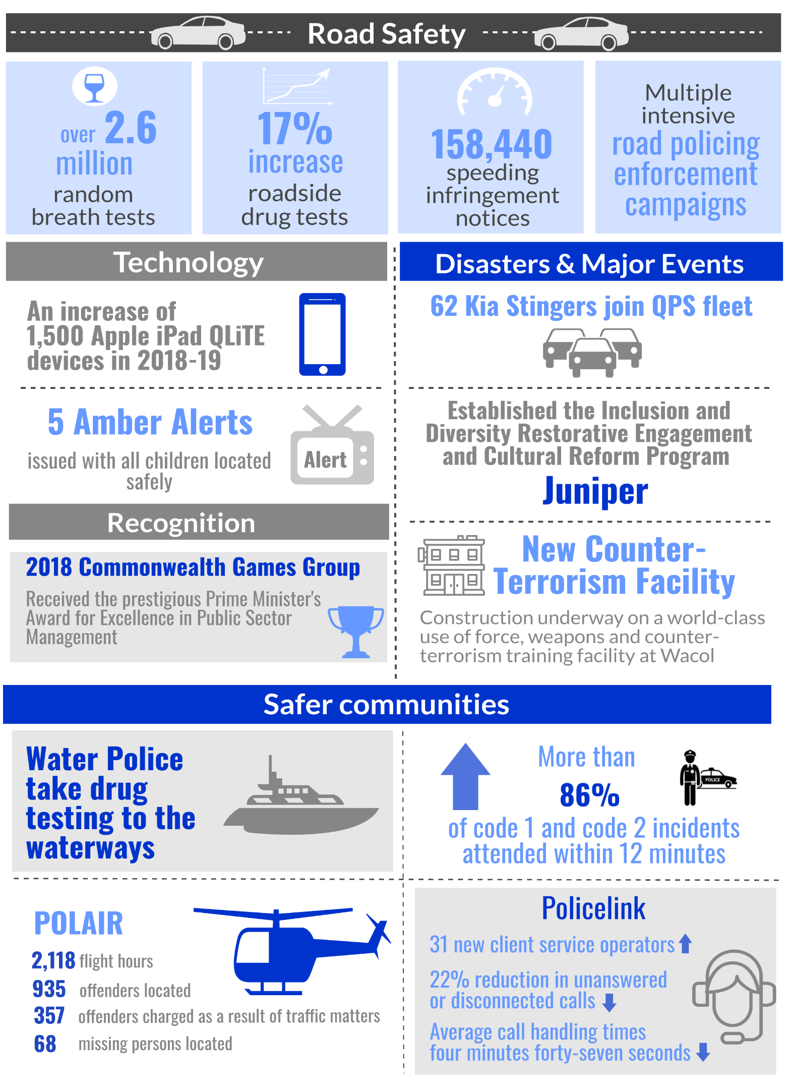
2018-19 at a glance (cont’d)

About us
The QPS is the primary law enforcement agency for Queensland. It fulfils this role throughout the state, 24 hours a day, seven days a week, upholding the law and providing assistance to the community particularly in times of emergency, disaster and crisis.
The QPS has two service areas as outlined in the 2018-19 Service Delivery Statement (a State Budget Paper): Crime and Public Order; and Road Safety.
Our Vision
Delivering safe and secure communities through collaboration, innovation and best practice

Our Purpose
To stop crime, make the community safer, including reducing road trauma, and build relationships with the community



Our accountabilities
Under the Police Service Administration Act 1990, the QPS is responsible for:
- preserving peace and good order in all areas of Queensland
- protecting and supporting the Queensland community
- preventing and detecting crime
- upholding the law
- administering the law fairly and efficiently
- bringing offenders to justice.

Our values
QPS members value:
- Courage: by always doing the right thing
- Fairness: in making objective, evidence-based, consistent decision and by treating people with respect
- Pride: in themselves, the QPS, they work they do and the community they serve.
The QPS shares the Queensland Public Service values of:

 | Customers first  - Know your customers  - Deliver what matters  - Make decisions with empathy
 | Ideas into action  - Challenge the norm and suggest solutions  - Encourage and embrace new ideas  - Work across boundaries
 | Unleash potential  - Expect greatness  - Lead and set clear expectations  - Seek, provide and act on feedback
 | Be courageous  - Own your actions, successes and mistakes  - Take calculated risks  - Act with transparency
 | Empower people  - Lead, empower and trust  - Play to everyone’s strengths  - Develop yourself and those around you

Our objectives
The QPS contributed to the government’s objectives for the community by delivering quality frontline services and supporting safe, caring and connected communities. The QPS did this through our focus on:
- stopping crime
- making the community safer
- strengthening relationships with the community
- equipping our workforce for the future so we can meet the challenges of policing as we move forward.
Strategies
The QPS achieves its objectives through a range of strategies:
To stop crime, the QPS:
- focused resources to identify and deliver effective, innovative and efficient services to prevent, investigate and disrupt crime
- addressed the threat of serious and organised crime, terrorism and radicalisation through strong collaborative partnerships with the community and other law enforcement agencies.
To make the community safer, the QPS:
- fostered collaborative partnerships with government agencies, non-government organisations and community groups to maximise community safety
- worked to improve policing responses to people who are over-represented in the criminal justice system as either victims or offenders, including vulnerable persons and victims of domestic and family violence.
To strengthen relationships with the community, the QPS:
- worked to preserve the legitimacy of policing through fair and ethical service delivery
- provided timely and professional responses to calls for service to maintain community confidence
- strengthened positive online user and social media experiences to expand options for engagement with police.
To equip the workforce for the future, the QPS:
- pursued opportunities to optimise our workforce to meet current and future challenges through training and development
- worked to deliver world-leading equipment, technology and facilities to support our frontline staff
- supported healthy, safe and inclusive workplaces and promoted a diverse workforce that reflects the community we serve.
The QPS also contributed to a range of local, state and national strategies on matters including drugs and alcohol, domestic and family violence, mental health, child protection, counter-terrorism and road safety.

Queensland Government objectives
The Queensland Government remains committed to meeting the challenges facing Queensland communities, particularly around job creation and a stronger economy, education, health and community safety.

Our Future State
Our Future State: Advancing Queensland’s Priorities are the government’s objectives for the community. They are designed to confront and tackle the major challenges facing Queensland.
Advancing Queensland’s Priorities is part of the Government’s long term plan for the future of our state, guided by the Queensland Plan. More information about the plan is available online at www.queenslandplan.qld.gov.au
Community safety is a shared responsibility and the QPS works with other government departments, agencies, community groups and members of the community to support the safety and security of all Queenslanders.
Information about QPS policies, programs and services aimed at keeping our communities safe can be found in 2018-19 Highlights (refer pages 32-67).
Keep Communities Safe
As part of the Our Future State: Advancing Queensland’s Priorities, the government has identified six priority outcomes for Queensland now and into the future.
The Keep Communities Safe outcome will focus on reducing victimisation and youth crime and youth reoffending, and will build the government’s recent effort in key areas such as tackling Ice, domestic and family violence, and toughening its serious and organised crime legislation.
The Queensland Government will work to deliver the two key targets of the Keeping Communities Safe outcome:
- a 10% reduction in the rate of crime victims over 10 years
- more can be done to reduce the number of crime victims’—particularly victims of personal and property crime. This means reducing the number of people physically and sexually assaulted, and those affected by domestic and family violence, as well as reducing break and enters, vehicle thefts and property damage.
- a 5% reduction (by 2020-21) in the rate of youth reoffending over five years (from 2015-16)
- early intervention activities such as diversionary programs, along with engagement in education, training, employment and sport can have a positive impact on young people before they become ingrained in the criminal justice system.
More information about Keeping Communities Safe is available online at https://www.ourfuture.qld.gov.au/safe-communities.aspx.
The QPS will also contribute to other priority outcomes as part of the Our Future State: Advancing Queensland’s Priorities.

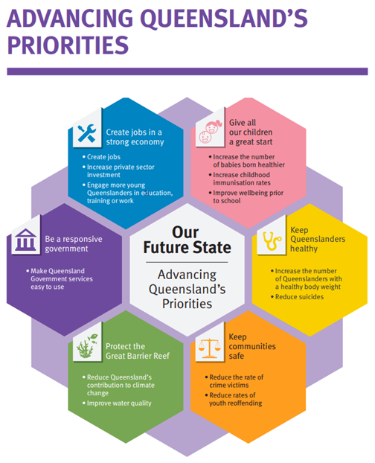

Our environment
The policing environment in Queensland is becoming increasingly complex and traditional policing services will need to adapt to meet the demand of policing now and into the future. Shifting community expectations, rapid technological innovation and new modes of offending are impacting on traditional approaches to policing and service delivery more broadly. Advances in technology are changing the way people interact with each other and also providing platforms for new modes of criminal offending. Criminal threats, including terrorism, are increasingly borderless and complex. Queensland also remains at risk from natural disasters and severe weather events which present threats to public safety.
In response, the QPS will:
- continue to deliver key initiatives of the Government’s Keep Communities Safe and Tackling Alcohol Fuelled Violence policies
- continue to support the implementation of the Domestic and Family Violence Prevention Strategy 2016-2026 and the Government response to the report from the Special Taskforce on Domestic and Family Violence in Queensland
- work with other relevant agencies to increase the proportion of offenders, particularly young people, diverted from the criminal justice system
- utilise new and emerging technologies to greatly benefit police by improving interoperability between public safety agencies and enhancing operational effectiveness. This includes trialling remotely piloted aircraft to map traffic crash scenes and on-water drug testing
- continue to work with collaboratively with police agencies in other jurisdictions to address serious criminal activity.

Our challenges and opportunities in 2018-19
The QPS acknowledges the importance of addressing a range of potential strategic challenges to ensure we keep Queenslanders safe. It has identified these challenges along with opportunities over the next 12 months, linking them to the four objectives and supporting the delivery of safe and secure communities.
Key challenges for the QPS during 2018-19 included:
- maintaining community satisfaction and confidence in police in an environment of changing expectations
- the ongoing threat of terrorism, including low capacity attacks which pose unique challenges to our people and safety within the community
- engaging our people in a truly inclusive workplace so they are more likely to contribute effectively to the activities of their workplace and enhance performance
- ongoing economic conditions which continue to impact on resource allocation to the QPS and number of vulnerable people within the community
- the proportion of demand on police containing digital elements with the knowledge and skills to understand criminal uses of emerging technologies being crucial for law enforcement.

The QPS also identified the following opportunities to best position the QPS to make Queensland safe:
- forging collaborative partnerships with the community and a wide range of agencies create opportunities for information sharing and improved responses to enhance community safety
- valuing the diversity of our people and investing in their expertise, knowledge and safety is imperative to continuing to deliver policing services to the community
- becoming more self-sufficient and looking for ways to encourage new ideas, use existing resources more efficiently, and challenge our people to work smarter
- technological advances and increased global connectivity provided opportunities to change and revolutionise policing
- securing legacies from the Gold Coast 2018 Commonwealth Games in respect of capabilities, experiences, infrastructure, equipment and processes for the QPS
- continue to enhance policing responses to Keep Communities Safe and reduce victimisation
- reduce the rates of youth reoffending by intervening early to divert young people at risk
- continue to implement and support the Government’s response to key reports and strategies, including the:
- Advancing Queensland Priorities
- Criminal Justice Reform Framework
- Domestic and Family Violence Prevention Strategy 2016-2026
- Action on Ice Plan.

2019-20 Outlook
Greatest strategic challenges for the QPS in 2019-20 will be:
- adapting to economic conditions and resources to ensure the delivery of high quality and efficient policing services
- strengthening the ethical behaviour of police to address the community’s changing expectations and building on the trust and confidence in the QPS
- adapting to the challenges of a dynamic policing environment in responding to cybercrime and the criminal use of emerging technologies.

To address these challenges, the key priorities for the QPS during 2019-20 include:
- maintaining strong leadership of the QPS service delivery model through growing and changing demands will improve the future direction of the organisation
- championing networks and partnerships across the public/private sectors and the community may create opportunities to improve responses and enhance social cohesion and community safety
- promoting a workforce which is flexible, inclusive and diverse will enhance engagement and performance in delivering services to the Queensland community
- empowering the workforce by investing in their safety and wellbeing, and organisational capabilities will improve responses to future challenges
- championing collaborative approaches through information sharing and coordinated case management with partnering stakeholders will benefit Queensland’s youth.

Legislation administered by the QPS
In accordance with Administrative Arrangements Order (No. 2) 2018, the portfolio administered the following legislation during 2018-19:
- Australian Crime Commission (Queensland) Act 2003
- Child Protection (Offender Reporting and Offender Prohibition Order) Act 2004
- Police Powers and Responsibilities Act 2000
- Police Service Administration Act 1990
- Prostitution Act 1999
- State Buildings Protective Security Act 1983
- Summary Offences Act 2005
- Terrorism (Preventative Detention) Act 2005
- Weapons Act 1990

Partners
The QPS has strong relationships with its partners in the community, including Community Policing Boards, Queensland Police-Citizens Youth Welfare Association, Neighbourhood Watch Queensland (NHWQ) and Crime Stoppers Queensland. The QPS works collaboratively with the Department of the Premier and Cabinet, Queensland Treasury and other government departments to deliver efficient and effective services to the Queensland community. These partnerships help Queensland police prevent crime and make the community safer.
- Community Policing Boards
Community Policing Boards provide the opportunity for local organisations and individuals to work together with police on strategies to address crime and safety issues in the community. The boards are made up of local police and community representatives, such as not-for-profit organisations, local businesses, chambers of commerce and relevant state, local and Australian government agencies, as well as other individuals who can help address specific issues.
The primary objectives of Community Policing Boards are to:
- promote community safety and security
- explore strategies to address societal issues associated with crime and community safety
- identify opportunities to integrate services at a local level
- develop partnerships to support government, industry and community working together
- promote evidence-based solutions using statistical data and empirical research.
Community Policing Boards complement existing community crime prevention frameworks including: NHWQ; Crime Stoppers; and Multi-faith, Cultural and Indigenous Community/Police Consultative Groups.
For more information or to contact your local board visit www.mypolice.qld.gov.au and follow the links.
- Queensland Police-Citizens Youth Welfare Association (QPCYWA)
The QPCYWA, commonly known as Police-Citizens Youth Club (PCYC), is a non-government, not-for-profit organisation that provides appropriate, affordable and accessible youth development programs and services to support young people in making positive life choices.
Every PCYC is managed by a QPS Sergeant as its Branch Manager. This encourages positive relationships in the community and fosters unique interactions and experiences between QPS officers and young Queenslanders. The PCYC was first established in 1948 and there are 54 PCYC locations and more than 76 QPS officers working to manage and coordinate their operations across the state.
For more information or to find a club near you, visit the PCYC website at www.pcyc.org.au.
- Neighbourhood Watch Queensland (NHWQ)
NHWQ is a joint partnership between the QPS and the Queensland community to enhance community safety. It encourages communities to join together in small informal groups to improve the safety of their families and other people who live, visit and do business in their neighbourhood. NHWQ is focused on improving home security, reducing the fear of crime and reporting suspicious activity to police. There are approximately 400 NHWQ groups located throughout Queensland.
The NHWQ blog provides daily NHWQ information from around the state.
For more information or to find your local NHW group, visit the NHWQ website at www.nhwq.org.
- Crime Stoppers Queensland
Crime Stoppers Queensland is a community volunteer organisation that believes the general public can help make a difference in solving and preventing crime. It provides an avenue for the community as a whole to assist police to solve crimes.
Crime Stoppers Queensland provides a telephone hotline and website for members of the community to provide anonymous information about criminal activity. This information is sent electronically to the relevant police establishment for investigation in the area where the crime is occurring.
The QPS assists Crime Stoppers Queensland through the following mechanisms:
- the Assistant Commissioner, State Crime Command is on the Board of Directors as the Commissioner’s representative
- a dedicated police unit manages the partnership deliverables, administers intelligence reports, handles investigator inquiries and assists Crime Stoppers State Office personnel with promotional displays and presentations as required
- police officers act as partnership representatives on each of the 31 Volunteer Area Committees spread throughout the state.
For more detailed information, visit the Crime Stoppers Queensland website at www.qld.crimestoppers.com.au.
Volunteers
Volunteers are critical to the successful delivery of frontline services and support the QPS in keeping the Queensland community safe.
- Volunteers in Policing
The aim of the Volunteers in Policing (ViP) program is to recruit and train local community members to carry out a range of voluntary tasks that complement but do not compete with the established responsibilities of police officers and other paid staff members. In general, these tasks assist police to deliver a range of services designed to reduce crime and to help people feel safe. ViPs are based in local police establishments where they work with police to address customer service, community safety and crime prevention needs in the community. ViPs also support victims of crime, often attending with police to speak with and provide support to people who have gone through difficult and traumatic experiences. ViPs also assist Police Recruiting with the overall recruiting process. There are approximately 350 ViPs throughout the state.
For more information or to become a ViP, visit the QPS website www.police.qld.gov.au/join/vip/default.htm.

Organisational structure
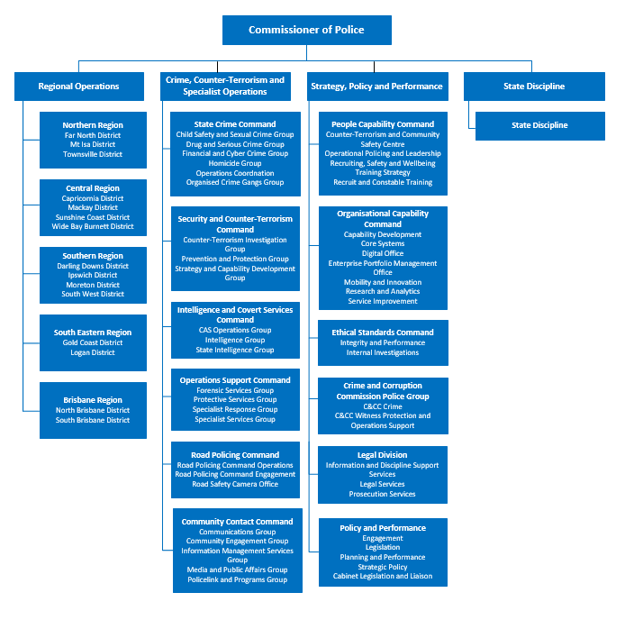
(as at June 2019)

Regional Operations is responsible for the provision of strategic direction, leadership, overview and review of the delivery of policing services to the community across the five regions statewide.
Crime, Counter-Terrorism and Specialist Operations is responsible for the provision of specialist police services through Community Contact Command, Security and Counter-Terrorism Command, Intelligence and Covert Services Command, Operations Support Command, Road Policing Command, State Crime Command.
Strategy, Policy, and Performance is responsible for continuous improvement and review, organisational efficiencies and better service provision to the Queensland community.
State Discipline is responsible for the effective management of the discipline process across the QPS, by providing consistency with Government policy directions and the Service’s strategic plan.

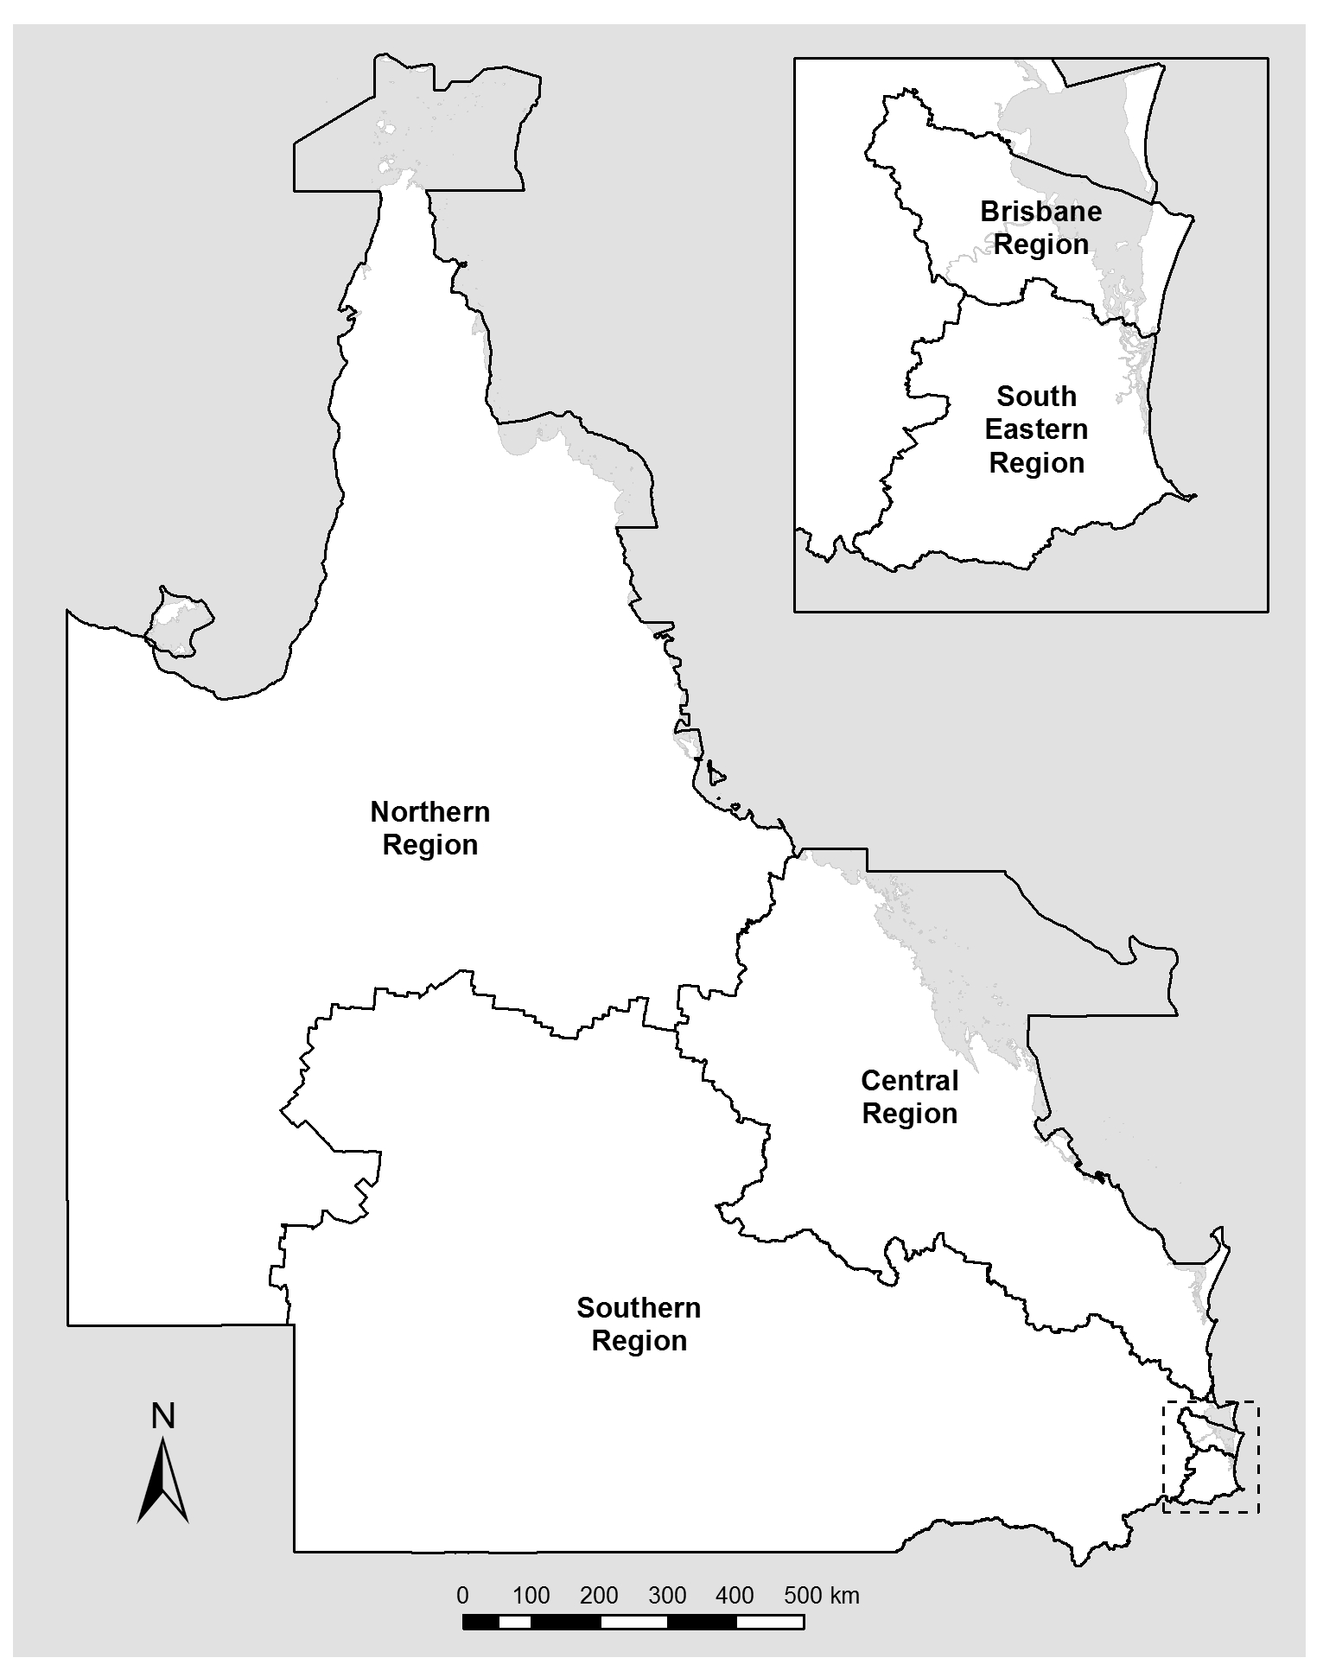
QPS Regional Map

Locations
QPS delivers its services from various locations throughout the state including:
- Police stations | 335
- Police watchhouses | 58
- Police neighbourhood beats and shopfronts | 88
- District offices | 15
- Headquarters and regional offices | 6
- Communication centres | 14
- Police Academies located in Oxley and Townsville | 2
- Policelink located in Brisbane (Zillmere) | 1
- Rapid Action and Patrols (RAP) located at Gold Coast and Townsville | 2
In addition, each police district is supported by a range of specialist areas which may include the Child Protection and Investigation Unit, Criminal Investigation Branch, Intelligence Unit, Scenes of Crime and Scientific Units, Dog Squad Unit, Forensic Crash Unit, Road Policing Unit, Prosecutions Corp and Water Police Unit. There are also purpose-built investigation centres to respond to major incidents located at various stations and district offices throughout the state. A list of contacts and key locations for QPS is included in the appendices of this report.



Financial Summary

Summary of financial performance
The following table summarises the operating result and financial position for QPS 2018-19 and the previous financial year.

Statement of comprehensive income | 2018-19  $’000 | 2017-18  $’000
Total income from continuing operations | 2,397,039 | 2,352,278
Total expenses from continuing operations | 2,393,656 | 2,251,975
Total other comprehensive income | (1) | (225)
Total comprehensive income | 3,383 | 78
Statement of financial position | 2018-19  $’000 | 2017-18  $’000
Total assets | 290,481 | 268,188
Total liabilities | 164,521 | 149,315
Net assets/equity | 125,960 | 118,872

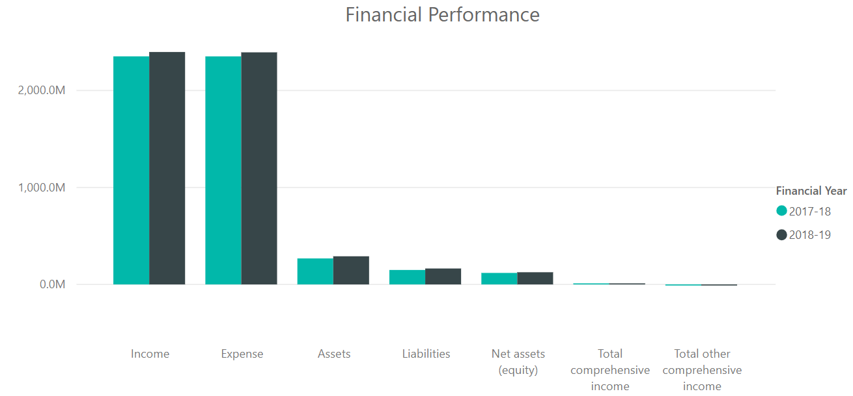

Income and expenses from continuing operations
QPS is funded to deliver timely, high quality and efficient policing services, in collaboration with community, government and non-government partners, to keep communities safe. Funding for these services is received principally through appropriations.
QPS also receives income from other sources including user charges and fees comprising special services, the sale of goods and services, corporate services provided by the PSBA at below fair value and government grants and contributions.
QPS aims to deliver safe and secure communities through innovation, collaboration and best practice. The expenses incurred in the delivery of these services are summarised further below.
For 2018-19, QPS received income from continuing operations totalling $2,397.039 million and incurred total expenditure from continuing operations of $2,393.656 million. This was comprised of:
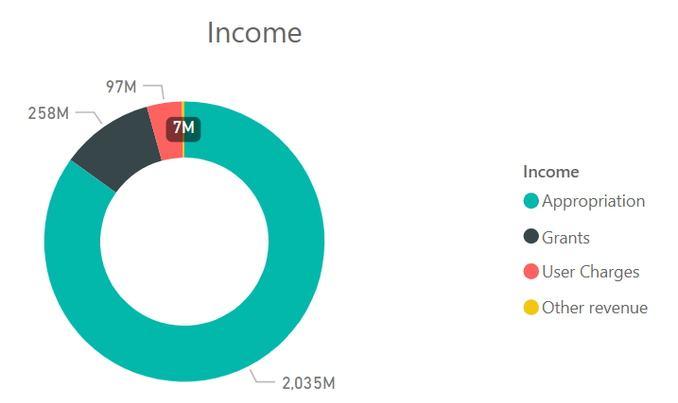

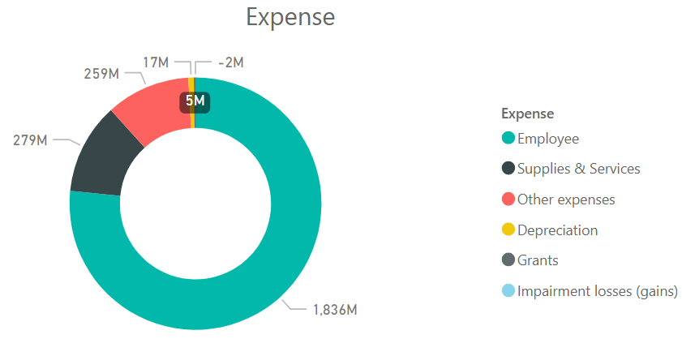

Summary of financial position
QPS was in a positive financial position at the end of the financial year. The total equity (assets less liabilities) of QPS at the end of 2018-19 was $125.960 million. This was comprised predominantly of:
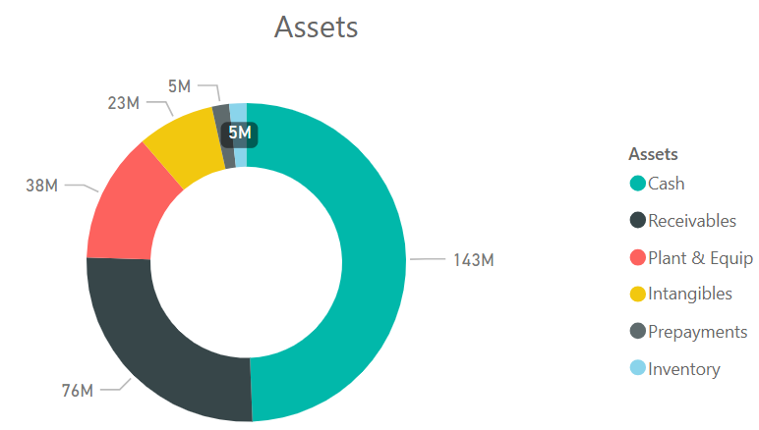

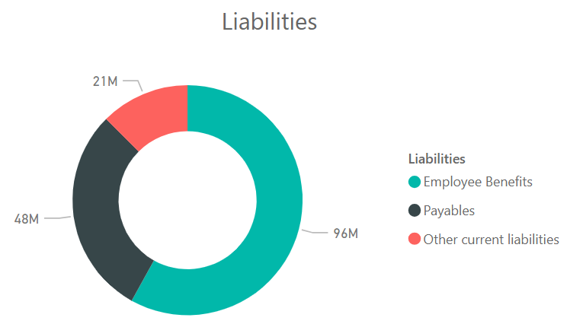

There were no significant events after balance date that could be expected to impact the reported operating result for QPS for the year ended 30 June 2019.

Performance

Key performance measures
The services provided by the QPS focus on reducing and preventing the incidence of crime, public disorder, and road trauma to build safe, caring, and connected communities. These are delivered through two service areas – Crime and Public Order, and Road Safety.
The objective of Crime and Public Order is to uphold the law by working with the community to stop crime and make Queensland safer. A range of services are provided by the QPS to support this and includes:
      - protecting personal safety and preventing and detecting related offences including homicide, assault, sexual assault and robbery
      - protecting property and preventing and detecting related offences including unlawful entry, other property damage, motor vehicle theft, and other theft
      - maintaining public order and safety, including during major events and natural disasters (from planning to recovery); addressing public space enjoyment, street and nuisance offences; liquor licensing issues; and environmental design to reduce crime including alcohol-fuelled violence.
The objective of Road Safety is to contribute to stopping crime and keeping communities safe through road safety relationships, reducing road trauma and evidence-based enforcement anywhere, anytime. This includes targeting the prevention and detection of speeding; red light offences; driving while distracted; driving under the influence of alcohol or drugs; driving while fatigued; and not wearing seatbelts.
The delivery of Crime and Public Order and Road Safety policing services to the community of Queensland is supported by a range of activities designed to promote ethical behaviour, discipline and professional practice.
The following tables provide an overview of the key performance measures for the QPS for 2018-19. Data for 2017-18 is sourced from the Queensland Police Service 2017-18 Annual Report unless otherwise stated in the Notes.

Service Area: Crime and Public Order
Performance measures | Notes | Strategic Plan | 2017-18 SDS | RoGS | 2017-18 Actual | 2018-19 Target  /Estimate | 2018-19 Actual
Percentage of personal safety offences cleared within 30 days: | 1,4
- Homicide |  |  |  |  | 67% | 70-83% | 78%
- Assault |  |  |  |  | 56% | 54-63% | 55%
- Sexual assault |  |  |  |  | 50% | 48-57% | 48%
- Robbery |  |  |  |  | 64% | 57-62% | 67%
- Total personal safety |  |  |  |  | 55% | 54-61% | 54%

Service Area: Crime and Public Order (cont’d)
Performance measures | Notes | Strategic Plan | 2017-18 SDS | RoGS | 2017-18 Actual | 2018-19 Target  /Estimate | 2018-19 Actual
Percentage of property security offences cleared within 30 days: | 2, 4
- Unlawful entry |  |  |  |  | 21% | 18-21% | 20%
- Other property damage |  |  |  |  | 28% | 25-27% | 25%
- Motor vehicle theft |  |  |  |  | 39% | 36-39% | 37%
- Other theft (excluding unlawful entry) |  |  |  |  | 28% | 26-28% | 26%
- Total property security |  |  |  |  | 30% | 28-30% | 28%
Percentage of good order offences cleared within 30 days | 3, 4 |  |  |  | 82% | 80-85% | 81%
Rate of complaints against police per 100 sworn (operational) staff | 5 |  |  |  | 12.0 | ≤9.8 | 9.5
Public perception of police integrity | 6
- Police perform their job professionally |  |  |  |  | 86.2% | ≥85% | 87.1%
- Police treat people fairly and equally |  |  |  |  | 75.8% | ≥75% | 74.4%
- Police are honest |  |  |  |  | 75.1% | ≥75% | 73.9%
- I do have confidence in the police |  |  |  |  | 84.3% | ≥85% | 84.8%
Satisfaction of members of the public who had contact with police in the last twelve months | 7 |  |  |  | 83.7% | ≥85% | 84.5%
Public satisfaction with police dealing with public order problems | 7 |  |  |  | 75.4% | ≥70% | 73.8%
Public satisfaction with police dealing with emergencies and disasters | 7 |  |  |  | 82.6% | ≥85% | 83.5%
Percentage of code 1 and code 2 incidents attended within 12 minutes | 8 |  |  |  | 84% | ≥80% | 86%
Juvenile diversions as a proportion of all juveniles proceeded against by police |  |  |  |  | 61% | ≥60% | 57.3%
Cost of crime and public order per person | 9 |  |  |  | $372 | $377 | $380
Rate of victimisation | 10, 11
- Offences against the person |  |  |  |  | New measure | New measure | 6.8
- Offences against property |  |  |  |  | New measure | New measure | 47.5
Youth reoffending | 12, 13, 14 |  |  |  | New measure | New measure | 73%
Offender Diversions as a proportion of all offenders proceeded against by police | 15 |  |  |  | Not available | N/A | N/A
Public perception of safety | 6, 16, 17
- Feelings of safety walking alone in neighbourhood during the day |  |  |  |  | 89.7% | ≥89.7% | 92.0%
- Feelings of safety walking alone in neighbourhood during the night |  |  |  |  | 53.2% | ≥53.2% | 53.4%
- Feelings of safety travelling alone on public transport during the day |  |  |  |  | 60.7% | ≥60.7% | 62.9%
- Feelings of safety travelling alone on public transport during the night |  |  |  |  | 32.2% | ≥32.2% | 32.3%
Agency engagement | 18, 19 |  |  |  | 51% | ≥51% | 53%
Workforce diversity | 20, 21, 22
- Women in SO, SES and above |  |  |  |  | 12.5% | 16.7% | 13.8%
- Aboriginal and Torres Strait Islander peoples |  |  |  |  | 2.3% | 3.0% | 2.4%
- People with Disability |  |  |  |  | 3.4% | 5.0% | 2.9%
- People from non-English speaking background |  |  |  |  | 7.2% | 9.0% | 7.0%

Notes
- The offence categories reported separately are those classified as ‘violent’ crimes and are the most significant personal safety offence categories in terms of their impact on the community. The ‘total personal safety’ offences figure also includes the offence categories of extortion, kidnapping, abduction and deprivation of liberty and other offences against the person. Homicide includes the offence categories of murder, attempted murder and conspiracy to murder.
- The offence categories reported separately are considered high volume property security offences. The total property security offences figure also includes arson, fraud and handling stolen goods.
- Good order offences include offences relating to public nuisance, obstructing police and other offences against good order. An increase in good order offences generally indicates an increase in policing activity around public spaces and major events, and a range of related proactive policing strategies often focusing on liquor-related enforcement.
- The 2018-19 Target/Estimate considers recent results and any known factors that are likely to have an impact during the year.
- Sworn operational staff refers to a police officer employed by the QPS who has sworn the Oath of Office under the Police Service Administration Act 1990, delivering a police or police-related service to an external customer, and includes officers seconded to the Crime and Corruption Commission. ‘Complaints’ are defined as statements by members of the public regarding police conduct, including officers on, off or unknown duty, when a person was in police custody or had voluntary dealings with the police.
- Public perceptions are sourced from the results of the National Survey of Community Satisfaction with Policing. The National Survey of Community Satisfaction with Policing is a general community survey. Respondents to these questions may or may not have had contact with police in the last 12 months.
- Public satisfaction is sourced from the results of the National Survey of Community Satisfaction with Policing. The National Survey of Community Satisfaction with Policing is a general community survey. Respondents to these questions may or may not have had contact with police in the last 12 months.
- Data measures the time taken to attend code 1 and code 2 incidents. Code 1 and 2 incidents include very urgent matters when danger to human life is imminent and urgent matters involving injury or present threat of injury to person or property. The benchmark of 12 minutes was chosen for comparability with New South Wales police who use similar methodology, business rules and systems.
- Cost of crime and public order per person is the proportion of the total cost of delivering crime and public order-related policing activities. This measure is reported in line with Report on Government Services methodology. Total cost is calculated based on the estimated percentage of police activity applied to crime and public order related activities. This includes operating expenditure plus a calculated user cost of capital for property, plant and equipment assets excluding land assets. This measure is acknowledged as a high-level estimate only owing to current limitations of aligning budget allocation to specific service areas.
- The measure counts the number of people or addresses classed as a ‘victim’ of a personal or property offence in the preceding 12-month period and represents this as a rate per 1000 population. The measure is used as a headline measure for the Queensland Government’s Advancing Queensland Priority ‘Keep Communities Safe’ and employs the same definition and methodology. The figure is separate and distinct from the rates of offending. It is possible to have a reduction of the number of victims, without a reduction in offences.
- As part of the ‘Keep Communities Safe’ Advancing Queensland Priority the Queensland Government has set a target that the rate of victimisation should reduce by 10% over 10 years to 2028, based on baseline figures for 2017-18.
- Also known as ‘Proportion of young offenders with another charged offence within 12 months of initial finalisation for a proven offence’, the measure is currently used as a headline measure for the Advancing Queensland Priority ‘Keep Communities Safe’.
- Measuring recidivism is complex due to the varying nature, detection and processing of offending and offenders, and the variety of ways to measure re-offending. This measure reflects the offending of all young people in Queensland who have had a proven charge, regardless of whether they had prior contact with the youth justice system or had received youth justice services.
- As part of the ‘Keep Communities Safe’ Advancing Queensland Priority the Queensland Government has set a target for a 5% reduction (against a 2015-16 baseline) by 2020/21.
- Offender Diversions refers to the number of all offenders who are diverted as a proportion of all offenders proceeded against by police. The term ‘diverted’ includes diversions of offenders away from the courts by way of: community conference, cautioning by police, intoxication diversion, drug diversion or graffiti diversion and infringement notices (excluding traffic infringement notices).
- The figure refers to the percentage of Queensland survey respondents who selected “very safe” or “safe” with each following statements:
- Walking alone in your neighbourhood during the day
- Walking alone in your neighbourhood during the night
- Travelling alone on public transport during the day
- Travelling alone on public transport during the night.
- The measures for feelings of safety on public transport are based on the entire survey population and includes those participants that have not used public transport. The figure is reported to match the existing RoGS standard.
- Data for this measure is taken from responses of QPS employees to the whole of government Working for Queensland survey, conducted annually. The measure describes employees’ level of engagement with the organisation in relation to motivation, inspiration and pride.
- The target is based on continual improvement from the baseline figure of 2016 (53%) or the most recent figure (whichever is the higher).
- In early 2016, the Leadership Board of Directors-General introduced and committed to sector-wide diversity targets, working from the principle that our workforce should closely represent the community we serve.
- Data is based on substantive placements and includes paid and unpaid employees, excluding staff members engaged on a casual relief basis. Figures are based on self-reported data that is not mandatory which may result in under-reporting on at least some of the diversity categories included. QPS has an operational workforce with 96.5% of police officers employed in operational roles. Policing roles have minimum fitness standards which impact on the ability to engage persons with disability. Due to the operational requirements of police, the “People with disability” target is based on non-operational staff members only.
- The targets listed for each group represent the target percentage representation for the year 2022. It is not considered appropriate to set an annual target in the context of police officers. The QPS workforce generally changes at a slower rate compared to other agencies as it has a lower attrition rate, and regarding police officers, generally fills positions internally only. Consequently, it is challenging to achieve changes to the workforce except over an extended period.

Key
RoGS – Report on Government Services
SDS – Service Delivery Statement
Strategic Plan – Queensland Police Service Strategic Plan 2018-2022

Service Area: Road Safety
Performance measures | Notes | Strategic Plan | 2017-18 SDS | RoGS | 2017-18 Actual | 2018-19 Target  /Estimate | 2018-19 Actual
Rate (per 100,000 people) of road crash fatalities | 1, 2 |  |  |  | 4.99 | 4.7 | 4.47
Rate (per 100,000 people) of people hospitalised following a road crash | 1, 2 |  |  |  | 131.98 | 121 | 134.0
Cost of Road Safety per person | 3 |  |  |  | $83 | $87 | $88

Notes:
- The 2018-19 Target/Estimate is consistent with the targets outlined in Safer Roads, Safer Queensland: Queensland's Road Safety Strategy 2015-21 (the Road Safety Strategy) as well as taking into account historic trends and the economic outlook. The 2018-19 Target/Estimates have been amended to be consistent with targets set by the Department of Transport and Main Roads (DTMR).
- Population data is sourced from Australian Bureau of Statistics Australian Demographic Statistics Catalogue No. 3101.0.
- Cost of road safety per person is the total cost of delivering traffic-related policing activities divided by the estimated population of Queensland. This measure is reported in line with Report on Government Services methodology. Total cost is calculated based on the estimated percentage of police activity applied to road safety related activities. This includes operating expenditure plus a calculated user cost of capital for property, plant and equipment assets excluding land assets. This measure is acknowledged as a high-level estimate only.

Key
RoGS – Report on Government Services
SDS – Service Delivery Statement
Strategic Plan – Queensland Police Service Strategic Plan 2018-2022

2018-19 Highlights
This section reports on the objectives of the QPS Strategic Plan 2018-2022. To drive delivery of its objectives, the QPS focusses on four main strategies: to stop crime, make the community safer, strengthen relationships with the community and equip our workforce for the future (refer page 10 for further information).

This is a snapshot of performance highlights from 2018-19 and is not representative of all work undertaken during the reporting period.





During 2018-19, police officers in Brisbane Region undertook a diverse range of policing activities, including:
- approximately 158,000 hours of proactive patrols
- over 49,600 hours of traffic enforcement
- attended more than 318,000 calls for service

Key achievements during the reporting period for Brisbane Region include:
Brisbane Region Major Events and Planning Unit
In May 2019, the QPS established a dedicated Major Events Planning Unit for Brisbane Region which brings together the North and South Brisbane District resources into one team that can better support event organisers, and work with the community and other partners to deliver safe events throughout the region. The unit, which is the largest planning unit in the state, will deliver a safe environment for the people of Brisbane and visitors.
The unit provides planning support across the region with a strong focus on the City, Valley and Riverside patrol groups. This enables a consistent approach across district boundaries during the planning of major events across the Brisbane Region.
The unit plans for over 1,000 events every year including major sporting events, and celebrations such as Riverfire, New Year’s Eve and concerts, Bridge to Brisbane and the Ekka.

Black Dog Breakfasts
The Black Dog Breakfast which stems from the Black Dog Institute complements the QPS ‘Our People Matter’ strategy, focuses on the health, safety and wellbeing of all QPS employees and their families. The breakfasts have key note speakers and presentations from human support officers to recognise key signs in mental health. This initiative was first implemented in the Centenary Patrol Group in February 2018 and was expanded to include North Brisbane District in May 2018, South East Region in October 2018 and State Crime Command in March 2019.
As at 30 June 2019, 28 sessions were delivered within the Brisbane Region with 1,090 members attending, with plans for at least eight more sessions for the second half of 2019.
These breakfasts allow members to better understand mental health and reduce the general stigma attached. The focus in 2018 was directed at anxiety and depression. In 2019, the focus is towards building resilience.
West End Community Safety Action Plan
The action plan is a multi-faceted project focussing on partnerships with government and non-government agencies, local community groups and NGOs to reduce crime through the Crime Prevention Through Environmental Design framework, case management of a cohort of young offenders and public awareness of safety issues in West End.
Through coordination of police resources, targeted enforcement, cross border operations, engagement and case management of young people at risk, and the installation of lighting in Musgrave Park, unarmed robbery offences have been reduced by 75%, and armed robberies reduced by 66% since December 2018. The case management of young people at risk is ongoing. The group being managed has been reduced, with many young people re-engaging with family and education.
Operation Jing
In 2017, the Inala Child Protection and Investigation Unit (CPIU) within South Brisbane District commenced Operation Jing, a protracted operation targeting suppliers of drugs to youths and vulnerable persons. In 2018-19, 67 persons were charged with 194 drug and associated offences.
The purpose of this operation is to reduce youth recidivism by limiting access to identified crime drivers. Young offenders continue to be dealt with under the provisions of the Youth Justice Act 1992, with all persons involved offered police referrals.
Crowded Places Team
The Brisbane City Station has introduced a new high-visibility team to enhance the community’s sense of safety in the City’s popular public spaces. The Crowded Places Team (CPT) comprises eight members who perform intelligence-based taskings, patrol counter-terrorism priority sites, and respond to major events and protests. CPT members physically stand out in a crowd with the help of reflective epaulettes and Load Bearing Vest patches and are highly mobile using Segways, trail bikes and an All-Terrain Vehicle. They work with the Bike Squad which is highly visible and moves freely throughout the Central Brisbane District.
CPT comprises members who are qualified in basic bomb search, crowd control, Behavioural Observation and Suspicious Activity Recognition, and the Security and Counter Terrorism Network. As at 30 June 2019, the CPT has conducted patrols at 350 events and participated in five operations which resulted in 60 arrests and 650 intelligence submissions.

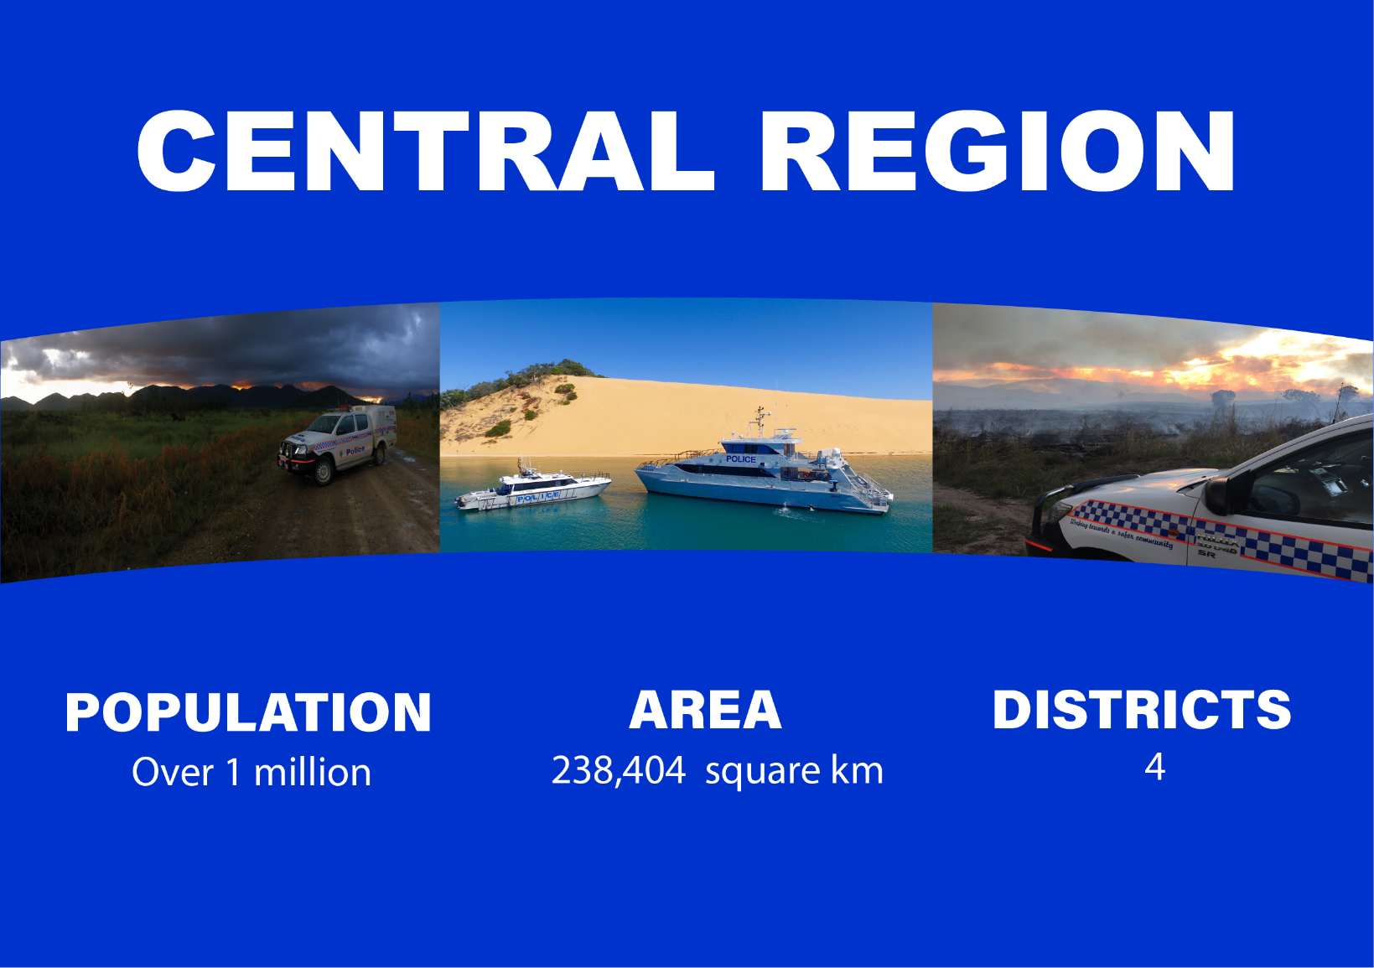

During 2018-19, police officers in Central Region undertook a diverse range of policing activities, including:
- approximately 116, 391 hours of proactive patrols
- about 121,620 hours of traffic enforcement
- responded to more than 335,000 calls for service

Key achievements during the reporting period for Central Region include:
Primary School Re-Engagement Program (P.R.E.P)
The P.R.E.P is an eight-week hands on program aimed at supporting children aged 10 to 12 years to re-engage with school. The program is an early intervention program that also supports children from homes where domestic and family violence is being experienced.
Proserpine Indigenous Reference Group
Officers from Central Region are working collaboratively with the Proserpine Indigenous Reference Group to conduct a multi-agency project targeting Indigenous youth crime and transition to employment opportunities using senior Indigenous leaders as role models.
Personal Locator Beacon Project
Central Region covers bushland and remote areas where there is limited or no mobile phone communication available. Pioneer Valley, in the Mackay District, is a large geographical area with national parks and state forests and is very popular for recreational activities including bush walking and motorised vehicle activities. Due to limited mobile phone coverage, there has been multiple incidents of search and rescue where persons have been injured or lost and unable to raise help. Central Region partnered with local businesses and community groups to provide free hire of Personal Locator Beacons to members of the community working or undertaking recreational activities in remote areas of the valley.
Bowen Youth Network
The Bowen Youth Network Group (BYNG) is a community initiative to address youth concerns, trends, programs and needs for young people up to age of 25 years within the Bowen and Collinsville areas. The group focuses on various avenues that can offer support to youths.
Since its inception in 2014 to 30 June 2019, the BYNG has achieved the following success:
- supported the implementation of the Edmund Rice School, an alternative learning high school for disengaged youths;
- supported the PCYC Braking the Cycle Program, a community initiative for vulnerable and disengaged youths.
Vulnerable Persons Unit
Supporting the Queensland Government’s response to the taskforce report on Domestic and Family Violence in Queensland, the Wide Bay Burnett District established a Vulnerable Persons Unit (VPU) in January 2019. The newly-established VPU provides services to the Bundaberg, Hervey Bay, Maryborough and Gympie areas. A Domestic and Family Violence Coordinator (DFVC) position has also been created at Gympie.
The QPS has been working collaboratively with the Department of Child Safety, Youth and Women to integrate domestic violence referral agencies into the policing response. This initiative commenced on 5 January 2019 and focusses on case management, mental health and domestic and family violence related matters.
Coordinated Response High Risk Team
The Coordinated High-Risk Response Team (CHaRRT) is a domestic and family violence initiative in Capricornia District. CHaRRT was established in September 2018 and provides services to the Rockhampton, North Rockhampton and Gracemere areas. CHaRRT is a joint-initiative between Relationships Australia and QPS to address domestic and family violence in Rockhampton and North Rockhampton areas.
The inaugural CHaRRT meeting was held in Rockhampton in September 2018. The meeting was attended by representatives from government departments including QPS, Queensland Health, Department of Child Safety, Youth and Women, Department of Housing and Public Works and Queensland Corrective Services, and non-government agencies including Family and Child Connect, Relationships Australia and Helem Yumba, an Indigenous healing centre offering therapeutic support
During 2018-19, the CHaRRT met twice a week and overviewed approximately 100 high risk domestic violence couples. This collaboration, which facilitated information sharing across government departments, resulted in multiple coordinated arrests of DV offenders, the allocation of new housing for victims, and the establishment of support networks and safety plans to better assist victims and families.
The CHaRRT is delivering outcomes that are enhancing the safety of the community and providing a wholistic intervention for vulnerable persons and their families. CHaRRT was also awarded the 2019 QPS Domestic and Family Violence Prevention Award for Community Service/Partnership.



During 2018-19, police officers in Northern Region undertook a diverse range of policing activities, including:
- approximately 157,000 hours of proactive patrols
- more than 73,800 hours of traffic enforcement
- responded to more than 242,900 calls for service.

Key achievements during the reporting period for Northern Region include:
Speak Up Be Strong Be Heard Project
The Cairns Child Protection and Investigation Unit developed the Speak Up, Be Strong, Be Heard project to address reported child abuse matters in discrete Indigenous communities. This project was established in June 2016 by Cairns CPIU in partnership with Far North District (FND) Cross Cultural Liaison Unit.
The project initially focused on West Cairns and Aurukun and was extended to all discrete Indigenous communities in FND.
The project is designed to develop an ethos of child protection through increasing community awareness of abuse, strengthen reporting obligations and improving overarching agency interventions to child protection matters within FND, in particular discrete indigenous communities in Cape York and Torres Strait.
The project is led by an Indigenous police officer and it has greatly enhanced engagement and delivery with Aboriginal and Torres Strait Islander peoples and communities, and ensured the project was developed and implemented in a culturally appropriate manner. The project has built and strengthened relationships in a number of discrete Indigenous communities in the Cape York area.
Disaster and Flood Response
An unusual, extended period of heavy rainfall over large areas of tropical Queensland began in late January 2019 and continued into February 2019. The heavy rainfall was associated with an intense and very slow-moving monsoon over northern Queensland. In Townsville, the accumulated totals of heavy rainfall were the city's highest on record since 1888.
In the Gulf Country and North West Queensland, record-breaking rainfall also occurred in previously drought affected regions, including Julia Creek, Richmond Flinders, McKinlay, Cloncurry, Carpentaria and Burke Shires, resulting in major flooding across large areas. Several sites in northwest Queensland had seven-day rainfall accumulations of more than 600 millimetres, and large areas received more than four times their February average rainfall.
The disaster and emergency management response was instrumental in the preservation of life. Well-planned emergency evacuation responses were critical to the evacuation of more than 10,000 residential homes during this period. Delivery of the disaster management response was undertaken over a protracted period of time under dynamic and changing circumstances across multiple locations in Northern Region.
Mount Isa Community Connect Project
The QPS is the lead agency in a co-located, multi-agency project called Community Connect. The project was launched in early 2019 to develop a coordinated approach to the issue of recidivist youth offending and the associated social issues that lead children to commit offences. Key agencies engaged in the project include the Department of Child Safety, Youth and Women (Youth Justice), Department of Education, Department of Housing, Department of Aboriginal and Torres Strait Islander Partnerships and Department of Corrective Services (Probation and Parole).
Through a combined, multi-agency approach, the project is seeking to develop programs that reduce truancy, deter children away from the criminal justice system and support offenders returning to the community after serving periods of incarceration.



During 2018-19, police officers in South Eastern Region undertook a diverse range of policing activities, which included:
- more than 111,300 hours of proactive patrols.
- about 78,360 hours of traffic enforcement.
- responded to over 171,400 calls for service.

Key achievements during the reporting period for South Eastern Region include:
Victim Engagement and Referral Approach Strategy (VERAS)
In November 2018, the Gold Coast District Crime Prevention Unit commenced Project VERAS (Victim Engagement and Referral Approach Strategy). Victims of property crime are offered home security and business security audits and are provided with crime reduction education material, with a focus on reducing victimisation and assisting vulnerable members of the community. The project currently operates in the Surfers Paradise and Broadbeach Police Divisions and since its inception until 30 June 2019, 888 victims have been contacted. Project VERAS has also identified and assisted victims of domestic violence and elder abuse.
Project Street CRED
Project Street CRED (Collaborate, Re-engage, Empower, Deter) commenced in June 2018 as a new initiative to reach out to at-risk young people. The project was implemented in the Surfers Paradise, Southport and Broadbeach Police Divisions as a multi-agency approach to improve service responses to ‘at risk’ young people in order to keep them safe and reduce youth offending and recidivism. The QPS has formed partnerships with the Department of Child Safety, Youth and Women, the Department of Youth Justice and Gold Coast Youth Service to form outreach teams. These teams engage vulnerable young people and utilise diversionary strategies to provide appropriate health, wellbeing and support. Since its inception in June 2018 to 30 June 2019, the project had 830 engagements with 223 individuals.
‘A fight over nothing, changed everything’ campaign
‘A fight over nothing, changed everything’ campaign was launched by the Gold Coast District in December 2018 to assist in addressing alcohol fuelled violence. Innovative strategies including a campaign utilising street artwork, development of a video production outlining the concept of the campaign, merchandise and innovative technological communication techniques on social media platforms have been implemented, all with key educational messaging.
Across the QPS social media channels, the campaign video has reached over 80,000 Facebook users and 7,900 Twitter users. The campaign continues to utilise innovative social media messaging in order to communicate with the target demographic. This includes the recent adaption of artwork for a Snapchat geofilter.
‘Think you know’ Program
The ‘Think you know’ program commenced in Logan District in April 2019 and provides information to parents, carers, teachers and students on the various types of technology young people use, the challenges they face and how they can be overcome. The program delivered presentations on topics including social media reputation management, cyberbullying, ‘sexting’, online grooming, online gaming and identity theft. Logan District has partnered with schools in the local area with presentations being delivered to over 5,000 students in 2019.
Safe Road 4 Logan
Logan Police are actively engaged in making the roads of the district safer. Members of the Springwood Road Policing Unit facilitate the ‘Drive 2n2’ program which forms part of the Safe Road 4 Logan, a partnership between Logan Police and Logan City Council. This initiative targets high school students in the process of obtaining their driver licence and comprises interactive lectures and is supported by activities in a driving simulator that demonstrates the dangers of driving whilst using a mobile phone or being distracted. The program is aimed at reducing the road toll within the Logan Police District.
To further enhance community safety and reduce youth recidivism within the Logan community, local School Based Police Officers have introduced this program into schools including Marsden State High School, Woodridge State High School, Kingston State Community College, Mable Park State High School and Flagstone State Community College.

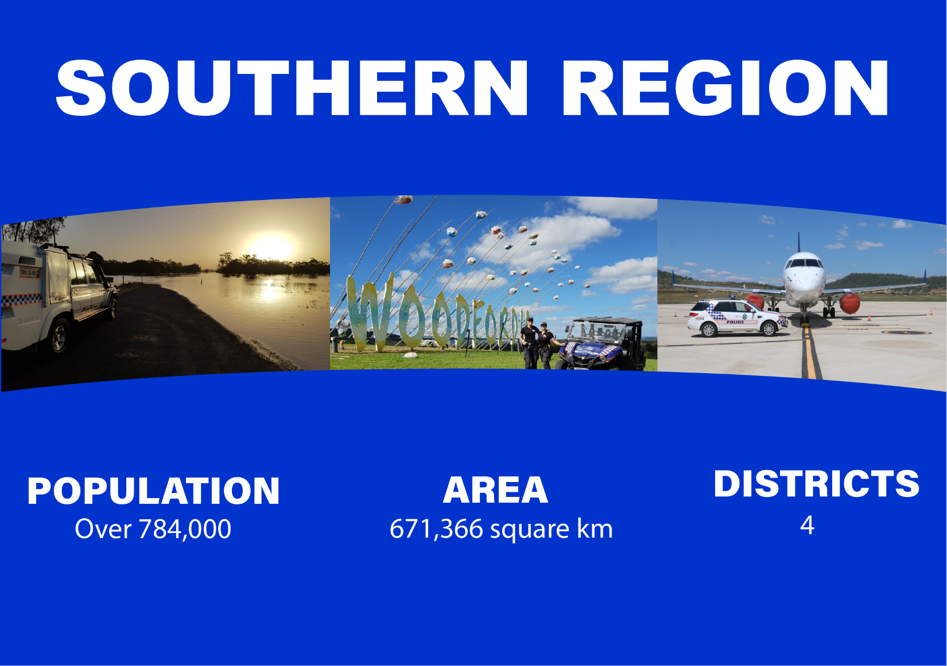

During 2018-19, police officers in Southern Region undertook a diverse range of policing activities, including:
- approximately 87,000 hours of proactive patrols
- more than 126,000 hours of traffic enforcement
- responded to more than 245,000 calls for service.

Key achievements during the reporting period for Southern Region include:
Functional Capabilities Course tours Southern Region
Southern Region put their operational skills to the test when the Functional Capability Course (FCC) visited their stations in late 2018. The FCC, developed by the Toowoomba Education and Training Office together with the Health, Safety and Wellbeing Section, is an obstacle course broken into three components – get to the problem, resolve it, then remove it. The FCC can be used for a variety of activities including training days, team building activities, voluntary fitness training and Operational Skills and Tactics Training.
During 2018-19, 33 officers across Southern Region participated in the FCC, while 16 instructors were trained to set and facilitate future FCC sessions across the state.

Community Engagement Officer
In the same period, Moreton District commenced a trial of a Community Engagement Officer to coordinate and promote the online media presence of Moreton District via the myPolice blog site.
The Community Engagement Officer provides advice to QPS members, the community and stakeholders on policing issues, through monitoring and managing and/or assisting with the preparation of media releases, social media content, articles for service publications, talking points and briefing material for use by district management.
The trial for this position commenced in October 2018 and concluded in June 2019. Since the commencement of the trial, there has been an increase in police engagement through police and social media. Police use these avenues for the identification of offenders and providing information to the community with the Community Engagement Officer assisting officers with this process.
The trial indicated a distinct increase in social media activity in the Moreton District since the introduction of the Community Engagement Officer. In September 2018, the Moreton ‘myPolice blog’ had 28 posts with a community viewing of 10,950. In January 2019, the number of posts had increased to 42 posts with a community viewing of almost 58,000.
Darling Downs District policing operations
During 2018-19, the Darling Downs District conducted a number of policing operations, including:
- Operation Quebec Trawler, a combined operation with officers from various work units, targeting property and drug crime over seven months which resulted in 387 people charged with
1,054 offences.
- Operation Quebec Midway, which focused on the disruption of the drug network, resulted in the significant seizure of dangerous drugs including Ice. This operation concluded in November 2018 and resulted in 72 people being charged with 670 drug related offences, including 12 offences of trafficking in dangerous drugs, the seizure of 229 grams of Ice and over $95,000 cash allegedly from the proceeds of sale of dangerous drugs. This operation also recovered 13 illegal firearms.
- Operation Barracuda was conducted in Warwick, Stanthorpe and Goondiwindi from 30 August 2018 to 31 March 2019 targeting the trafficking and supply of dangerous drugs in the Southern Downs area. As at 30 June 2019, the operation has resulted in 88 people being charged with 237 offences, including four charges of trafficking in dangerous drugs and 48 charges of supplying dangerous drugs.
Community Engagement and Proactive Strategies
The District Crime Prevention Unit (DCPU) for Darling Downs District established the Community Matters Group, which is aimed at improving relationships between police and Culturally and Linguistically Diverse communities. This group met six times during 2018-19.
The QPS has partnered with Multicultural Development Australia, the local settlement agency for new arrivals, and Queensland Fire and Emergency Services to create ‘Migrant Welcome Morning Teas’. The DCPU hosted welcome events for refugees to the Darling Downs District, including a multifaith afternoon tea garden party. The purpose of the welcome events is to bring people of differing faiths and backgrounds together in a friendly and lively atmosphere with police, encouraging a more informal connection and discussion.

Exercise Austral Moreton
In September 2018, Moreton District conducted Exercise Austral Moreton, a multi-agency
counter-terrorism exercise at Caboolture State High School.
Exercise Austral Moreton was a sequence of short drill exercises aimed at key tactical considerations for responding to a terrorist armed assault at a place of mass gathering. The exercise involved multi-agency participation to test current plans, capabilities and inter-operability when responding to an active armed offender and a siege incident resulting in security issues and mass casualties. QPS tested first response, command and control, negotiators, Public Safety Response Team, Polair and implementation of an Affected Person Reception Centre following just-in-time training for investigators.
Exercise Austral Moreton had 298 participants and observers including 80 role players from across government. This exercise provided all participants and agencies a realistic drill style exercise to allow participants to gain experience, examine inter-operability and review plans to improve its tactical response and better understand the roles of each agency during and immediately following an incident.

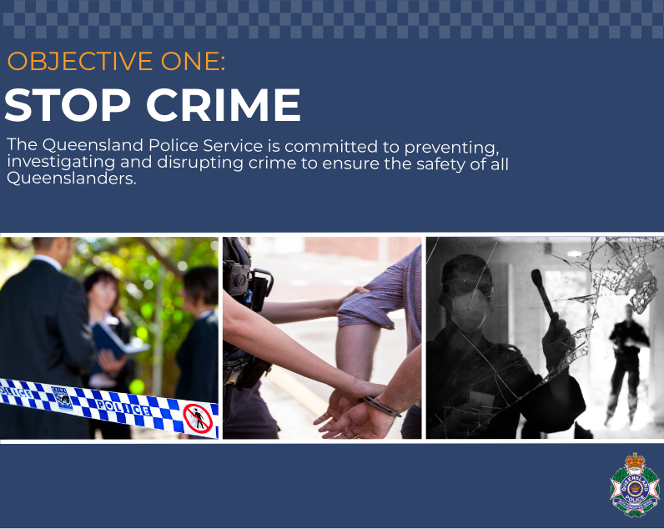
Child Abuse and Sexual Crime Group
The QPS is one of the primary agencies which provide first response, around-the-clock services for child harm investigations. The statewide Child Protection and Investigation Unit structure provides a specialist policing response to children, both as victims and offenders. The units are centrally supported by the QPS Child Safety Director of the Child Abuse and Sexual Crime Group. The Child Safety Director is also responsible for working across government and non-government agencies to ensure child protection issues receive a state-wide coordinated response.
Child protection reforms
The QPS is continuing to collaborate across agencies to deliver child protection reforms from the Carmody Commission of Inquiry, subsequent inquiries undertaken by the Queensland Family and Child Commission, and recommendations from the Royal Commission into Institutional Responses to Child Sexual Abuse. The QPS continues to drive cultural change across the Service to meet the intent of the reforms.
Argos Unit
The Argos Unit is principally responsible for the investigation of organised child exploitation, including computer-facilitated offences. Investigators proactively and reactively target a broad range of websites and mobile applications used by child sex offenders to prey on children. Argos staff also identify and implement new strategies to combat computer-facilitated crimes against children.
The unit works with national and international law enforcement agencies, technology providers, non-government agencies and child protection advocates in a collaborative effort to protect children.
During the reporting period, Argos investigators:
- contributed to the identification of 219 children in circumstances of sexual harm nationally and internationally
- arrested 112 child sex offenders on 1,299 criminal charges
- referred 829 cases to law enforcement agencies nationally and internationally.
An important part of the work performed by the Victim Identification team at Argos has been the establishment of the Griffeye Database. This database is the largest of its kind in the southern hemisphere with over 85 million seized images that have been processed with 40 million classified as unique (approximately 20% depict or relate to child exploitation). Discussions are currently under way to make this database accessible as a resource for specialist investigators across Australia.
Argos will continue to progress the Queensland Sentencing Advisory Council recommendations in relation to categorisation of child exploitation material (CEM), including development of a CEM investigation package and implementation of Interpol Baseline Categorisation schedules.
Sexual Crimes Unit
The Sexual Crimes Unit (SCU) targets sexual offenders who pose the highest risk to the community, by disrupting and preventing serious and repeat offending and or complex investigations. The unit also provides investigative expertise to regional investigators and works collaboratively with external law enforcement agencies to prosecute offenders for both state and commonwealth offences.
The SCU has conducted various operations during the reporting period, including:
- Operation Quebec Darwin – SCU worked collaboratively with regional investigators and partner agencies to identify a serious sex offender leading to the identification of multiple victims and the arrest for offences of rape, sexual assault and deceptive recruiting through an employment scheme for overseas travellers.
- Operation Quebec Javelin – SCU continued to conduct cold case reviews of all unsolved rape offences by liaising with regional investigators, identifying possible suspects, using specialist investigative strategies and advances in forensic technology. This resulted in the successful finalisation of four cold case investigations and the arrest of six offenders for 17 offences including rape and sexual assault charges.
The QPS is continuing to implement recommendations from the Royal Commission into Institutional Responses to Child Sexual Abuse. In response to recommendations relating to improving accessibility for victims of crime, the QPS initiated a project in January 2018 to establish online reporting of sexual assault and is working closely with the Policelink Communications Centre to implement online reporting by December 2019. Online reporting will provide another avenue for victims of sexual assault to report a matter, in addition to the current Alternative Reporting Options (ARO) process. The QPS continues to develop and implement processes to enhance responses to victims of sexual assault.
Child Trauma Unit
The Child Trauma Unit (CTU) continued to provide high-level specialist investigative and operational assistance to regional investigators on sudden, unexplained deaths of children, and serious injuries and deaths resulting from suspected child abuse and neglect during the reporting period.
This group of highly trained investigators is experienced in child abuse and suspicious death investigations. The CTU uses diverse investigative techniques and has developed networks with a range of government and non-government experts in the field of child trauma to provide additional capability to these complex investigations. During 2018-19, the CTU was engaged in 27 cases of significant injury and child death, which resulted in 11 persons being charged with serious offences including murder.
The CTU provides specialist training to regional investigators associated with child death investigations, and actively participates in the facilitation of lectures to tertiary education establishments and external government departments on child homicide.
In June 2019, the CTU was recognised as a leader in child protection and was invited to present at the Homicide Forum for Investigators hosted by the Cambodian Child Protection Unit (CPU). The CTU shared specialist investigative techniques used in Queensland in cases involving child trauma and abuse. The Cambodian Children’s Fund established a CPU to assist the Cambodian National Police in the investigation of offences against children and to provide extensive training in the investigation of abuse and associated crimes committed against children.
Child Protection Offender Registry
The Child Protection (Offender Reporting and Offender Prohibition Order) Act 2004 requires people convicted of committing serious offences against children (Reportable Offenders) to register their personal details and inform police of their whereabouts. Reportable Offender details are recorded on, and administratively managed, by the Queensland Child Protection Offender Register (CPOR). Reportable Offenders are required to make ongoing reports of their personal details.
The CPOR comprises specialist investigators and dedicated administrative resources trained in the investigation, administration and management of Reportable Offenders in Queensland. To fulfil their specialist role, CPOR officers undergo specialist training and participate in ongoing professional development opportunities.
CPOR officers work in partnership with Queensland Corrective Services to improve the efficiency and effectiveness of the management of reportable offenders, including those subject to supervision orders under the Dangerous Prisoners (Sexual Offenders) Act 2003. During the reporting period, QPS preferred a total of 71 charges against persons under the Act, and four children and three adults were identified and removed from being at risk of harm.
Drug and Serious Crime Group
The Drug and Serious Crime Group (DSCG) provides a high-level investigative capacity to disrupt and dismantle organised criminal networks involved in drug trafficking and production, firearms trafficking, and major and organised crime more generally.
The DSCG engages with other law enforcement agencies to build relationships and enhance a collaborative and cooperative approach to targeting serious unlawful criminal activities.
Significant achievements for the DSCG in 2018-19 include:
- 1,072 persons charged with 3,684 offences
- an estimated $41 million worth of drugs were seized
- 82 illicit drug labs were located and seized
- asset restraint matters commenced, valued over $17 million
- cash and asset seized to the value of $1,454,289.
Financial and Cyber Crime Group
The Financial and Cyber Crime Group (FCCG) within State Crime Command is central to the QPS’ response to reported financial and cyber crime.
Key achievements for the FCCG in 2018-19 include:
- the Electronic Evidence Unit examined over 5,500 electronic and digital devices supporting police investigations for a wide range of offences including organised crime, serious crimes including homicide, domestic violence, property crime, and road safety.
- the Investigative Accountants Unit analysed the financial data of 51 investigations relating to the dangerous drug Ice, organised crime and serious crimes including fraud, money laundering and homicide to a total value of $45.41M. Over $28.2M of proceeds of crime referrals were made to the Crime and Corruption Commission. A further 37 investigations are being analysed.
- the ACORN Unit managed over 17,000 cybercrime reports referred to QPS from the Australian Cyber Crime Online Report Network. These reports related to cybercrime offending against Queenslanders or committed by Queenslanders.
- the Stolen Property Investigation and Recovery Unit logged in excess of 1.1 million trades of over 3.9 million items of property. The unit identified 262,000 potential property matches for further investigation.
The FCCG has responsibility for investigating and disrupting major and serious fraud, identity theft, money laundering and cyber-related crime. During the reporting period, the FCCG investigated numerous protracted cases of serious and organised fraud, with a value in excess of $50 million. This resulted in 49 offenders being charged with 535 serious criminal offences including serious and complex major fraud, corruption, money laundering, cold call investment fraud and cybercrime.
The group operates a community awareness crime prevention program to reduce victimisation across Queensland. The program, R U In Control, encourages Queenslanders to maintain control of their financial and personal identification information with the emphasis on control.
The FCCG and People Capability Command also developed a Financial Crime Investigations Course, drawing on the research from best practice investigative strategies used around the world. During the reporting period, 48 officers have been trained in this course, with over 250 officers having received the training. Due to its success, the training was extended to officers from Northern Territory Police and the Crime and Corruption Commission.
Organised Crime Gangs Group
The Organised Crime Gangs Group (OCGG) works in partnership with police districts and various government departments to target the crime linked to organised crime gangs, including Outlaw Motorcycle Gangs (OMCG). The National Anti-Gang Squad Queensland Strike Team is a partnership between the OCGG, Australian Federal Police and Australian Taxation Office, providing a cooperative approach to the prevention and investigation of cross-jurisdictional gang related crime.
Key achievements for OCGG for 2018-19 include:
- 363 OMCG participants arrested on 1,376 charges
- 389 official consorting warning notices have been issued deterring recognised offenders from establishing, maintaining and expanding criminal networks
- 30 persons charged with wearing gang related prohibited items
- since 2013, in partnership with the Crime and Corruption Commission, 78 restraining orders have been obtained over property to the value of $22.35 million. In addition, a number of Australian Taxation Office tax assessments have been levied from operations identifying unexplained income
- an attempt to establish a Rebels OMCG clubhouse was disrupted through the exercise of the new restricted premises search powers.
OCGG continues to have a statewide focus with operations in all 15 police districts resulting in the disruption of criminal activity linked to OMCGs.
Cold cases solved in 2018-19
The Cold Case Investigation Team examines previously unsolved homicide and suspicious long-term missing persons investigations. The team reviews these cold case investigations and utilises advances in forensic and criminal investigative techniques. During the reporting period, the Homicide Investigation Unit and Cold Case Investigation Team solved eight cold case investigations dating back to 1978.
New laws for Child Sex Offenders
The government further strengthened the laws to protect the community from child sex offenders. Amendments to the Police Powers and Responsibilities and Other Legislation Act 2018 extended strict monitoring conditions for life and created stronger powers for the police and the courts. The new laws lower the threshold for what constitutes ‘concerning behaviour’ and expands the types of conditions courts can impose, including enforcing GPS tracking, making counselling sessions compulsory, and directing offenders where to live.
From November 2017, under the new Passports Legislation Amendment (Overseas Travel by Child Sex Offenders) Act (Cth) Reportable Offenders are required to seek permission from the State Child Protection Offender Registry to undertake international travel. As of 30 June 2019, 119 applications for international travel have been received from 90 Reportable Offenders, of which 20 were approved, 71 denied, 28 withdrawn. As a result, 56 Queensland offenders have been restricted from travelling overseas and have been denied the opportunity to have unrestricted access to vulnerable children in countries where activities are not regulated as stringently as Australia.
Counter-Terrorism Investigation Group
The investigations and intelligence portfolios are critical to the prevention of, preparation for, and response to terrorism. In January 2018, the Counter-Terrorism Investigation Group (CTIG) was established to enhance the QPS’ capability to investigate, prevent and deter terrorism, and respond to politically motivated violence and security threats through collaborative and intelligence driven methodologies. The CTIG works in partnership with the Australian Federal Police and the Department of Home Affairs to combat the threat of terrorism in Queensland and nationally.
This capability has been further enhanced by the delivery of a nationally accredited Counter-Terrorism Investigations Program (CTIP). In 2018-19, 48 officers across the state completed the CTIP, with more officers expected to complete the training in 2019-20.
The Counter-Terrorism Investigation Group continues to expand its investigative, intelligence and mitigation of security risk assessments by forensic behavioural consultants to provide an improved response capability as well as assist with the ongoing management of any associated risks to the community.
Prevention and Protection Group
The QPS Prevention and Protection Group conducts vulnerability assessments on a number of significant ‘crowded public places’ in Queensland, working collaboratively with local councils and industry partners to minimise the risk of attacks. The Prevention and Protection Group encompasses the Security and Counter-Terrorism Network, Engagement and Diversion Program, and the Queensland Fixated Threat Assessment Centre.
The Prevention and Protection Group implemented the Counter-Terrorism Security Coordinator (CT SecCo) capability across the QPS and recently trained more QPS personnel to increase the CT SecCo capability throughout the state. The CT SecCo undergo intense training to enable the development of protective security plans to mitigate the risk of terrorism at major events. These plans have been implemented and CT SecCo personnel deployed at numerous major events across Queensland including Anzac Day, Cairns Ironman, Townsville Supercars, Riverfire, Brisbane International Tennis, Major Stadium Concerts, Australian Defence Force Welcome Home and Freedom of Entry Parades, National Police Remembrance Day and New Year’s Eve.
- Security and Counter-Terrorism Network
The Security and Counter-Terrorism Network (SCTN) continued in 2018-19. The Network, which is unique in national law enforcement, was developed to strengthen QPS’ capacity and capability statewide by delivering an agile approach to security in the contemporary risk environment. In 2019, the Network received an allocation of permanent full-time positions, which are predominantly regionally based, to further enhance the organisations frontline counter terrorism capability. The Network provides frontline officers with awareness training and a framework for enhanced community engagement, reporting, investigations and intelligence-sharing.
The QPS has conducted 10 Skills Enhancement training programs to 125 regionally based SCTN trained police to further enhance frontline capability. The Skills Enhancement program focused on updating participants on the contemporary threat environment, identifying behavioural indicators of radicalisation and methodologies for the protection of major events and ‘crowded places’. Through the SCTN, the QPS has facilitated 10 counter-terrorism forums for 509 owners and operators of ‘crowded places’. These forums focussed on the importance of understanding the threat environment through greater information sharing, Active Armed Offender and Improvised Explosive Device response, emergency management planning, protective security overlays and reporting suspicious behaviour to ensure ‘crowded places’ are equipped to prepare for, prevent, respond and recover from terrorism.
- Engagement and Diversion Program
The QPS Engagement and Diversion Program (formerly known as the Queensland Living Safe Together Intervention Program) continued in 2018-19. The Program supported people to disengage from behaviours that may lead to criminal and violent extremism by working with families and vulnerable people and connecting them to appropriate support services in the community.
- Queensland Fixated Threat Assessment Centre
The Queensland Fixated Threat Assessment Centre (QFTAC), an Australian first joint QPS and Queensland Health initiative, continued nation leading work assessing fixated persons who predominantly suffer from untreated mental illness and pose a risk to public office holders and members of the judiciary. Recent expansion into the assessment of grievance-fuelled violence, including lone-actor terrorism, provides further enhancement to community safety reassurance.
Strategy and Capability Development Group
The Strategy and Capability Development Group ensure the QPS is equipped and well-prepared to prevent and respond to counter-terrorism by building capability and shaping counter-terrorism strategy. Two bodies of work undertaken by the group during the reporting period include:
- Queensland Police Security Alert Level System (QPSAL)
The QPS developed and implemented the QPSAL, a scalable threat notification system designed to raise awareness of potential threats and allow for effective planning to minimise or mitigate threats to police buildings and employees. The QPSAL guides and instructs officers in charge and supervisors on appropriate steps to be taken if there is a credible threat to police buildings or employees. The system enables the QPS to prepare for and respond to threats to ensure the safety of our members and the community.
- Authorisations made relating to a terrorist act or threat
In terms of the Police Service Administration Act 1990 section 5.17(15) Authorisation of non-State police officers, no authorisations were made relating to a terrorist act or threat during 2018-19.

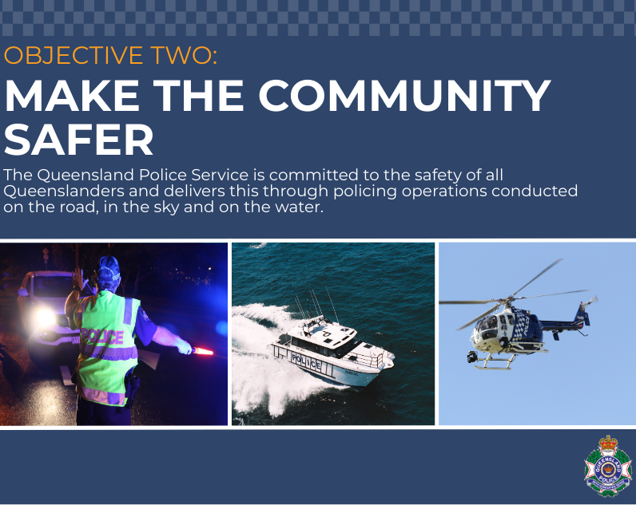
Road safety and the Fatal Five
The Queensland road toll for the 2018-19 financial year was 226 road fatalities, which equates to 4.47 fatalities per 100,000 population. This represents 20 fewer fatalities than the previous financial year, when 246 fatalities were recorded (4.96 fatalities per 100,000 population).
Many road crashes involve at least one of the ‘Fatal Five’ high-risk road user behaviours which include speeding, drink and drug driving, not wearing a seat belt, driving while fatigued, and driver distraction and inattention. In 2018-19, multiple statewide road policing enforcement campaigns were coordinated to influence driver behaviour and target criminal offending on the road network.
As at 30 June 2019, 2,787 police attended Crime and Traffic Connecting on Highways (CATCH) workshops. The CATCH workshops train officers to observe situations and behaviours that may indicate criminal activity by offenders who are initially detected committing a traffic offence. Officers continue to utilise CATCH principles in routine traffic enforcement activities and through the delivery of road safety operations.
In 2018-19, the QPS delivered the following high visibility road safety operations:
- Operation Quebec Yield targeted registration offences including obscured, missing, false or cloned plates, red light offences, seat belts and distracted driving over a five-month period. Officers also conducted a range of enforcement activities including roadside breath and drug testing and the detection of traffic and criminal offences
- Operation Romeo Arcadian involved high visibility enforcement and community engagement activities to promote safe road user behaviour in rural and remote locations. Road Policing Units were deployed across several launch points over a five-month period to cover road networks in western and central Queensland.
In 2018-19, the various road safety operations resulted in:
- more than 158,440 speeding infringement notices issued (excluding camera detected offences)
- approximately 9,000 infringement notices issued for not wearing seat belts
- almost 12,000 infringement notices issued for using mobile phones
- over 2.66 million random breath tests which detected approximately 16,650 drink driving offences.
Roadside Drug Testing
During the reporting period, the QPS conducted more than 70,000 roadside drug tests, with approximately one in five drivers testing positive. This represents an increase of just over 4,000 tests from 2017-18. The QPS also expanded its roadside drug testing capability by increasing the number of officers trained to perform testing to 696. This is a significant increase from 276 officers in 2015-16 and 510 officers in 2016-17.
Collaborative partnerships
Queensland Road Safety Week
The QPS continues to work collaboratively with stakeholder agencies to increase community awareness of road safety concerns. The QPS, in partnership with the Department of Transport and Main Roads (DTMR), coordinated the 2018 Queensland Road Safety Week campaign, “Speak Up For Road Safety”. The annual campaign aims to promote road safety messages and encourage greater community ownership of road safety issues.
‘Hold the Red’
During 2018-19, the QPS upgraded six existing red-light camera sites to improve intersection safety. Four of the upgraded red-light speed camera systems include a ‘Hold the Red’ functionality. This functionality delays the signals changing from red to green for cross traffic when a vehicle is detected disobeying the red-light signal. This functionality also reduces side impact road crashes at signal controlled intersections. This initiative was undertaken with the DTMR and was nominated and recognised at the Queensland Premier’s Innovation Awards in 2018.
Trial to reduce road closure times
In July 2018, the Forensic Crash Unit (FCU) commenced trialling the use of Remotely Piloted Aircraft (RPA) to map traffic crash scenes, with the aim of reducing the amount of time required for road closures. Previously, FCU investigators would spend up to two hours at a scene using a robotic total station to manually record the location of road fixtures and physical evidence.
During the trial, the RPA was used to fly over a scene and a series of overlapping images were taken to record fixtures such as kerbing, traffic lights and line markings, along with physical evidence including tyre marks, scrapes, gouges and the final resting position of vehicles. Once the images are combined, two dimensional scaled aerial images are produced using specialist software. On average, the time taken to record a scene would be reduced by up to 50% using the RPA.
Since the trial, FCU investigators have used the RPA to record crash scenes on six occasions. During May 2019, a further six Forensic Crash Investigators were trained as remote pilots, and four RPAs with improved capability were purchased. These aircraft were deployed across Brisbane, Logan, Gold and Sunshine Coasts in June 2019.
GPS Tracking Project (Electronic Monitoring)
In March 2018, amendments to the Bail Act 1980 commenced to empower a court to impose a ‘tracking condition’ as part of a person’s bail undertaking for any offence. The GPS Tracking Project Team has successfully implemented the operational requirements to ensure the QPS meets its obligations in delivering the capability to fit electronic monitoring ankle devices to offenders who have been granted bail with the electronic monitoring condition by the court. This has included creation of internal procedures and practices as well as external requirements such as Gate 3 Assurance Review for Queensland Government Chief Information Office.
The Project Team received Level 1 Certification training (delivered by the USA Scram team). This training enabled the team to develop and commence delivery of full training packages for Watchhouse Officers, Prosecutions and General Duties officers. As at 30 June 2019, 78 bail orders have been imposed statewide by Magistrates.
New laws for Child Sex Offenders
The government further strengthened the laws to protect the community from child sex offenders. Amendments to the Police Powers and Responsibilities and Other Legislation Act 2018 extended strict monitoring conditions for life and created stronger powers for the police and the courts. The new laws lower the threshold for what constitutes ‘concerning behaviour’ and expands the types of conditions courts can impose, including enforcing GPS tracking, making counselling sessions compulsory, and directing offenders where to live.
POLAIR Queensland
The QPS has two helicopters, POLAIR 1 and POLAIR 2, based on the Gold Coast and Brisbane respectively, which are available for tasking 24 hours a day, every day of the year. The helicopter service is provided under a contractual arrangement with Surf Life Saving Queensland. Surf Life Saving is responsible for providing the helicopters, associated equipment and pilots and the QPS provides police tactical flight officers who direct the operations.
POLAIR Queensland provides tactical aerial support to police operations, improving officer and community safety and situational awareness of major events and critical incidents. While routine operations are limited to the south-east corner of the state, the aircraft are capable of deployment statewide for major incidents and disaster events.
During 2018-19, the two helicopters undertook:
- 2,118 flight hours
- 1,067 proactive tasks (planned)
- 1,732 reactive tasks (in response to Police Communication Centre requests)
From tracking offenders, to search and rescue, and providing real time situational awareness of major incidents, police helicopters help keep the community safe by providing quality support to frontline police.
In 774 instances during the reporting period, POLAIR was the first police resource on scene to reported incidents. This capability enhances officer and community safety as the helicopter crews provide information to the attending police about what to expect at the incident including best access points, number of persons observed and any movement around the location, vehicles at the incident location and perceived threats.
The helicopters are fitted with state-of-the-art equipment which allows them to identify, track and record vision of offenders in a range of operational contexts. In 2018-19, POLAIR proactively identified 357 traffic-related matters which resulted in offenders being charged with offences including unlawful use of motor vehicles, dangerous operation of motor vehicles and evading police.
Both helicopters are fitted with state-of-the-art night-vision and infra-red technology and are used extensively in search and rescue operations. This technology has enabled POLAIR to locate 68 missing persons during 2018-19.
During the same period, POLAIR helicopters have been responsible for locating 935 offenders. The offenders located by POLAIR were wanted for a wide range of offences including murder and attempted murder, rape, armed robbery, kidnapping, stalking, domestic violence, property offences and serious traffic offences.
POLAIR has also been involved in 117 counter terrorism and covert surveillance operations.
POLAIR prides itself on its commitment to continuous improvement and innovation. Innovations include the ability to download encrypted live-footage from the helicopter to Police Communication and State Disaster Coordination Centres, as well as to iPads used by general duties officers. This downlink capability greatly improves the situational awareness of police commanders and enhances their ability to make informed, tactical decisions during police operations. This underpins the safety of police officers and the community. This capability has also assisted Queensland Fire and Emergency Services in managing bushfires where people and property were threatened.
Assistance was also provided to interstate policing jurisdictions, including 27 incidents assisting the NSW Police Force during 2018-19. These incidents have included search and rescue operations, high risk offender searches, domestic violence incidents, organised crime investigations and police pursuits.
Remotely Piloted Aircraft Systems
In 2010, QPS considered the potential benefits of Remotely Piloted Aircraft Systems (RPAS) and subsequently commenced research into their use, focusing on the vertical deployment of cameras to provide thermal imaging, enhanced situational awareness, officer safety and command and control at significant incidents. In December 2013, Operations Support Command was successful in achieving a Civil Aviation Safety Authority (CASA) Operators Certificate which formalised the QPS as the first Australian Law Enforcement Agency and first Queensland Government Agency to achieve this credential. On 26 December 2013, the QPS became the first Australian law enforcement agency to use RPAS operationally.
All flights require a minimum two crew operation consisting of a pilot and a trained secondary observer. Annual practical and theory exams are conducted on all RPAS pilots by the Chief and Deputy Chief Pilots.
The RPAS is utilised by the Specialist Response Group, Specialist Services Group, Forensic Services Group, State Crime Command and Road Policing Command for operations and investigations including:
- terror incidents within the arrangements agreed to under the National Counter Terrorism Plan
- potentially violent incidents that exceed normal police capabilities
- incidents involving explosives/ordinance or chemical, biological and radiological (CBR) devices
- natural disasters to preserve life and protect property
- search and rescue operations
- forensic investigations.
As at 30 June 2019, the QPS has an inventory of 56 operational multi rotor RPAS, 35 licenced remote pilots and 93 officers trained as payload operators/secondary observers. The RPAS have been deployed to 926 jobs/scenes (as at 30 June 2019).
The use of RPAS in QPS is greatly increasing with very successful results. These flights have been used in support for major and critical incidents, a large variety of major forensic scenes, and in support of the drug and serious crime group operations.
QPS Dog Squad
The QPS Dog Squad operates in every region with general purpose handlers based in most police districts. The QPS has 95 dogs including general purpose, drug detection, urban search and rescue, cadaver and blood detection dogs. The demand for operational handler/dog teams is rising in response to the specialist services available through the squad.
In 2018-19, the QPS Dog Squad Units:
- attended over 32,000 calls for service
- attended over 2,600 tracking deployments
- located over 2,000 persons
- located 679 items of property
- attended 799 search warrants
- attended in excess of 1,500 drug locations
- 35,380 Passive Searches Conducted.
Water Police
The QPS Water Police supports a safer Queensland by delivering an integrated specialist policing resource focused on enforcement and educational activities on our waterways.
In 2019, QPS Water Police celebrated 160 years of service. The Water Police was first established in 1859 and 160 years later, with a fleet of 65 vessels, it continues to provide a professional and committed response to ensure the safety of the marine community across the state.
The Water Police has a staff of 100 and operates the fleet from 11 main water police bases across Queensland 24/7. Water Police staff include a full time Dive Unit of eight permanent staff; a State Search and Rescue Coordinator and Trainer; and the State Marine Training Section. The fleet is managed and maintained by seven Public Safety Business Agency staff at the Marine Technical Section, Lytton.
The primary role of the Water Police is to provide statewide specialist support focusing on maritime incidents and operations. This activity includes:
- maritime safety and enforcement activity on our coastal and inland waterways to a distance of 200 nautical miles offshore
- drug and alcohol enforcement activity and intelligence gathering
- search and rescue with approximately 1,200 operations undertaken annually
- providing a statewide Dive Unit response with approximately 150 deployments each year.
In performing their roles, the Water Police rely on their partnerships and relationships with other agencies, including:
- Maritime Safety Queensland
- Australian Maritime Safety Authority
- Queensland National Parks and Wildlife Service
- Queensland Fisheries
- Australian Border Force
- Maritime Border Command
- Australian Navy & visiting foreign naval forces
- Australian Federal Police
- Queensland Volunteer Marine Rescue
- Australian Volunteer Coast Guard
- numerous recreational and commercial boating organisations and committees.
Water Police take drug testing to the waterways
In February 2019, the QPS commenced a six month trial of on-water drug testing and enforcement to create a safer environment on water. Previously, on-water drug testing was undertaken during joint operations with the Road Policing Command. The QPS trial aims to provide water police with the equipment, training and capacity to undertake their own on-water drug testing independent of these joint operations.
Water Police are using the Draeger Drug Test 5000 instrument to test for drugs with this instrument to be available on the six class one vessels across the state in 2019-20. Currently, 16 Water Police Officers are trained to use the drug testing equipment, with more officers expected to be trained in 2019-20.

Disaster Management
The QPS Disaster Management Unit is located at the State Disaster Coordination Centre (SDCC), Emergency Services Complex, Kedron and has a permanent staff of six. During the reporting period:
- the SDCC activated a total of six times for events including wildfires (central Queensland), an active monsoon (north Queensland) and tropical cyclones for a total of 42 days
- 110 QPS officers undertook training for roles within the SDCC
- two Deputy District Disaster Coordinator courses were conducted in Brisbane to increase capacity across the service. Thirty-six police officers from around Queensland participated
- three Deputy Executive Officer courses were conducted in Longreach, Maryborough and Mt Isa where 43 officers were trained
- local and district disaster management plans were assessed and updated prior to the 2018-19 summer storm season. The assessments were conducted using the assessment tool provided by the Office of the Inspector-General Emergency Management and the Emergency Management Assurance Framework
- two Exercise Management courses were conducted in the Gold and Sunshine Coasts, 22 additional staff from QPS, government and non-government agencies were trained in developing Disaster Management exercises
- the QPS undertook training and completed exercises at 22 disaster districts and have provided exercise management assistance to a number of the 78 local government authorities.
Railway Squad co-responder initiative with the NOFFS Foundation
The QPS Railway Squad has partnered with Queensland Rail and the NOFFS foundation to address Volatile Substance Misuse (VSM) on and off the rail network. The NOFFS Foundation seeks to support socially disadvantaged and disconnected people through treating drug and alcohol programs, including those with mental health issues. The first joint VSM patrols commenced in May 2019 involving plain clothes officer from the Railway Squad and NOFFS Foundation, focussing on diverting at-risk youths. Initial intelligence-led patrols targeted stations from Woodridge to Loganlea and have since expanded to the Ipswich and Caboolture lines. The joint patrols have resulted in a number of at-risk youths identified and referred via the Police Referral System to the NOFFS foundation.
Introduction of Tactical First Aid Training
The successful implementation of Tactical First Aid Training was finalised this year with all sworn members trained in the delivery of life saving trauma skills. Police have applied these skills using tourniquets, chest seals and wound bandages in situations including serious road crashes, an aircraft crash, and incidents of self-harm. The skills, equipment and training were developed in partnership with the Trauma Council Queensland and national tactical medical organisations. The QPS is one of the few large-scale police services in the world to have developed this training and delivered it to all frontline police. The training now forms part of annual operational skills training for all police.
Commonwealth Games Group awarded with highest honours
The Commonwealth Games Group received national accolades, with a stunning result in the prestigious Prime Minister’s Award for Excellent in Public Sector Management. The Institute of Public Administration Australia (IPAA) recognised the Commonwealth Games Group with not only the Gold Award, which is one of two supplementary awards given at the discretion of the judgement for joint nominations between two or more organisations. The Gold Coast 2018 Commonwealth Games was the biggest sporting event in Australia this decade and presented the largest operational challenge ever faced by the QPS. The Commonwealth Games Group was established as early as April 2015 to plan and execute what would become known as Operation Sentinel, the integrated security operation ensuring a safe and secure Games. Counter-terrorism planning strategies were developed, drawing on learnings from previous major events across the globe, including G20. All desired outcomes were delivered on time and under budget. The IPAA judges were extremely impressed with all facets of the Service’s nomination, noting that it represented a major international event, with high risks and high expectations. The QPS delivered security operations of the highest order.
New investigative powers to fast track missing person cases
New laws have been passed by Parliament to allow the QPS to fast track investigations into high-risk missing persons. Recent amendments to the Police Powers and Responsibilities Act 2000 included a new framework to respond to high risk missing persons. The framework incorporates a new missing person scene warrant where police will have the power to enter and search a place for the missing person or for information which may lead to the person’s whereabouts. The new legislation will significantly assist police in the initial stages of a high-risk missing person investigation when locating the missing person or obtaining information as to their whereabouts is vital.

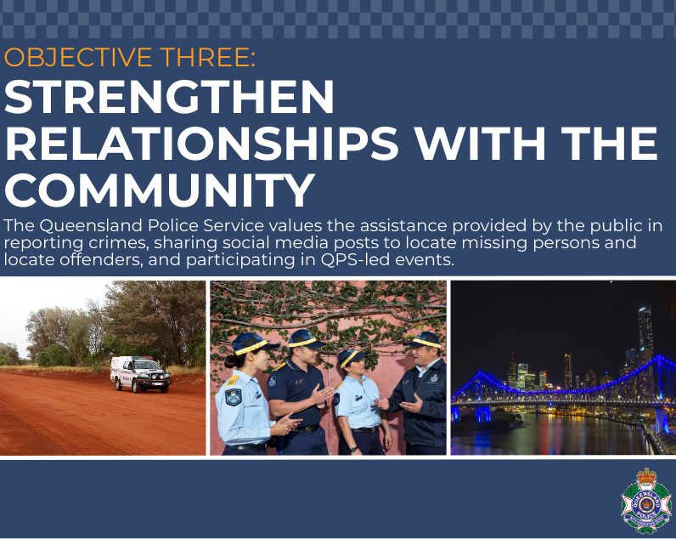
Crimestoppers Queensland
The QPS Crime Stoppers Unit, in partnership with Crime Stoppers Queensland, continued to receive information from the public on criminal activity. During 2018-19, Crime Stoppers Queensland collected over 26,200 pieces of information and received over 36,500 contacts from members of the public. As at 30 June 2019, this had resulted in:
- the apprehension of 1,823 people
- more than 6,100 charges being laid
- the confiscation of more than $6 million worth of drugs
- the seizure of approximately $594,000 in proceeds of crime
- the recovery of more than $1.3 million worth of stolen property.
Improving communications with the community
The QPS has established award-winning and best practice examples of social media use by government agencies during crisis situations, including disaster management. The QPS has embraced the use of social media as a community engagement strategy.
During 2018-19, the QPS Media and Public Affairs Group launched or managed a number of media and social media campaigns including:
- The West End Serial Hub (recording bicycle serial numbers);
- Christmas Road Safety and Easter Road Safety;
- Queensland Road Safety Week;
- Operation Wake Up (traffic enforcement operation);
- Stop stolen motorbikes project with Brisbane City Police and RACQ;
- Promoting local ‘look to the stars’ events (indigenous artwork);
- Fatality Free Friday
- Mounted Unit promotional videos;
- One Step Better (LGBTI campaign);
- Gold Coast Alcohol Fuelled Violence;
- Changing perspectives on property crime;
- Inner West Alcohol Fuelled Violence;
- My story (recruiting campaign);
- Law Week;
- Brisbane City crowded places team launch;
- National Police Remembrance Day;
- State Crime Command – ‘If you’d seen what I’d seen’.
The QPS Media Unit continues to provide operational support and advice 24/7. During the reporting period, the Unit:
- received more than 65,830 calls (approximately 5500 per month)
- issued more than 3,010 media releases
- issued approximately 635 written media responses
- held more than 485 press conferences.
Amber Alert System
The QPS Media and Public Affairs Group continues to manage the Amber Alert public messaging system to help locate abducted or high-risk missing children.
Amber Alerts are issued by police when they need urgent public assistance in time critical cases of missing children who are at imminent risk of death or serious harm. Amber Alerts are broadcast to the public through secondary alerting partners including the media, commercial billboard companies, community groups and other Government agency shared messaging, public transport messaging systems, a national emergency alerting company and social media. The Amber Alert branding is now widely recognised by the community as an urgent ‘call to action’.
In 2018-19, there were five Amber Alerts issued with all children safely located, with evidence showing the Amber Alert directly led to the safe recovery of these children.
NAIDOC Week 2018
The National Aboriginal and Islander Day Observance Committee (NAIDOC) Week 2018 was held nationally in July to celebrate the history, culture and achievements of Aboriginal peoples and Torres Strait Islander peoples. The national theme for 2018 was ‘Because of her, we can.’
The QPS acknowledged this important occasion with flag raising ceremonies at police establishments throughout Queensland. Additionally, the Commissioner continued the tradition of hosting a celebratory NAIDOC event with the flag raising followed by a breakfast. This brings together representatives from Aboriginal and Torres Strait Islander communities, Queensland Government and the QPS.
This ceremony which has been an annual event since 2011 and is attended by approximately 100 community members, government representatives and QPS senior executives.

Putting an end to domestic and family violence
During 2018-19, the QPS implemented the remaining Second Action Plan initiatives of the Queensland Government’s Domestic and Family Violence Prevention Strategy 2016-2026. Collectively, these strategies focussed around changing culture to promote and embed best practice policing strategies to deliver appropriate support and protection to the victim and their families, whilst strengthening processes to increase accountability of domestic and family violence offending.
In 2018-19, the QPS:
- delivered a presentation to the Domestic and Family Violence Implementation Council in September 2018 on progress with the Service’s Not Now, Not Ever report recommendations; and to the Council’s Aboriginal and Torres Strait Islander Advisory Group in April 2019 sharing some of the policing approaches in responding to domestic and family violence affecting Aboriginal and Torres Strait Islander people and communities.
- developed the Vulnerable Persons Framework in recognition of the growing evidence highlighting the intersection between persons affected by domestic and family violence and other vulnerabilities such as disability, mental impairment, elder abuse and homelessness; and to promote a shared vision amongst district-level operated Vulnerable Persons Units based on commonly agreed principles and objectives.
- made enhancements to the Police Referrals Network to ensure frontline officers can continue to provide individuals, their families and carers, the option of a referral to local service providers.
- invested in training, education and professional development opportunities for members related to domestic and family violence and vulnerable persons, including:
- delivered the inaugural Domestic and Family Violence Specialist course in February 2019, with feedback helping to refine the content for future courses planned later in 2019
- continued to offer access to professional development opportunities, such as the Queensland University of Technology Graduate Certificate in Domestic Violence, where members learn about risk assessment tools in actual cases and the impact of domestic violence on victims, carers and the community.
- offered further opportunities to members to attend strangulation prevention training, delivered by the internationally renowned Training Institute on Strangulation Prevention from San Diego. The aim of the training is to build an in-house knowledge and skill base to help embed a uniformed, best practice response during investigations
- enhanced existing training products to assist police with appropriate communications skills to build rapport with victims (and other persons coming in to contact with police at times of crisis or intervention)
- developing online resource for use by QPS members to raise awareness about domestic and family violence in the LGBTIQ+ community
- working with Disability Ambassadors, including Ms Karni Liddell, to help educate QPS members about how to support people with disabilities experiencing domestic and family violence.
- hosted the Third Australasian Indigenous Family Violence Policing Conference in Cairns in June 2019. Queensland was honoured to host this two day event that offered participants an opportunity to collaborate with police, practitioners, Aboriginal and Torres Strait Islands Elders and community leaders, and members working in the anti-violence space to identify solutions in a policing context, to progress and improve responses to Indigenous family violence.

Elder abuse
The QPS is committed to working with older people and the community to reduce elder abuse. Elder abuse takes many forms including assault, financial exploitation, intimidation, isolation and neglect.
It can be challenging to identify elder abuse as there is no single type of person who is at risk or who may cause harm. Elder abuse is often unreported as older people are unwilling or unable to speak up.
Key achievements during the reporting period include:
- commencing a review of the QPS’ current policing responses to elder abuse and people with a disability to plan for potential future demands resulting from the Royal Commissions into Aged Care and Disability
- initiating the development of a suite of new education materials for internal and external use related to elder abuse and the policing response; and progressed preparations for a QPS display at the 2019 National Elder Abuse Conference in July 2019.
- continuing to collaborate with partner agencies, government and non-government as well as Seniors groups to develop and promote joint initiatives that educate and raise awareness around social issues related to elder abuse.
Mental Health
The QPS continues to play a significant role in the response and intervention of incidents involving persons with mental health illness. Key achievements during 2018-19 included:
- commencing a refresh of the QPS’ Mental Health Strategy
- progressing the review of the Mental Health Intervention Program, with initial findings from this review planned for delivery in late 2019
- collaborating with the Queensland Mental Health Commission on the development of a 10-year Suicide Prevention Plan
- collaborating with other jurisdictions in the development of the Australia New Zealand Policing Advisory Agency Mental Health Guide for police responding to Mental Health Incidents, which is planned for release in late 2019. The aim of the guide is to create consistency across all policing jurisdictions when responding to people with mental illness in the community
- reviewing the First Year Constable Mental Health Intervention Training program and delivering train-the-trainer workshops to prepare Education and Training Officers, Mental Health Intervention Coordinators and Negotiators involved in facilitating the training to First Year Constables.
Sexual Assault Counselling Privilege
Organisational Capability Command played a key role in the development of operational policy and procedures to underpin the implementation of the complex and sensitive Sexual Assault Counselling Privilege (SACP) laws, and support referrals to the government’s free legal service, Counselling Notes Protect which protects counselling records of victims of sexual assault or alleged sexual assault from being used in some courts. The policy delivered a QPS position that prioritises the confidentiality of counselling communications to support the therapeutic role of counselling for victims of sexual assault.
Boost in call service operators for Policelink
Call service operators at Policelink take more than a million calls from the public and police each year and has dealt with over 700,000 online contacts from members of the public since the rollout of the online offering in 2015. Policelink is the non-urgent contact centre for QPS and its client service operators take reports from members of the public that can assist police with their investigations. The focus of Policelink operators is on resolving the needs of each caller, and the QPS is always looking for ways to improve the level of service provided to the public.
During the reporting period, 31 Policelink client service operators completed their training and transitioned onto the operational floor, boosting the number of operators by 2.5% over the 2018-19 financial year. Seven client service officers who commenced training on 7 May will complete their initial training and move into ‘transitional’ operational roles in July 2019 where they will be monitored until they complete their training on 20 August 2019. The recruitment for the next group of trainee client service operators will commence in July 2019, with more intakes planned for 2019-20.
In addition, new strategies, such as side-by-side coaching and investment in new technologies and processes, are being implemented at the Policelink call centre which have reduced the average call handling times. The changes commenced in June 2018 and have produced great results. The average handling time has been reduced by four minutes and forty-seven seconds across all calls which has resulted in a 22.89% reduction in unanswered or disconnected calls from November 2018 to June 2019.
Adopt-a-cops recognised across the state
Adopt-a-Cops (AAC) perform outstanding work in their school communities, establishing relationships, winning over young hearts and minds, and helping to address anti-social behaviour before it becomes out of hand. The program was first implemented by the QPS in 1985, and since 2010, the annual Adopt-a-Cop of the Year Awards have acknowledged the efforts and commitment displayed by these volunteers.
Each year, the 15 police districts are tasked with judging the nominees and awarding a district finalist. From the 15 district award winners, five regional award winners are selected by the regions.
All nominees must meet two criteria:
- the AAC has been formally adopted by the primary or secondary school or educational institution
- the AAC has performed their role in an outstanding manner and, in doing so, has built/maintained a positive relationship between police and the students, teachers and parents/carers of the school community
In November 2018, the five regional award winners attended an awards ceremony at Police Headquarters in Brisbane where they were recognised for their valuable and voluntarily contribution to their local school communities. At this ceremony the state award winner was announced.
2018 state winner
- Senior Constable Kurt Foessel: South Eastern Region (Elanora Community Beat)
2018 regional award winners and state finalists
- Sergeant Steve Heemi: Northern Region (Smithfield Division)
- Senior Constable Cameron Hill: Central Region (Nambour Station)
- Sergeant Brett Hunter: Southern Region (South West District, Dalby)
- Senior Constable Belinda Wilcox: Brisbane Region (Inala Station)
- Senior Constable Kurt Foessel: South Eastern Region (Elanora Community Beat).
New police memorial a permanent place for reflection in City Botanic Gardens
A new Queensland Police Memorial has been dedicated in Brisbane’s City Botanic Gardens to honour the 147 officers who have died while serving the Queensland community since 1861. The Brisbane City Botanic Gardens opened only a few years before the Police Service was formally established in Queensland, so it’s an appropriate historic setting for a permanent memorial, honouring officers from one of our State’s oldest and most important institutions.
The new Queensland Police Memorial in the Botanic Gardens incorporates various symbolic aspects including five individual archways and 10 pillars representing the 10 ranks within the QPS. The archways reflect the memorial ribbon that officers wear on National Police Remembrance Day, and the pathway that connects the archways emphasises that ‘no officer or affected family member will stand alone’.


Enterprise Portfolio Management Office
The policing environment is becoming increasingly complex and traditional policing services will need to adapt to meet the demands of policing in the future. The growing demand for services, rapid technological innovation and changing public preferences are just some of the factors that are compelling the QPS to reconsider the way it does business to ensure the agency is prepared for future service delivery needs.
The QPS is embarking on a body of work to reposition the agency for service delivery in the long term. A priority for the program is service delivery reform focussed upon improvements to internal processes, customer experience and community safety for the people of Queensland. The Service is examining how it might better leverage intelligence, resources and partners to provide a more effective policing service that emphasises prevention as a first order priority.
The program is being absorbed into a larger body of work which will be progressed over the next five to ten years.
Our People Matter Strategy
The QPS, together with the Queensland Police Union of Employees, Together Union and the Queensland Police Commissioned Officers’ Union, launched the ‘Our People Matter’ Strategy on
27 February 2018 at the Queensland Police Service Academy in Oxley. The strategy sets a direction and standard for the QPS executive and workforce in creating working environments that improve support to police employees and their families.
Employees and family members contributed to the strategy’s development via an organisational wide survey and 30 face-to-face statewide workshops. This consultation provided more than 20,000 ideas and suggestions for activities, services, business processes and practices that could be changed or implemented to better support employees and their family members.
The Strategy has four priority areas including fair and positive workplaces; safer workplaces; healthy minds; and healthy bodies.
A list of immediate organisational priorities was developed to provide knowledge and new services to employees and their families, based directly on the consultation responses. These deliverables included the release on 1 June 2018 of the new Flexible Working Arrangements Policy in line with the Industrial Relations Act 2016 and relevant industrial provisions. To assist supervisors in applying the policy, workshops are currently being delivered across the state.
QPS Innovation Unit
Innovation in the QPS is about thinking differently, embracing new ideas, enabling collaboration and having a strong performance focus. The QPS Innovation Unit is committed to driving and enabling innovation within the QPS and being an active contributor to the broader Queensland Government Innovation Strategy.
The Innovation Unit continued to promote the ideas management system called iCOP (ideas connecting our people) which provides a mechanism for all QPS members to collaborate on ideas, share knowledge and problem solve together.
All QPS members are encouraged to actively participate in the QPS innovation process by submitting and voting on ideas, providing constructive comments on the ideas generated by others and sharing solutions that have (or have not) worked. As at 30 June 2019, over 7,500 members had registered with iCOP which represents over 45% of the workforce. In addition, members generated over 900 ideas, contributed over 5,665 comments and cast over 37,569 votes. The open interactions enabled by iCOP have been the catalyst to prioritise, investigate and implement solutions around legislative and policy amendments and provide positive operational equipment enhancements for our people. This transparent digital channel for members, regardless of rank or location; supports a collaborative workforce that shares ideas, information and implements solutions that create positive change.
In 2018, the success of iCOP was recognised internationally by IdeaScale (iCOP vendor) at their 2018 Open Nation Conference in San Francisco. The QPS was awarded the Best Innovation Engagement Strategy. This achievement was significant given the highly regarded international organisations using IdeaScale including NASA, US Coastguard, KPMG and IKEA.
The Innovation Unit is in the process of embarking on a Service Experience (SX) Pilot where the customer and employee experience of the end-to-end journey of a break and enter occurrence will be mapped to identify service delivery improvements. Improvements will be assessed using the customer and employee voice to prioritise critical changes in service delivery aimed at building community trust and confidence in the QPS.
In addition, the Innovation Unit continued to work with internal and external stakeholders to develop better ways of doing business. Some key achievements for 2018-19 included:
- positive change in Working for Queensland measures since implementation of iCOP with ‘My organisation is open to new ideas’ seeing a 4% increase; and ‘Management is willing to act on suggestions to improve how things are done’ increasing by 5%.
- successful pilot of Email-to-SMS capability which offers an additional communication channel for members to engage with the community. Positive feedback from both community members and officers has provide support for the capability to be rolled out statewide.
- QLiTE challenge – a targeted campaign in iCOP led by the Mobile Capability Centre (MCC). MCC sought advice from iCOP members through a specific campaign where operational officers voted for the most relevant QLiTE improvements. This generated over 1,900 votes and 90 comments; informing MCC’s work schedule, by directly listening to the voice of our people.

Mobile Capability
Mobile Capability has continued to deliver new mobile capability and enhance mobile applications to enable first response officers to be more efficient and effective and spend more time engaging with the community. The QPS entered into a new 5-year managed service contract with Telstra which provides additional benefits to both officers and the community, particularly with the addition of Telstra LANES priority data for new devices providing officers with far better access to services during major planned and unplanned devices.
Significant improvements were made to mobile capability including:
- Police activity auto logging functionality which reduces officer administration time by more than 20 minutes per officer per day.
- electronic ticketing for traffic infringements was successfully deployed to all officers following an extensive pilot and release process.
- significant investment was also made in developing and implementing mobile capability for Domestic and Family Violence investigations. Policing response for DV matters has been significantly enhanced through reducing the complexity and time taken to complete the investigative records.
The QPS has increased the number of Apple iPad QLiTE devices from 5,400 to 6,900 in 2018-19.
Electricity Optimisation Project (EOP)
The EOP commenced on 1 January 2017 to reduce QPS electricity costs and emissions through investment in a range of capital initiatives including solar, air conditioning and lighting upgrades, tariff optimisation and installation of Power Factor Correction (PFC) equipment. Sites and initiatives that are selected for EOP investment are based on a cost benefit analysis to maximise return on investment.
Between January 2017 and May 2019, the EOP operational savings were estimated to be approximately $1.5 million, with $850,000 projected annual savings forecast for the life of the infrastructure (15+ years).
As at 30 June 2019, the EOP has achieved:
- 1.7MW of solar at 45 sites across the state
- lighting upgrades at eight sites
- major air conditioning control system upgrade at Police Headquarters in Brisbane
- Tariff optimisation at 10 sites
- Installation of power factor correction at 26 sites
- reviewing and updating the QPS Building Design Manual for energy efficiency and sustainability.
Fleet Achievements
Organisational Capability Command is participating in a range of fleet reform activities with the Public Safety Business Agency which will seek to identify a range of operational efficiency and officer safety improvements.
Stronger engagement with insurance partners has been a key aspect of the Fleet Review Team during 2018-19. Improvements within the insurance portfolio include:
- transition of crash reporting into QPRIME to improve the capture of information and cost recovery potential
- positioning a dedicated insurance claims officer to provide statewide assistance to members reporting departmental crashes and to conduct quality assurance checks, ensuring compliance with service expectations
- implementing strategies to raise driver awareness regarding departmental crashes and strategies when slow speed manoeuvring. Strategies include videos, posters and awareness stickers along with a slow speed manoeuvre driver training course;
- delivering a statewide insurance dashboard for advice to regions and commands on the status of their departmental crashes. Also, the team is currently developing new reporting systems to assist regions/commands to better understand and reduce departmental crashes.
Furthermore, the fleet team has worked extensively on a range of other projects, including:
- collaborating with partners to implement new vehicle repair processes to ensure repairs are undertaken proactively, whilst also guaranteeing lifetime warranties and reducing officer downtime
- actively looking to improve QPS FBT liability through the delivery of fresh opportunities and improved processes
- assisting the Road Policing Command test, review and deliver the first plug-in hybrid vehicle into the QPS fleet (Mitsubishi Outlander PHEV – Speed Camera).
Kia Stinger joins the QPS fleet
The cessation of manufacturing by Ford and General Motors Holden (GMH) in Australia necessitated a re-assessment of the composition of the current Road Policing Command (RPC) high performance fleet. A market assessment of suitable vehicles, followed by an evaluation process, identified the Kia Stinger as a suitable replacement for RPC’s Holden SV6, SS and the Ford XR6. As at 30 June 2019, 62 Kia Stingers have been rolled out into the RPC fleet.

Capital Asset Services Achievements
Capital Asset Services administers the future minor and medium works, and major capital investment projects of the Service, in partnership with PSBA Property and Facilities Management.
During the reporting period, the QPS, in partnership with PSBA, delivered:
- replacement of the Gordonvale police station in November 2018
- delivery of the Woree police facility, August 2018
- stage 2 completion of the replacement Bowen police station, September 2018
- practical completion of residential accommodation at Aurukun, September 2018
- completion of the Howard police station, November 2018
- replacement of Kilcoy police station, in November 2018
- contracts of sale arranged for land acquisitions for future police facilities, including Highfields
- a security audit of police residences
- replacement of the Caboolture station and district headquarters in April 2019.
Health, safety and wellbeing initiatives
The QPS supports the health and safety of its employees and their families. During 2018-19, the Health and Wellbeing Section continued to provide health and safety support services including:
- establishing the Inclusion and Diversity Restorative Engagement and Cultural Reform Program (Juniper)
- establishing an external, independent ‘safe space’ model (1800 Speak Safe) for employees affected by workplace bullying, sexual harassment and unlawful discrimination
- coordinating the statewide Influenza Vaccination Program which delivered over 6,000 vaccinations across 448 community pharmacies
- publishing three Our People Matter e-newsletters to approximately 2,500 subscribers
- delivering 13 statewide pre-retirement Life Beyond the Service seminars to more than 950 employees and their partners aged 50 years and over
- delivering 16 statewide Prostate Cancer Information Seminars to more than 420 employees
- coordinating QPS participating in the annual Movember campaign which raised over $45,000 for the Movember Foundation. The QPS was the highest raising Australian police jurisdiction.
- Participating in the Australian Red Cross Blood Services’ Emergency Services Challenge which saw more than 670 donations from QPS employees. The QPS made the highest number of donations of all Queensland emergency services
- coordinating 22 statewide health expos attended by approximately 2,200 employees
- coordinating two Workplace POWER weight loss programs which saw 55 QPS employees lose a combined total of 355kgs, with an individual average weight loss of 7.4kgs within 12 weeks
- coordinating three statewide step challenges to encourage physical activity
- establishing the External Job Portal which displays positions suitable for QPS employees seeking a career change
- establishing the internal Workplace Champions Program comprised of more than 450 Workplace Champions throughout Queensland.
- coordinating statewide internal communication campaigns promoting Safe Work Month, Queensland Mental Health Week, Women’s Health Week, Men’s Health Week, National Diabetes Week and Smart Eating Week.
New Counter-Terrorism Facility
The Queensland Government is investing in a world-class use of force, weapons and counter-terrorism training facility at Wacol. When complete, this facility will include two indoor firearms’ ranges, a scenario village and specialist training areas to increase capability in managing terrorism and critical incidents. Its co-location with the police driving skills section will enhance training on the growing issue of vehicles being used in attacks on public safety. Another advantage of the site is officers will be able to update their operational training at the one location and return to duties much sooner. For example, the provision of indoor firearms’ ranges will enable police to train day or night in any weather, and the facility’s flexibility will enable first response officers to practice for emerging trends such as active shooter incidents.

Inspector David Stevenson Field Training Officer Award
In 2014, the QPS introduced the annual Inspector David Stevenson Field Training Officer Award to recognise Field Training Officers (FTO) who demonstrate the highest standards and commitment expected of this important role. The award was first granted in 2015 and is named in honour of the late Inspector David Stevenson who passed away suddenly in 2013.
The award recognises excellence in the training of First Year Constables by operational police performing as workplace assessors. As well as recognising the legacy of Inspector Stevenson, this award also recognises the crucial role that FTOs play in training, supervising and mentoring First Year Constables. Senior Constable Jay Prothero was announced as the winner of the 2019 lnspector David Stevenson Field Training Officer Award.
Senior Constable Prothero mentors and guides FYCs across the Gold Coast District and was nominated as South Eastern Region's finalist. He has mentored several FYCs over the past 12 months and continues to work with many of them in the general phase of their training. The learning environment he creates allows FYCs to build confidence and broaden their skills and knowledge.
Increasing workforce diversity
During this fiscal year, 51 individuals successfully completed the Culturally and Linguistically Diverse Recruit Preparation Pathway to commence within Recruit Training. A further 11 individuals successfully completed the Indigenous Recruit Preparation Pathway at the QPS Academy in Townsville. These programs prepare Indigenous and culturally and linguistically diverse individuals for the rigours of police recruit training. These members add to the cultural depth and richness of the QPS workforce.
Additionally, 24 Police Liaison Officers were inducted into the QPS receiving initial employment training to prepare them for their role in community liaison and engagement. These officers come from a range of backgrounds including Aboriginal, Torres Strait Islander, Chinese, Korean and Kurdish. A further three Torres Strait Islander Police Support Officers have received initial employment training. These officers contribute to the unique policing model for the Torres Strait Islands, providing advice, engagement and support to their local communities.
Training and Development Enhancements
A Best Practice Framework – Education and Training, Design, Delivery and Transfer to the Workplace was developed in late 2018 incorporating contemporary evidence-based research to improve teaching, learner engagement, learner retention and transfer of learned knowledge, skill and attitudes to the workplace. The Framework will provide trainers and assessors with guidance and direction on the implementation of evidence-based design, teaching, learning and retention strategies to improve the skills of QPS members. A series of four workshops will provide the basis for skills development.

Governance

Executive management
Board of Management profiles (as at 30 June 2019)
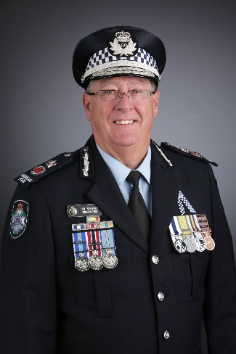 | Ian Stewart APM  Commissioner  The Commissioner is responsible for the efficient and proper administration, management and functioning of the QPS in accordance with law.  The Commissioner provides the business direction and represents the organisation at local, community, state, national and international forums as well as ceremonial functions. The Commissioner is a Chairperson, Council Member and Board Member on numerous national and international boards, committees and professional organisations; and performs the role of Patron and Ambassador for a number of police and community groups.  In February 2019, Commissioner Ian Stewart announced his retirement from the Service, effective 7 July 2019. On 30 April 2019, Ms Katarina Carroll, Commissioner for Queensland Fire and Emergency Services was announced as the new Queensland Police Commissioner and will officially commence on 8 July 2019.
 | Stephan Gollschewski APM  Deputy Commissioner, Crime, Counter-Terrorism and Specialist Operations  The Deputy Commissioner, Crime, Counter-Terrorism and Specialist Operations is responsible for the provision of specialist police services including Community Contact Command, Security and Counter-Terrorism Command, Intelligence and Covert Services Command, Operations Support Command, Road Policing Command, State Crime Command.  Nationally, the Deputy Commissioner is the QPS representative on the Australia-New Zealand Counter-Terrorism Committee (ANZCTC) and Chair of the Public Information Sub-Committee of ANZCTC.  The Deputy Commissioner is the Domestic and Family Violence champion for QPS and on the State Domestic and Family Violence Implementation Council as well as the Inclusion and Diversity champion for the QPS.
 | Tracy Linford APM  Deputy Commissioner, Strategy, Policy and Performance  The Deputy Commissioner Strategy, Policy and Performance has direct responsibility for a diverse portfolio including People Capability Command, Organisational Capability Command, Policy and Performance, Ethical Standards Command, Legal Division and the Crime and Corruption Commission (Police Group). She also has direct engagement with the Public Safety Business Agency.  The Deputy Commissioner performs key governance roles on Boards and Committees including Boards of Management for both the QPS and Public Safety Business Agency, QPS Audit and Risk and the QPS Demand and Resource Committees. She chairs the Our People Matter Steering Committee, State Honours and Awards Committee, Cyber Security Committee and the Senior Women’s Collective and is the QPS representative on the National Police Memorial Coordination Committee. She also represents the QPS on several state and national intergovernmental committees.
 | Mike Condon APM  Acting Deputy Commissioner, Regional Operations  The Deputy Commissioner, Regional Operations is responsible for providing the strategic direction, leadership, overview and review of the delivery of policing services to the community of Queensland across the five regions statewide.  The Deputy Commissioner provides leadership to Regional Assistant Commissioners to facilitate the effective management of their areas of responsibility including promotion and maintenance of an ethical and professional organisational climate.  The Deputy Commissioner performs key governance roles within the QPS and he is also the Indigenous Champion for the QPS.
Elizabeth Jameson
External member
Ms Elizabeth Jameson worked for almost 15 years as a corporate/commercial lawyer, including as a partner of a national law firm and 10 years as a practicing director. In 2002 Elizabeth founded Board Matters Pty Ltd where she is the Executive Chair. Board Matters is a team of specialist governance, legal and strategy consultants delivering corporate, legal and governance assistance and advice.
Ms Jameson also maintains an active portfolio of directorships, presently with RACQ, John Villiers Trust and The Pinnacle Foundation and Chairs the Board of Queensland Theatre Company. Her past directorships have also included the boards of over 20 organisations, for-profit and not-for-profit, including private companies, a Federal Government advisory board and Queensland Government-Owned Corporations.
Elizabeth’s aim is to help build great governance for better boards, through the integration of her extensive practical experience over twenty years as both a corporate/commercial lawyer and a practising director. Her work has focused on creating and implementing tailored board development programs and developing and conducting board evaluations.
In 2016 Ms Jameson joined the QPS Board of Management and has led reinvigoration and redesign of QPS governance.
 | Jenny Walker  External member  Jenny has held various positions on boards and committees of a number of community, non-profit and private organisations and companies, including Personalised Plates Queensland and Sisters of St Joseph Aged Care Services (Queensland). Jenny is also a Member of the Veterans’ Review Board and is Chair of the Audit and Risk Committee of Queensland Police Service. She is also the Chair of the Strategic Governance Board, Advocacy Training and Development Program (ATDP), a partnership between the Department of Veterans’ Affairs (DVA), ex-service organisations (ESOs) and the Department of Defence to provide advocacy services to veterans.  Jenny has been the Chief Executive Officer of Legacy Australia, and United Synergies. She is Principal Consultant with Directors Australia and has had 40 years’ organisational experience in public and private sector and not for profit organisations. She is a graduate of the Australian Institute of Company Directors and has tertiary qualifications in Business (Marketing, HR and Government), Market Research and a background in land and engineering survey drafting and cartography. Her public sector experience includes Commonwealth, State and Local Government agencies. She has had over 25 years’ management experience in line management and project management roles and has consulted widely to Queensland Government Departments and agencies, being involved in numerous reviews and investigations. These include specific involvement in disaster management arrangements in Queensland.  She served for 16 years in the Australian Intelligence Corps of the Active Army Reserve. Major Walker received the Reserve Force Medal and the Australian Defence Medal.
 | Sandra Slater  External member  As Chief Information Officer for the Department of Transport and Main Roads (TMR), Sandra leads a team of more than 400 staff and contractors. She is responsible for delivering a significant Information and Communication Technology (ICT) program to improve customer experience and deliver better digital business outcomes for the department.  Sandra has proudly dedicated her 25+ year career to TMR, working predominantly in ICT roles. She has led the development of ICT strategies and solutions and led teams to deliver many large-scale business and ICT change projects. Sandra is an experienced ICT executive across all elements of ICT planning, delivery, operations and governance, maintaining strong engagements with customers, stakeholders, vendors and industry.  She is passionate about leading Information Technology Branch (ITB) to become an agile organisation with a strong customer focus, delivering innovative ICT and digital solutions and driving outstanding performance in partnership with key TMR stakeholders and external vendors.  As a proud champion of gender diversity in technical professions, Sandra participates in multiple mentoring programs, and creates opportunities in the workplace including the recent establishment of the first Women's Lean-in-Circle in ITB.
 | Katarina Carroll APM  Incoming Commissioner (commencing 8 July 2019)  On 30 April 2019, Ms Katarina Carroll, Commissioner for Queensland Fire and Emergency Services was announced as the new Queensland Police Commissioner and will officially commence on 8 July 2019.

Boards and committees
The QPS governance framework is as follows:

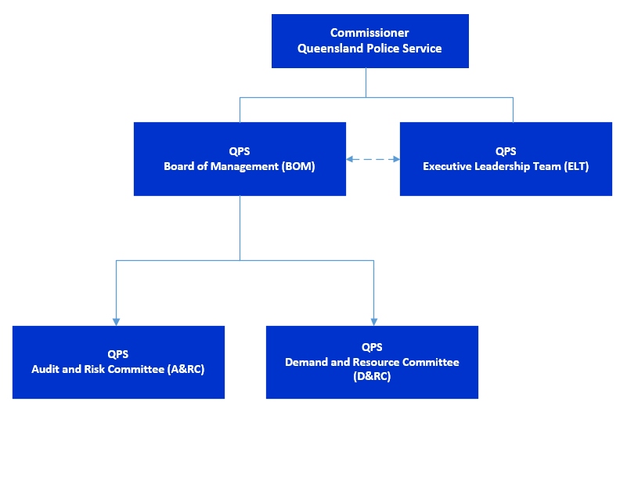

(as at 30 June 2019)

QPS Board of Management
The Board of Management (the Board) supports and advises the Commissioner on strategy, direction and setting the tone of the Service. The Board supports the Commissioner as the sole decision-making authority pursuant to the Police Service Administration Act 1990 and the Financial Accountability Act 2009.
The QPS Board provides support and expert advice to the Commissioner in making key decisions that deliver a strategic or Service-wide impact. The Board meetings are chaired by the QPS Commissioner.
The Board meets bi-monthly or as determined by the Chair. In 2018-19, the Board met on six occasions and considered 16 matters out-of-session.
The independent external members collectively received $12,600 in remuneration. There were no other on costs.
Board Members
- Ian Stewart APM, Commissioner (Chair)
- Tracy Linford APM, Deputy Commissioner, Strategy, Policy and Performance
- Stephan Gollschewski APM, Deputy Commissioner, Crime, Counter-Terrorism and Specialist Operations
- Mike Condon APM, Acting Deputy Commissioner, Regional Operations
- Margaret Allison, external member (1 July 2018 to 30 June 2019)
- Jenny Walker, external member (1 January 2019 to 30 June 2019)
- Elizabeth Jameson, external member
- Sandra Slater, external member
Achievements
During 2018-19, the Board approved a number of significant matters including:
- QPS 2018-19 Budget Allocations
- engagement of consultants to provide proposals for an independent review of governance
- appointment of a fifth member to the Audit and Risk Committee
- 2019 Environmental Scan
- QPS Forward Capital Works Program 2019-20
- the Integrity and Performance Group Inspections Plan (2019-20) and Internal Audit Function Charter
- the 2019-23 Strategic Plan and Operational Plan.
The Board further engaged in a series of themed strategic discussions on the following topics:
- workforce strategy
- Working for Queensland Survey results
- policing strategies
- internal communications
- risk management.

QPS Demand and Resource Committee
The Demand and Resource Committee supports the Commissioner and QPS Board in delivering the organisational prioritisation of resources. The committee assists by ensuring effective processes are used relating to direction and control of finances, people, assets and ICT. This includes oversight of policies, plans and practices relating to demand management and resource management.
The Chair of the Committee is rotated among the Deputy Commissioners on an annual basis.
The committee meets monthly or as determined by the Chair.
During 2018-19, the committee met on 11 occasions and considered 11 urgent matters
out-of-session.
Board Members
- Stephan Gollschewski APM, Deputy Commissioner, Crime, Counter-Terrorism and Specialist Operations (Chair)
- Tracy Linford APM, Deputy Commissioner, Strategy, Policy and Performance
- Mike Condon APM, Acting Deputy Commissioner, Regional Operations
Achievements
In 2018-19, the committee considered a number of significant matters which included:
- creation and allocation of permanent positions and position reclassifications which enabled appropriate resource allocation across the Service
- operational funding for key organisational priorities
- funding and prioritisation of significant capital works, including the strategic acquisition of assets
- monitoring Service Delivery Standards and consideration of performance measures.
Key decisions by the Committee included:
- approval of a staged approach to centralise towing
- approval of funding for the ITAS Modernisation Project Leave Leakage Solution
- approval of Stage 2 of the Aurion 11 Upgrade Project
- approval of the Domestic, Family Violence and Vulnerable Persons Unit to be established as a permanent unit
- approval of a 12-month pilot of the Asset Management Governance Framework
- approval of the Email to SMS statewide rollout.

Public Safety Portfolio Audit and Risk Committee
The Public Safety Portfolio Audit and Risk Committee (PSP ARC) was established under, and operated in accordance with, the terms of its charter which was developed in line with Queensland Treasury’s Audit Committee Guidelines: Improving Accountability and Performance; the Financial and Performance Management Standard 2009 and the Financial Accountability Act 2009. The Committee reviewed the charter annually to ensure consistency with the Committee’s authority, objectives and responsibilities.
The PSP ARC provided independent assurance on audit functions for partner agencies and oversight and assurance over the effectiveness, efficiency and economy of the Public Safety Business Agency (PSBA) risk, control and compliance frameworks. To ensure strong governance across the public safety agencies, advice of material issues was provided to the audit, risk and compliance committees of the partner agencies as and when relevant.
The Committee was chaired by an independent external member. Each public safety partner agency was represented by one member. The Chair could invite or give approval for other persons to attend a Committee meeting.
In August 2018, the Committee was renamed the Public Safety Agencies Audit, Risk and Compliance Committee (PSA ARCC) to reflect the broader public safety agencies coverage of the Committee and to explicitly capture compliance in the Committee’s considerations.
Prior to a revision of the Committee’s charter on 11 January 2019, the Committee met on two occasions. A further revision of the Committee’s charter, effective 11 January 2019, renamed and repurposed the Committee as the PSBA and Office of the Inspector-General Emergency Management Audit, Risk and Compliance Committee (PSBA and IGEM ARCC). Part of this revision was a change in the membership composition, which included the cessation of partner agency representation, including the QPS.
The independent external Chair received $7,016.59 (including GST) in remuneration for services provided to 10 January 2019. There were no other on costs incurred.
Committee Members
- Marita Corbett, Chair (Independent Chair)
- Geoff Waite, Executive General Manager, Risk and Intelligence Queensland Treasury, (appointed member of the PSBA Board of Management)
- Tracy Linford APM, Deputy Commissioner, Strategy, Policy and Performance, QPS
- Doug Smith APM, Deputy Commissioner, Chief Strategy Officer, Strategy and Corporate Services, QFES
- Iain MacKenzie AFSM, Inspector-General Emergency Management, IGEM
- Peter Griffin, Chief Operating Officer, PSBA
Achievements
During 2018-19, the committee’s achievements included:
- oversight of the progression of Queensland Audit Office (QAO) issues and the status of the QAO Audit Program
- consideration of all audit reports and provision of direction regarding the implementation of report recommendations and actions
- monitoring compliance with the Annual Internal Audit Plan 2018-19 and Strategic Internal Audit Plan 2019-2022 and oversight of the actioning of open recommendations
- endorsement of the PSBA and IGEM 2017-18 annual financial statements.
QPS Audit and Risk Committee
The QPS Audit and Risk Committee (A&RC) scrutinises, challenges and delivers oversight of the management responsibilities imposed on the Commissioner under legislation. Relevant legislation includes the Police Service Administration Act 1990, the Financial Accountability Act 2009, Financial and Performance Management Standard 2009 and other legislation.
The A&RC delivers independent oversight and assistance to the Commissioner and Board of Management on:
- risk management policy/framework
- internal control and compliance plans and framework
- financial compliance
- the internal and external audit functions.
The committee meets quarterly or as determined by the Chair. During 2018-19, the committee met on four occasions.
The two independent external members collectively received $8,350 in remuneration. There were no other on-costs.
Board Members
- Jenny Walker, external member (Chair)
- David Evans, external member
- Tracy Linford APM, Deputy Commissioner, Strategy, Policy and Performance
- Shane Chelepy APM, Assistant Commissioner, Organisational Capability Command
- Sharon Cowden APM, Assistant Commissioner, Ethical Standards Command
Achievements
In 2018-19, the committee provided strategic advice and support to the BoM by considering matters including:
- implementation of the QPS Enterprise Risk Management Framework
- 2017-18 Annual Financial Statements
- QPS 2019 External Audit Plan
- QPS Strategic Risk Report
- 2019-20 QPS Risk Appetite Statement
- the Integrity and Performance Group Inspections Plan (2019-20) and Internal Audit Function Charter
- Annual Internal Audit Plan 2019-20 and Strategic Internal Audit Plan 2020-23
- Public Safety Agencies Internal Audit Charter.

QPS Executive Leadership Team
The Executive Leadership Team (ELT) is a ‘think tank’ assisting the Commissioner through support and advice in operational execution of decisions. The QPS BoM also requests and relies on ELT recommendations and advice.
The ELT assists the Commissioner, BoM and entire governance structure through delivering a collaborative environment for:
- provision of advice on the strategic direction of the QPS operationalising strategy
- leading change management and promotion of the Commissioner’s intent
- acting as a consultative forum on opportunities and risks arising from key changes to strategy, policy and operations within and outside the QPS
- identifying opportunities for creating efficiencies
- uncovering opportunities to improve the quality of service delivery and for fostering an environment for innovation
- identifying new or emerging opportunities, technologies, better practice and risks for the QPS.
The ELT meets via video conference each week and in person as determined by the Chair.
During 2018-19, the ELT met on ten occasions (in-person) including meetings at Mount Isa (Northern Region) and Roma (Southern Region).
The independent external members of the QPS Board of Management and QPS Audit and Risk Committee attended one ELT meeting as guests in 2018-19. The members collectively received $1,800 in remuneration. There were no other on-costs.
Board Members
- Ian Stewart APM, Commissioner (Chair)
- Mike Condon APM, Acting Deputy Commissioner, Regional Operations
- Stephan Gollschewski APM, Deputy Commissioner, Crime, Counter-Terrorism and Specialist Operations
- Tracy Linford APM, Deputy Commissioner, Strategy, Policy and Performance
- Tony Wright APM, Acting Deputy Commissioner, State Discipline
- Maurice Carless APM, Assistant Commissioner, Intelligence and Covert Services Command
- Shane Chelepy APM, Assistant Commissioner, Organisational Capability Command
- Brian Codd APM, Assistant Commissioner, State Crime Command
- Mike Brady APM, Acting Assistant Commissioner, Southern Region
- Sharon Cowden APM, Assistant Commissioner, Ethical Standards Command
- Peter Crawford APM, Assistant Commissioner, Brisbane Region
- Alistair Dawson APM, Assistant Commissioner, People Capability Command
- Peter Fleming APM, Assistant Commissioner, Security and Counter-Terrorism Command
- Mike Keating APM, Assistant Commissioner, Road Policing Command
- Allan McCarthy APM, Assistant Commissioner, Operations Support Command
- Clem O’Regan APM, Assistant Commissioner, Central Region
- Brett Schafferius APM, Assistant Commissioner, Community Contact Command
- Paul Taylor APM, Assistant Commissioner, Northern Region
- Brian Wilkins APM, Assistant Commissioner, South Eastern Region
- Cheryl Scanlon APM, Chief Superintendent, Crime and Corruption Commission – Police Group
- Carolyn Harrison, Executive Director, Legal Division
- Andrew Ross, Acting Executive Director, Policy and Performance
Achievements
In 2018-19 the ELT discussed significant matters including:
- 2018-19 Internal QPS Budget
- human resources and the safety and wellbeing of members
- performance
- complaints
- crime statistics
- Working for Queensland Survey Results
- policing options to combat elder abuse
- Criminal Justice System Reform Framework
- internal audit analytics
- risk management
- Queensland Government Chief Information Office Digital Projects Dashboard
- leadership and engagement
- closure of recommendations from the Not Now, Not Ever report
- Organised Crime Disruption Strategy
- Crime Harm Index
- Crime Prevention Framework.
The ELT also engaged with the following people/groups:
- Australian Institute of Company Directors
- Sonia Cooper, Deputy Commissioner, Public Service Commission
- Brendan Moon, Chief Executive Officer, Queensland Reconstruction Authority
- Alan MacSporran (QC), Chairperson, Crime and Corruption Commission
- Australian Bureau of Statistics
- Police-Citizens Youth Club
- Senior members of the Northern Territory Police
- Dr Vanessa Teague, Melbourne University
- Executive member of QBank
- Tyson Golder, Mayor of the Maranoa Regional Council
- Karni Liddell, Domestic and Family Violence Implementation Council
- Department of Transport and Main Roads.

Government bodies
- Commissioner for Police Service Reviews
- Controlled Operations Committee
- Public Interest Monitor
For further information about the Government Bodies refer to page 127 within the appendices.

Ethics and code of conduct
The delivery of professional policing services must be underpinned by ethical decisions and actions. These ethical decisions and actions provide the QPS with its most valuable asset, namely its reputation and the confidence and trust that such a reputation inspires in the community. The QPS has a broad range of programs, policies and initiatives that support professional and ethical practice including a robust internal complaints system, policies on declarable associations, gifts and benefits, as well as discipline and ethical awareness training. The QPS Values, Standard of Practice and Procedural Guidelines for Professional Conduct supplement the Queensland Government values and the Code of Conduct for the Queensland Public Service, and outline appropriate behaviour for all QPS staff.
Members of the QPS continue to operate under the organisation’s Integrity Framework. This framework approach allows specific issues to be brought into focus more clearly by highlighting the principles that drive integrity and ethics management in the Service. The framework seeks to promote an actionable process of thinking about integrity and then integrating that thinking into all planning, implementation, monitoring and evaluation processes across the QPS.
During 2018-19, Ethical Standards Command (ESC) continued to promote, monitor and enforce ethical behaviour, discipline and professional practice across the QPS through education, deterrence and systems improvements. ESC is the principal work unit for communication between QPS and oversight bodies such as the Crime and Corruption Commission.
Reported complaints are continually monitored and reviewed by the QPS to identify primary contributing factors and/or trends which may arise from complaint types and/or the complaint data more generally. All complaints are considered, actioned and investigated as required. In 2018-19, the QPS received 1,069 complaints by members of the public against officers on or off duty. This figure counts the number of distinct individuals who have either lodged a complaint, or lodged a complaint on behalf of another person even if it relates to the same incident. When applying relevant context to this figure, the QPS undertakes millions of interactions with people in the community each day and moreover, each year. Comparatively, very few of those interactions result in complaints relating to the conduct of police.
As part of its monitoring role, ESC undertakes a range of inspections and evaluations of operational establishments, including their functions and duties. During 2018-19, ESC performed rostering and leave audits for 116 units and conducted compliance inspections of 43 stations and establishments. ESC also undertook quality assurance on all audits conducted independently by regions and commands.
Alcohol and drug testing continues to be part of QPS’ commitment to enhance police wellbeing, safety and integrity within the workplace. During 2018-19, 899 ‘relevant persons’ as defined in part 5A.3 of the Police Service Administration Act 1990 to include an officer or a staff member whose duties include performing functions in a critical area, watchhouse officers, recruits, etc., underwent a random alcohol breath test. 112 recruits were subject to random alcohol testing with nil positive alcohol test results. 478 recruits were subject to drug testing with 11 positive results. All positive results were consistent with information provided by recruits on the appropriate disclosure forms and required no further action. During the reporting period, 28 alcohol breath tests and 46 urine drug tests were conducted following critical incidents. Nil positive drug results were detected post the occurrence of a critical incident. 25 alcohol breath tests were conducted following departmental motor vehicle accidents during the reporting period. No positive test results were detected.

Risk management and accountability
Risk management
The QPS has adopted an Enterprise Risk Management approach, where risk is fully integrated into the management processes of the organisation. The Commissioner and Senior Executive are committed to the management of risk. The QPS has an Enterprise Risk Management Framework in compliance with Queensland Government standards, which provides a process for managing risk in the QPS.
The QPS produces a yearly Risk Appetite Statement which outlines the key risk categories and the QPS risk approach to those risks. The QPS embeds risk management into all planning processes and activities. Risk management planning and processes are aligned to the QPS Strategic Plan and Operational Plan, linking organisational objectives with identified strategic risks and challenges.
Risk management in the QPS is overviewed by the QPS Audit and Risk Committee (for further information regarding the committee refer to page 76). The Chief Risk Officer, promotes best practice, identifies whole-of-state risk issues, scans for emerging risk and provides advice and support on risk management practices. International Standard ISO 31000:2009 Risk management – Principles and guidelines has been applied to the QPS risk management framework and elements of the policy are drawn from this standard.
External scrutiny
This section provides information about external agencies and processes which examined the operations of QPS or other agencies with findings/issues requiring consideration by, or impacting on, QPS:
- Crime and Corruption Commission
The Crime and Corruption Commission (CCC) is a statutory body established to combat and reduce the incidence of major crime and corruption in the public sector in Queensland. Its functions and powers are set out in the Crime and Corruption Act 2001. The Commission investigates both crime and corruption, has oversight of both the police and the public sector, and protects witnesses.
Crime and Corruption Commission reports are available online at http://www.ccc.qld.gov.au/research-and-publications.
- Body worn cameras – their role in complaint resolution
The CCC reviewed the use of body worn cameras (BWCs) to illustrate their benefits in resolving complaints in potentially confrontational or high-risk situations. The review examined agencies, including the QPS who are currently using, or trialling, BWCs.
The CCC review identified that agencies, including the QPS, using BWCs should ensure that policies clearly state when and how BWCs are to be used. Additionally, given the effective use of BWCs in the complaint management process, evidence of staff-public interactions should be captured and retained to reduce the need for costly investigations and enable more timely resolutions.
The CCC review identified that officers who are issued with a BWC should be aware of their obligations in line with their agency’s policies. Officers should understand the benefits of early activation of their equipment and ensure that they are confident in their handling of a BWC, including in potentially stressful situations.
The QPS Ethical Standards Command commenced a review to evaluate the effectiveness and adherence to policy as well as officer knowledge. This review is expected to be finalised in 2019-20.

- Assessing complaints of corruption: the effectiveness of the Queensland Police Service’s policies and practices
The Crime and Corruption Act 2001 (the Act) requires the QPS to notify the CCC when a complaint is received about a police officer or staff member and the Commissioner has formed a reasonable suspicion of corruption (i.e corrupt conduct or police misconduct).
The audit considered a total of 143 complaints between 1 November 2016 and
1 August 2017 which were assessed by the QPS as not raising a reasonable suspicion of corruption and of these complaints a sample of 115 were audited.
At the end of the audit three areas of improvement by the QPS were identified.
- Update policy and develop procedures and a charter for complaints assessment
The CCC identified that QPS policies, procedures and manuals governing the assessment of complaints involving corruption were sometimes unclear and not fully in compliance with the Act.
While there was some disagreement between the two organisations on the findings of the audit it was identified with CCC that the concerns raised would be remedied by policy guidelines that had been drafted as part of the discipline reform process. The reform process includes the CCC as a stakeholder involved in the approval process. The guidelines have been developed to coincide with pending legislative changes to the QPS discipline system. Subject to existing legislative requirements, the guidelines are being applied as part of the implementation process.
- Application of the reasonable suspicion test
The CCC recommended the QPS provide assessing officers with adequately documented guidance on assessing initial complaints and their obligations to notify the CCC. The recommendations to this aspect of the audit were not fully supported by the QPS. Corrective action was taken for those matters where consensus was reached, however the application of the reasonable suspicion test remains an area of subjectivity that will not always be agreed upon between the two organisations. Notwithstanding the views of the respective organisations, the complaint assessment committee considers the position of the CCC when making decisions where the reasonable suspicion test is at issue.
- Improve the recording of information in the complaints management system
The audit recommended improvements to the way allegations and decisions were recorded in the complaints management system. This recommendation was supported by the QPS and had already instigated a process to better record assessment decision making into Client Service System (CSS). Administrative staff are now incorporated into the assessment process to record the rational of decision making along with a standardised briefing document from the Risk Analysis and Intelligence Section. Greater detail is provided in the articulating of decisions which are recorded within the CSS.
- Review of the Terrorism (Preventative Detention) Act 2005
The CCC reviewed the Terrorism (Prevention Detention) Act 2005 (TPDA) to determine the need for effectiveness of this legislation. The TPDA was introduced in 2005 to give effect in Queensland to a Council of Australian Governments (COAG) agreement for the states and territories to introduce anti-terrorism legislation providing for prevention detention.
Although it has never been used, the TPDA (section 83A) required the Police Minister to review the need for and effectiveness of the legislation, and a table a report in Parliament by 19 November 2018.
In March 2017, the Police Minister gave his approval for the review to be conducted by the CCC, and the CCC provided a report to the Minister in September 2018.
The CCC made nine recommendations for consideration. The Queensland Government’s response to the review was tabled in the Legislative Assembly on 19 November 2018 and noted that the government welcomed and supported the CCC’s overarching finding that there was a narrow but ongoing need for the specific powers contained in the Act.
Since publication of the report and tabling of the government’s response, the QPS has been working with Queensland Corrective Services and Department of Youth Justice to ensure alignment of respective departmental operational policies. Further work is also being undertaken to ensure operational policies and training material are consistent with the provisions of the new Human Rights Act 2019.
- Responding to corruption related failure of duty: An audit of the Department of Education and the Queensland Police Service
In June 2019, the CCC published its report on an audit of the QPS and Department of Education (DoE) on how both organisations dealt with complaints that alleged a failure of duty. The allegation of “failure of duty” refers to a lack of compliance with legal, policy or reporting obligations and/or failure to execute duties to an appropriate standard. This type of conduct includes failures resulting from a lack of knowledge, competence or appropriate care or diligence but does not include deliberate acts or omissions with the intent to gain a benefit or cause detriment to another.
For QPS, the audit reviewed 87 complaint matters from four police districts, occurring between 1 January 2016 to 30 June 2018. It was identified that failure of duty allegations tended to occur while an employee/officer was responding to an incident, during an investigation or while performing official duties.
Two areas of improvement were identified in relation to the QPS:
- the CCC recommended the QPS remind investigators/reviewers/decision makers to clearly record decisions in the Complaints Management System. In responding to this recommendation, the QPS has acknowledged and accepted the findings and recommendations.
- the CCC recommended the QPS consider and assess the adequacy of the prevention measures and internal controls when investigating a corruption matter (particularly those controls directly impacting in the corrupt incident and potentially allowing it to occur). Where improvements are required, these should be implemented as soon as possible. The QPS acknowledged and accepted this recommendation.
In response to the audit, modifications are being made to current reporting templates to ensure prevention measures and controls are addressed as part of the reporting protocol.
- Queensland Audit Office (QAO)
The QAO supports the role of the Auditor-General of Queensland in providing the Parliament with an independent assessment of the financial management and performance activities of public sector entities. The QAO provides an independent audit service and reports to the Parliament to enhance public sector accountability. QAO reports are available online at https://www.qao.qld.gov.au/reports-resources/parliament.
- Report to Parliament 6: Delivering coronial services
The QAO conducted a review to assess whether government agencies, including QPS, are effective and efficient in supporting the coroner in investigating and helping to prevent deaths. The report examined whether agencies provided adequate support to bereaved families, had efficient and effective processes and systems for delivering coronial services, and planned effectively to deliver sustainable coronial services.
The scope of the audit included three public sector agencies who have specific roles but are collectively responsible for providing coronial services, including the Department of Justice and Attorney-General, Queensland Health, and QPS. The report indicated that agencies need to work collaboratively and take a more integrated approach to managing and operating the system to improve coronial services. There were seven recommendations, of which five were directed to the QPS. The QPS supported the recommendations contained in the audit report.
In response to the audit, the QPS established a collegial implementation board to address the seven recommendation in the audit. Implementation of the recommendations is ongoing.
- Report to Parliament 14: Queensland state government: 2017-18 results of financial audits
The Queensland State Government delivers services and goods to benefit the public. To demonstrate their accountability in managing public money on behalf of the Queensland community, all government departments must report on their finances and have them audited. The Auditor-General of Queensland, supported by the QAO, is responsible for providing Parliament with an independent assessment of the financial management of government departments.
The audit assesses the position, performance and financial stability of the state government based on the assessment of financial statements. The QAO issues comments on the timeliness and quality of financial reporting and explains how QAO assessed the key audit matters disclosed by Queensland Government Departments.
The report refers to the QPS as meeting the statutory date for certification of the 2017-18 financial statements and acknowledges that no adjustments were required.
- Report to Parliament 21: Delivering forensic services
The QPS and Queensland Health deliver forensic services for criminal investigations and prosecutions. Forensic services involve collecting, storing and analysis of forensic material or exhibits and associated reporting in support of criminal investigations and the prosecution process.
The QAO conducted a review to determine how effectively and efficiently these services were being delivered. The review examined how agencies, including the QPS, collect and handle forensic material in accordance with relevant standards, perform quality analysis of forensic material and report results in a timely manner, and plan, monitor and report effectively on performance across the end-to-end process. The audit involved field interviews with sworn and unsworn staff from the Forensic Services Group and Child Abuse and Sexual Crime Group in addition to reviewing data from the QPS Queensland Police Reporting Information Management Exchange (QPRIME) and Forensic Register.
The QAO made four recommendations relevant to the QPS. The QPS accepted the findings of the audit and committed to all recommendations relating to the QPS being finalised by
December 2020.
Queensland Ombudsman
The Queensland Ombudsman investigates complaints about the actions and decisions of state government departments and agencies, local councils and public universities. Their role is to improve the quality of decision making and administrative practice in public organisations through identifying, investigating and publicly reporting serious systematic issues and making recommendations to improve decisions making practices.
Investigative reports prepared by the Queensland Ombudsman are available at https://www.ombudsman.qld.gov.au/improve-public-administration/reports-and-case-studies/investigative-reports
- The Brisbane Youth Detention Centre Report (March 2019)
The report presents the findings of an investigation into the management of young people at the Brisbane Youth Detention Centre (BYDC) between November 2016 and February 2017. The investigation examined a number of incidents at the BYDC during this timeframe, culminating in a violent and destructive riot at the centre on 30 January 2017 and the attendance of the QPS.
The report addressed 17 recommendations to the Director-General of the Department of Justice and Attorney-General, the agency responsible for the administration of Youth Justice Services prior to 12 December 2017. No comments, findings or recommendations were made in relation to the attendance and response of the QPS to the riot at the BYDC on 30 January 2017.
- Queensland Coroner
In accordance with the Coroner’s Act 2003, the State Coroner is responsible for investigating reportable deaths including deaths that were violent or unnatural, such as accidents, falls or suicides, or where the death occurred in custody or as a result of police operations.
The Queensland Government’s coronial reporting requirements, implemented on 1 January 2015, require departments to provide minister-approved responses to coronial recommendations/comments within six months of the coroner handing down the findings of inquest to the Attorney-General and Minister for Justice.
Departments provide updates until implementation of the recommendations/comments are delivered. These arrangements provide a timely response to the next of kin of the deceased, the community and Coroner of the measures being taken in response to coronial recommendations/comments.
During 2018-19, the State Coroner delivered findings requiring consideration by QPS relating to 10 Coronial Inquests with 14 recommendations. The QPS continued to provide responses for four Coronial Inquests with 15 recommendations for findings that were delivered prior to
2018-19. The responses (including implementation progress if accepted) are accessible at www.courts.qld.gov.au/courts/coroners-court/findings.
Internal audit
The PSBA Internal Audit Unit is an independent unit that provides advice across a wide range of disciplines including risk, assurance, information technology, finance, compliance and general consulting activities for the QPS, Office of the IGEM, PSBA and QFES. The Head of Internal Audit, PSBA is also the nominated Head of Internal Audit for the QPS, Office of the IGEM and QFES in accordance with the Financial Accountability Act 2009.
The work of the Internal Audit Unit is undertaken in accordance with the Institute of Internal Auditors’ standards and under an approved charter consistent with relevant audit and ethical standards.
In accordance with the Financial and Performance Management Standard 2009, an annual internal audit plan and three year strategic audit plan sets the direction of the unit. The Public Safety Business Agency Annual Internal Audit Plan 2018–2019 and Strategic Internal Audit Plan 2018-22 was endorsed by the QPS Audit and Risk Committee and approved by the Chair of the PSBA Board of Management on 29 May 2018. The PSBA Internal Audit Unit reports regularly to the QPS Audit and Risk Committee, which reviews the work of the internal audit function. The relationship with the committee is based on Queensland Treasury’s Audit Committee Guidelines.
The unit assists management to achieve its objectives by using a systematic, disciplined approach to review and improve the effectiveness of risk management and internal control and governance processes, improving the overall level of compliance and accountability. Under its approved charter, the unit can undertake a series of review types including compliance (effectiveness), performance (efficiency), financial management and information technology, to identify areas of risk and to improve outcomes. Systems are in place to ensure the effective, efficient and economic operation of the audit function.
In 2018-19, full delivery of the approved Annual Internal Audit Plan 2018-2019 will be achieved through a combination of in-house and co-sourced delivery. At 30 June 2019, fieldwork was fully completed for all reviews except for the QPS budgeting review. Whilst fieldwork is essentially complete for this review, issuance of the draft and final reports has been paused based on pending changes to accessing and reporting budget information. This has been undertaken with full support of the Chief Finance Officer. It is expected that all other QPS audit reports will be finalised by the end of September 2019.

Achievements specific to QPS for 2018-19 include:
- Mobile Computing
- Body Worn Cameras
- Budget Review of Northern Region
- Assurance Mapping Exercise
- VicRoads Information Protection Agreement
- Commonwealth Funding for Counter Terrorism
- Rehabilitations and Return to Work Case Management
Coverage also included the following Public Safety Agency (PSA) corporate activities that had a direct impact on QPS operations:
- Social Engineering – PSA
- Data Breach Readiness – PSA
- Cloud Computing Governance and Cybersecurity – PSA
- Open Data – PSA
- Social Media – PSA
- Procurement – PSA
- Workplace, Health and Safety and Sustainability – PSA
- Construction and Capital Projects – PSBA
- Build and Maintenance Program Delivery – PSBA
- CFO Assurance Statement – PSBA
- Vendor Management – PSBA
- Core Controls – PSBA
- Fraud Risk and Incident Management – PSBA

Information systems and recordkeeping
The PSBA, as the provider of strategic and corporate services to Queensland’s public safety portfolio agencies including QPS, is responsible for recordkeeping and information systems across the Public Safety Agencies. PSBA has a dedicated records management team, Information Management Unit (IMU), which provided advice and assistance to QPS during the reporting period resulting in improved efficiencies.
IMU provided advice relating to recordkeeping, and training in use of the Objective electronic document and records management system (eDRMS), and ensured new users were made aware of, and understood, their broader recordkeeping responsibilities.
During the reporting period, a generic correspondence ‘workflow’ tracking tool was successfully trialled (in the eDRMS test environment) in Northern Region. It is anticipated this generic correspondence workflow will be moved to the production eDRMS environment in 2019-20.
An advanced workflow to manage the police recruiting process was successfully promoted to the production version of eDRMS during the reporting period. It is currently being used, in parallel with the existing ‘hardcopy’ process, to manage documentation associated with police recruiting. It is expected the workflow will eventually replace the need for hard copy documents.
Access to eDRMS and use of the workflow has facilitated the capture and management of electronic documents in QPS. IMU continued working with QPS business units to identify how eDRMS and application of the whole-of-government (WoG) Source Records Policy (for digitising paper records) can be used to reduce duplication of records and minimise reliance on hardcopy documents.
Consultation with QPS business units regarding amendments and simplifications to the QPS Retention and Disposal Schedule continued in 2018-19. A draft schedule has now been completed.
It is expected a revised QPS schedule will be submitted to the State Archivist for approval in
2019-20. The simplified schedule, when used in conjunction with the WoG Disposal Schedule, will simplify the retention and disposal process for QPS business units.
During the reporting period, IMU was requested by the Forensics Services Group (FSG) to provide feedback on the existing procedures and statutory requirements for labelling of images managed in the QPS Forensic Register (FR). A detailed review of the FR functionality, including an assessment of ‘meta-data’ captured upon image upload, and reference/linkage data already present within the system, determined that selective labelling of images (rather than default labelling of each one) was sufficient to be fully compliant with all legislation and regulatory instruments relating to recordkeeping.
The introduction of selective labelling has provided benefits to FSG by significantly reducing their workload when undertaking upload and management of images managed in the FR.
No Permanent Records were transferred to Queensland State Archives in the reporting period.

Human resources
Workforce planning and performance
Workforce profile
The total number of full-time equivalent (FTE) staff in QPS was 15,285.27 as at 30 June 2019. The FTE figure is calculated using the Minimum Obligatory Human Resource Information (MOHRI) aligned information.
Between 1 July 2018 and 30 June 2019, the QPS permanent separation rate was 2.9% for police officers and 7.6% for permanent staff members (excluding temporary and casual employees).
The PSBA Human Resources Division has various policies and processes in place that promote flexible working arrangements and a healthy work-life balance for all QPS employees. These policies are reviewed periodically to ensure they meet the needs of the Service and its employees.
The QPS also has a dedicated Leadership Centre that facilitates and encourages learning and development of police officers and staff members at all levels of the organisation (see page 89 for more information).
Our People Matter Strategy
The QPS is committed to ensuring the safety and wellbeing of all employees, as well as their families. The Our People Matter Strategy which was launched in 2018 sets the direction for the QPS executive and workforce in creating working environments that improve support to police employees and their families.
The QPS has continued to implement the strategy in 2018-19 through the delivery of several strategic activities and events that support the four priority areas (fair and positive workplaces, safer workplaces, healthy minds and health bodies). These include:
- The Workplace Champions Program which was established to create a network of employees
- Our People Matter App (the App) which enables the entire workforce to co-produce actions, activities and events and implement and support the strategy at local levels. The App is an innovative and highly engaging internal social platform for QPS employees that captures QPS and Our People Matter activities. The App can used on a range of devices to:
- empower the workforce to create and deliver activities for their workplace
- keep employees up-to-date on whole-of-Service offerings
- facilitate the sharing of ideas, knowledge and information.
Flexible Working Policy
The QPS is committed to providing supportive work environments for its employees and their families. As part of the Our People Matter Strategy consultation process, it was identified that one of the greatest issues impacting members was the need for flexible work arrangements in the workplace.
The Service instigated a Part-time Employment Review focusing predominantly on sworn officers. The Review made 26 recommendations focusing on the need for greater flexibility in work arrangements. These recommendations formed the basis for the Flexible Working Arrangements Policy that was released on 1 June 2018, in line with the Industrial Relations Act 2016 and relevant industrial provisions.
This Policy focuses on three primary areas, namely:
- a concentration on joint problem solving and compromise to deliver acceptable outcomes for both applicants and managers
- a more effective, efficient and streamlined business process that delivers timely outcomes for applicants
- reducing bureaucracy and process by devolving decision making responsibility to managers and Officers in Charge.
The Flexible Working Arrangements Policy is focused on achieving a balance for the wellbeing of QPS employees and their families, with a focus on identifying and promoting ways the QPS can enhance organisational efficiency and effectiveness.
Inclusion and Diversity
The QPS is committed to building an inclusive and diverse workplace in which all employees feel valued, included and welcome and have equal access to opportunities. During the reporting period, the QPS evaluated the Inclusion and Diversity Plan for Action 2016-2018. The plan for action contained 26 actions, of which 20 were implemented and six were carried forward to the new QPS Inclusion and Diversity Plan for Action 2019-2020.
To ensure the QPS remains focussed on inclusion and diversity, work was undertaken to establish the QPS Inclusion and Diversity Restorative Engagement and Cultural Reform Program, known as Juniper. Three teams have been established within Juniper, including the Restorative Engagement Team, Investigations Team and Cultural Reform Team.
Implementation of the Juniper Policy Framework, program staffing and operating infrastructure have been completed, in addition to the delivery of:
- the QPS Workplace Behaviours Policy, Juniper Terms of Reference and the Juniper Complaint Assessment Committee (JCAC) Guidelines were approved by the Commissioner on 24 April 2019 for an initial trail period to 31 December 2019
- a safe space, known as ‘Speak Safe’ has been established as an independent, external therapeutic support option for current and former employees affected by workplace bullying, unlawful discrimination and sexual harassment
- organised external mediation and conflict coaching courses were undertaken to enhance existing non-investigative intervention capability across the QPS. The network of trained mediators and conflict coaches has more than tripled and will also provide preventative and reactive support to issues at the local level. This enhanced capability has been extended to Queensland Fire and Emergency Services
- a silo within the Client Service System (CSS) has been established to enable the confidential storage of information provided to Juniper
- the development of training, marketing and general information products to support cultural reform within the QPS and have conducted over 100 awareness presentations and workshops.
QPS Aboriginal and Torres Strait Islander Network
The QPS Aboriginal and Torres Strait Islander Network was established to provide a support mechanism for all Aboriginal and Torres Strait islander members of the QPS through a dedicated and culturally supportive network.
During the reporting period, the network undertook a range of activities including:
- completion of the Aboriginal and/or Torres Strait Islander Network Administrative Handbook
- design and development of the Aboriginal and/or Torres Strait Islander Network logo
- formalised governance structure including the appointment of an Executive Champion and Executive Sponsor.
Juniper is working closely with other QPS Support Networks to encourage inclusion and diversity within the QPS.
Working for Queensland
The Working for Queensland survey (WFQ survey) is an annual survey that measures employee perceptions of their work, manager, team and the QPS. The survey is administered by the Public Service Commission and it explores our people’s perceptions of their workplace climate in key areas.
Results from the WFQ survey drive workplace changes across the Service and helps the QPS measure how the Service is progressing towards the QPS’ strategic objective to Equip Our People for the Future. During 2018-19, the QPS focussed on helping local leaders better engage with the Working for Queensland results and develop effective people-focussed strategies that improve how our people experience work.
In 2018 results for Working for Queensland Strategic Objectives were:
- Agency engagement 53%
- Organisational leadership 39%
- Innovation 49%
The full 2018 Working for Queensland survey results are available to view at https://www.forgov.qld.gov.au/working-queensland-survey.
The 2019 Working for Queensland survey will be conducted across Queensland Government agencies in September 2019.
Leadership and professional development opportunities
People Capability Command continued to focus on the development of current and future leaders across all police ranks and civilian levels.
Facilitation of professional and personal development was conducted to enhance individual growth and improved performance through coaching capability. A mentoring framework has also been established and reflective practices such as 360 feedback and individual development plans have been offered as development strategies. Enhanced leadership for women was delivered through
Q-Balance.
During the reporting period, the QPS offered a range of professional development opportunities to police and civilian employees. This included:
- the Management Development Program which continues to develop the leadership abilities of members from frontline to senior leadership. The program combines post-graduate distance education with face-to-face workshops and culminates in a residential program with a diverse mix of participants including police officers, staff members, officers from international law enforcement agencies and other Queensland government departments
- programs to develop the behaviours, skills and knowledge required for critical operational roles including the Detective Training Program, Intelligence Practice and Intelligence Operations Courses, the Child Protection and Investigation Unit Course and Investigative Interviewing. New programs are being considered to meet the changing needs of members, including the Introduction to Investigations Course, which was introduced in 2018-19
- the Senior Leaders Course, introduced for all recently promoted QPS Inspectors, and designed to assist senior leaders with their expanding role and expectations. The course is made available to Administration Officer (AO) levels seven and eight (AO7/8), as well as equivalent personnel from other public safety organisations, to ensure participants have the opportunity to network with peers and other senior leaders

- collaboration with partner organisations including the Australian Institute of Police Management, Australian Institute of Management and the University of Queensland to offer educational programs. The Leadership Centre also administers scholarship programs provided by the RACQ, Suncorp, Public Sector Management Program through QUT, and the University of Southern Queensland, all of which provide our members with the opportunity to pursue areas of professional development.
Police Recruiting
The online application and initial online assessment of general cognitive ability, implemented on 1 July 2016, continues to provide greater accessibility for remote and regional applicants and minimises costs incurred by applicants. In the past 12 months, QPS Recruiting has received 11,125 applications (approximately 10% less than the previous 12 months) with 476 applicants subsequently receiving appointments as Recruits during this period. The implementation of the online processes enables the QPS to respond to strategic organisational and government priorities while maintaining a high-quality applicant pool. Additionally, the QPS is more accessible and expects to deliver more appointments of recruits from diverse backgrounds to the QPS Academies. This includes intakes of recruits to the ‘mainstream’ Recruit Training Program, as well as recruits undertaking the Culturally and Linguistically Diverse Recruit Preparation Program and the Indigenous Recruit Preparation Program.
The implementation of the online processes enables the QPS to respond to strategic organisational and government priorities while maintaining a high-quality applicant pool. Additionally, the QPS is more accessible and expects to deliver more appointments of recruits from diverse backgrounds to the QPS Academies. This includes intakes of recruits to the ‘mainstream’ Recruit Training Program, as well as recruits undertaking the Culturally and Linguistically Diverse Recruit Preparation Program and the Indigenous Recruit Preparation Program.
Safety, Injury Management and Wellbeing Services
The QPS has a comprehensive management system for the identification and management of risks and hazards. This includes a strong consultative framework for health and safety, which includes the QPS Safety and Wellbeing Coordinating Committee, and over 30 Health and Safety Committees across the state representing all workers within groups, districts, regions and commands. There are also 153 elected Health & Safety Representatives who provide representation for all workers within their group on health and safety matters. These committees and representatives are complemented by 200 Trained Safety Advisors who provide advice and assistance to management in fulfilling health and safety obligations.
The Lost Time Injury Frequency Rate has increased from 4.2 injuries per 100 officers in 2017-18 to a rate of 4.6 in 2018-19.
The QPS Injury Management Centre managed more than 5,489 injuries in 2018-19 with 3,342 injuries being unrelated to work. Of the injury management cases closed in 2018-19, 99.8% resulted in a return to work outcome. This high return to work rate has been achieved via a coordinated case management approach involving police management, treating practitioners, and specialist injury management advisers, utilising early intervention treatment programs, allied health assessments and, where required, a career transition program. The career transition program focusses on enabling workers to remain within the QPS when they are unable to return to their original duties and there is an existing vacant position and a skills match.
The QPS continues to focus on de-stigmatising mental health issues and promoting and encouraging members to seek help and counselling services either internally or externally from the Service. The number of police accessing free counselling services through external providers has increased from 394 in 2016-17 to 676 this year which is a positive and pleasing trend supporting QPS efforts to de-stigmatise mental health and encourage people to seek help. The utilisation rate for internal counselling services via QPS psychologists and social workers for 2018-19 remains stable at 13%.
The Employee Assistance Service helps prevent and manage mental health issues for employees across the public safety portfolio by providing advice, counselling and referral to external services for a full range of organisational and personal issues.
1800 ASSIST, established for QPS members and their partners in 2014, is a free, 24 hours a day, seven days a week, confidential, short-term counselling service, provided by independent, qualified, experienced professionals.
The Psychological Wellbeing Steering Committee comprising joint Union and QPS Executive members, continued to meet quarterly in 2018-19 to identify and drive improvements to support the wellbeing of employees. In 2018-19, the Steering Committee had significant input into the development of the Mental Health Strategy and Action Plan which is proposed to be finalised in 2019-20. External free and confidential counselling services have been extended to the partners of police employees and to their children as well as retired police.
White Ribbon accreditation
During 2018-19, the QPS progressed a number of activities to support its White Ribbon commitment to embed and drive further positive workplace reform in the prevention of violence, in particular, violence against women. Key activities in 2018-19 included:
- co-designed with external professional services, an innovative cultural change program to support continuous improvement and build strong leadership within the organisation related to domestic and family violence prevention, with the embedding of this program to occur as the Service’s key action in the Government’s Third Action Plan 2019-20 to 2021-22
- ongoing mandatory requirement for QPS members to complete the eLearning product Recognise, Respond, Refer to improve their awareness of domestic and family violence issues
- continued to foster a workplace culture where members affected by domestic and family violence are supported in the workplace, contributing to a healthy and safe working environment for all. This is achieved through whole-of-Service strategies such as: Our People Matter Strategy that takes a holistic approach supporting work and non-work issues impacting the health, safety and wellbeing of employees and their families; the Supporting Members affected by Domestic and Family Violence Policy; and Inclusion and Diversity
- participated in state-wide events to raise awareness about domestic and family violence prevention, including White Ribbon events in November 2018; Candle Light Vigil launching the start of Domestic and Family Violence Prevention Month of May and Australia CEO Darkness to Daylight Challenge in May 2019
- continued to influence cultural change using various communication platforms, e.g. myPolice and QPS Instagram, to deliver key messaging to prevent and how to respond to violence against women in our workplaces
- collaborated with partner agencies and the community on joint strategies that raise awareness about domestic and family violence and other vulnerabilities such mental illness and disability.
Enterprise Bargaining Agreement
The Queensland Police Service Certified Agreement 2016 delivered police officers and staff members covered by the agreement, an annual 2.5% salary increases with additional increase of 0.5% per annum in recognition of the national threat level assessment, counter-terrorism and security overlay for the 2018 Commonwealth Games. The Agreement has a nominal expiry date of 30 June 2019, and formal negotiations with the Queensland Police Union of Employees and the Queensland Police Commissioned Officers' Union of Employees for a replacement agreement commenced on 18 March 2019.
The State Government Entities Certified Agreement 2015 (the Core Agreement) delivered wage increases for public sector employees of 2.5% per annum operative from 1 September 2015 with an additional one-off payment of $1,300 in recognition of the period that wage increases were not awarded. Negotiations for a whole-of-government replacement agreement have been conducted through the Office of Industrial Relations with relevant agencies independently negotiating changes to specific Appendices.
The State Government Security Certified Agreement 2016 was certified on 30 September 2016 and delivered annual wage increases of 2.5% operative from 1 May 2016. The Agreement had a nominal expiry date of 30 April 2019 with negotiations commencing with the Together Queensland union on 5 May 2019 for a replacement agreement.
Early retirement, redundancy and retrenchment
No early retirement, redundancy or retrenchment packages were paid to QPS employees during 2018-19.

Financial statements
Statement of comprehensive income for the year ended 30 June 2019 94
Statement of financial position as at 30 June 2019 95
Statement of changes in equity for the year ended 30 June 2019 96
Statement of cash flows for the year ended 30 June 2019 97
Notes to the statement of cash flows for the year ended 30 June 2019 98
Statement of comprehensive income by major departmental services 99
Statement of assets and liabilities by major departmental services as at 30 June 2019 100
Notes to the financial statements for the year ended 30 June 2019 101
Management Certificate for the year ended 30 June 2019 123
Independent Auditor’s Report 124

Statement of comprehensive income for the year ended
30 June 2019
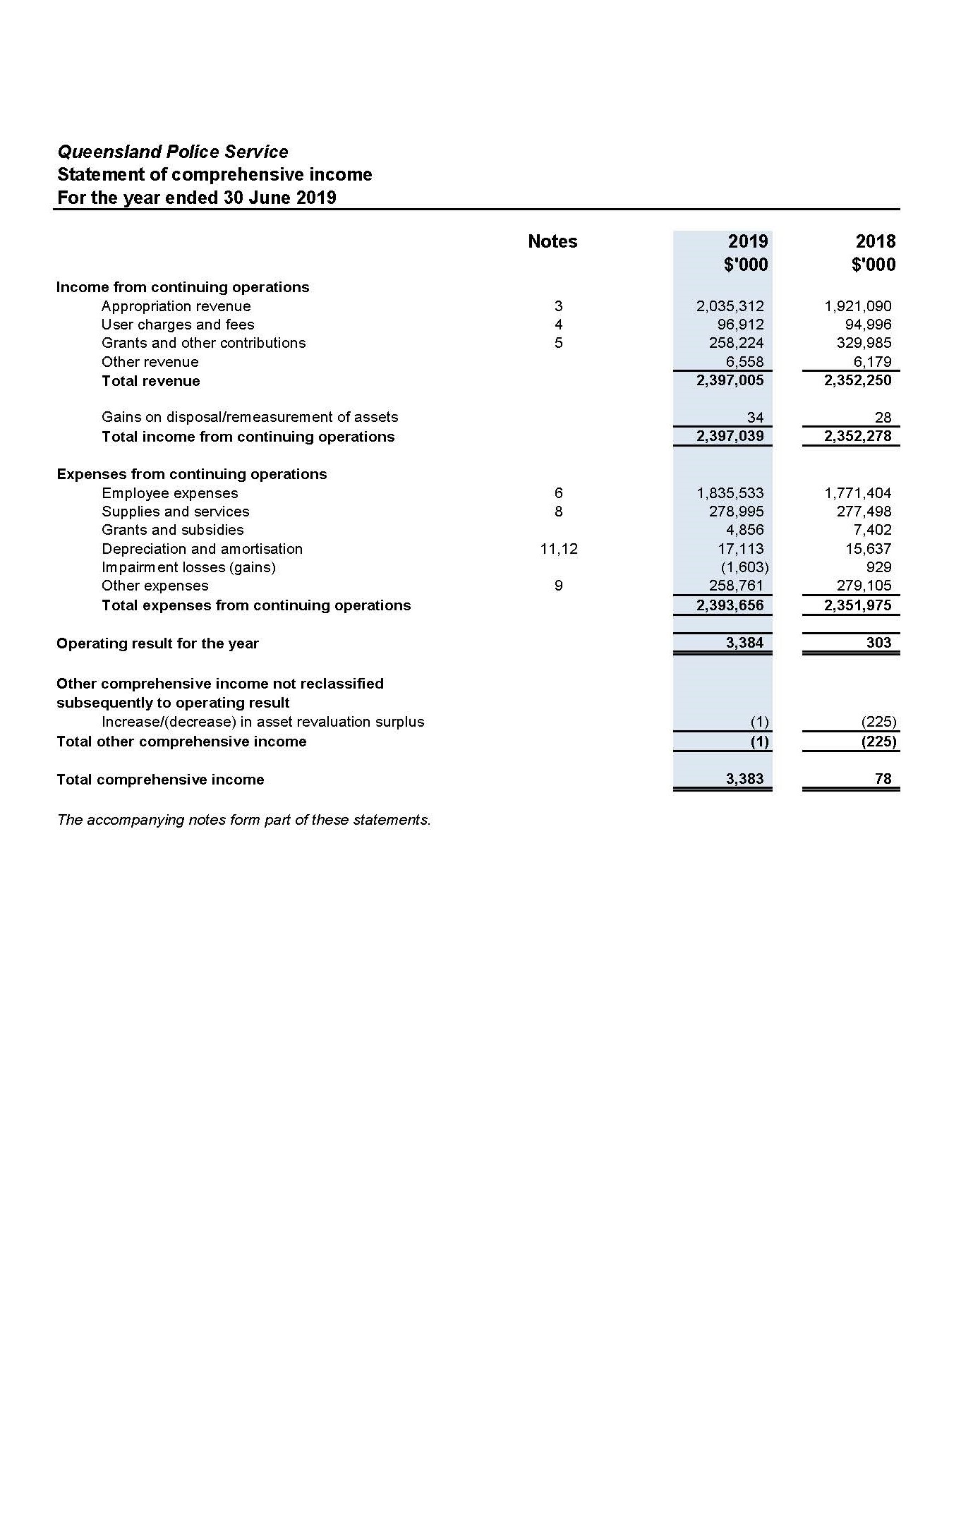

Statement of financial position as at 30 June 2019
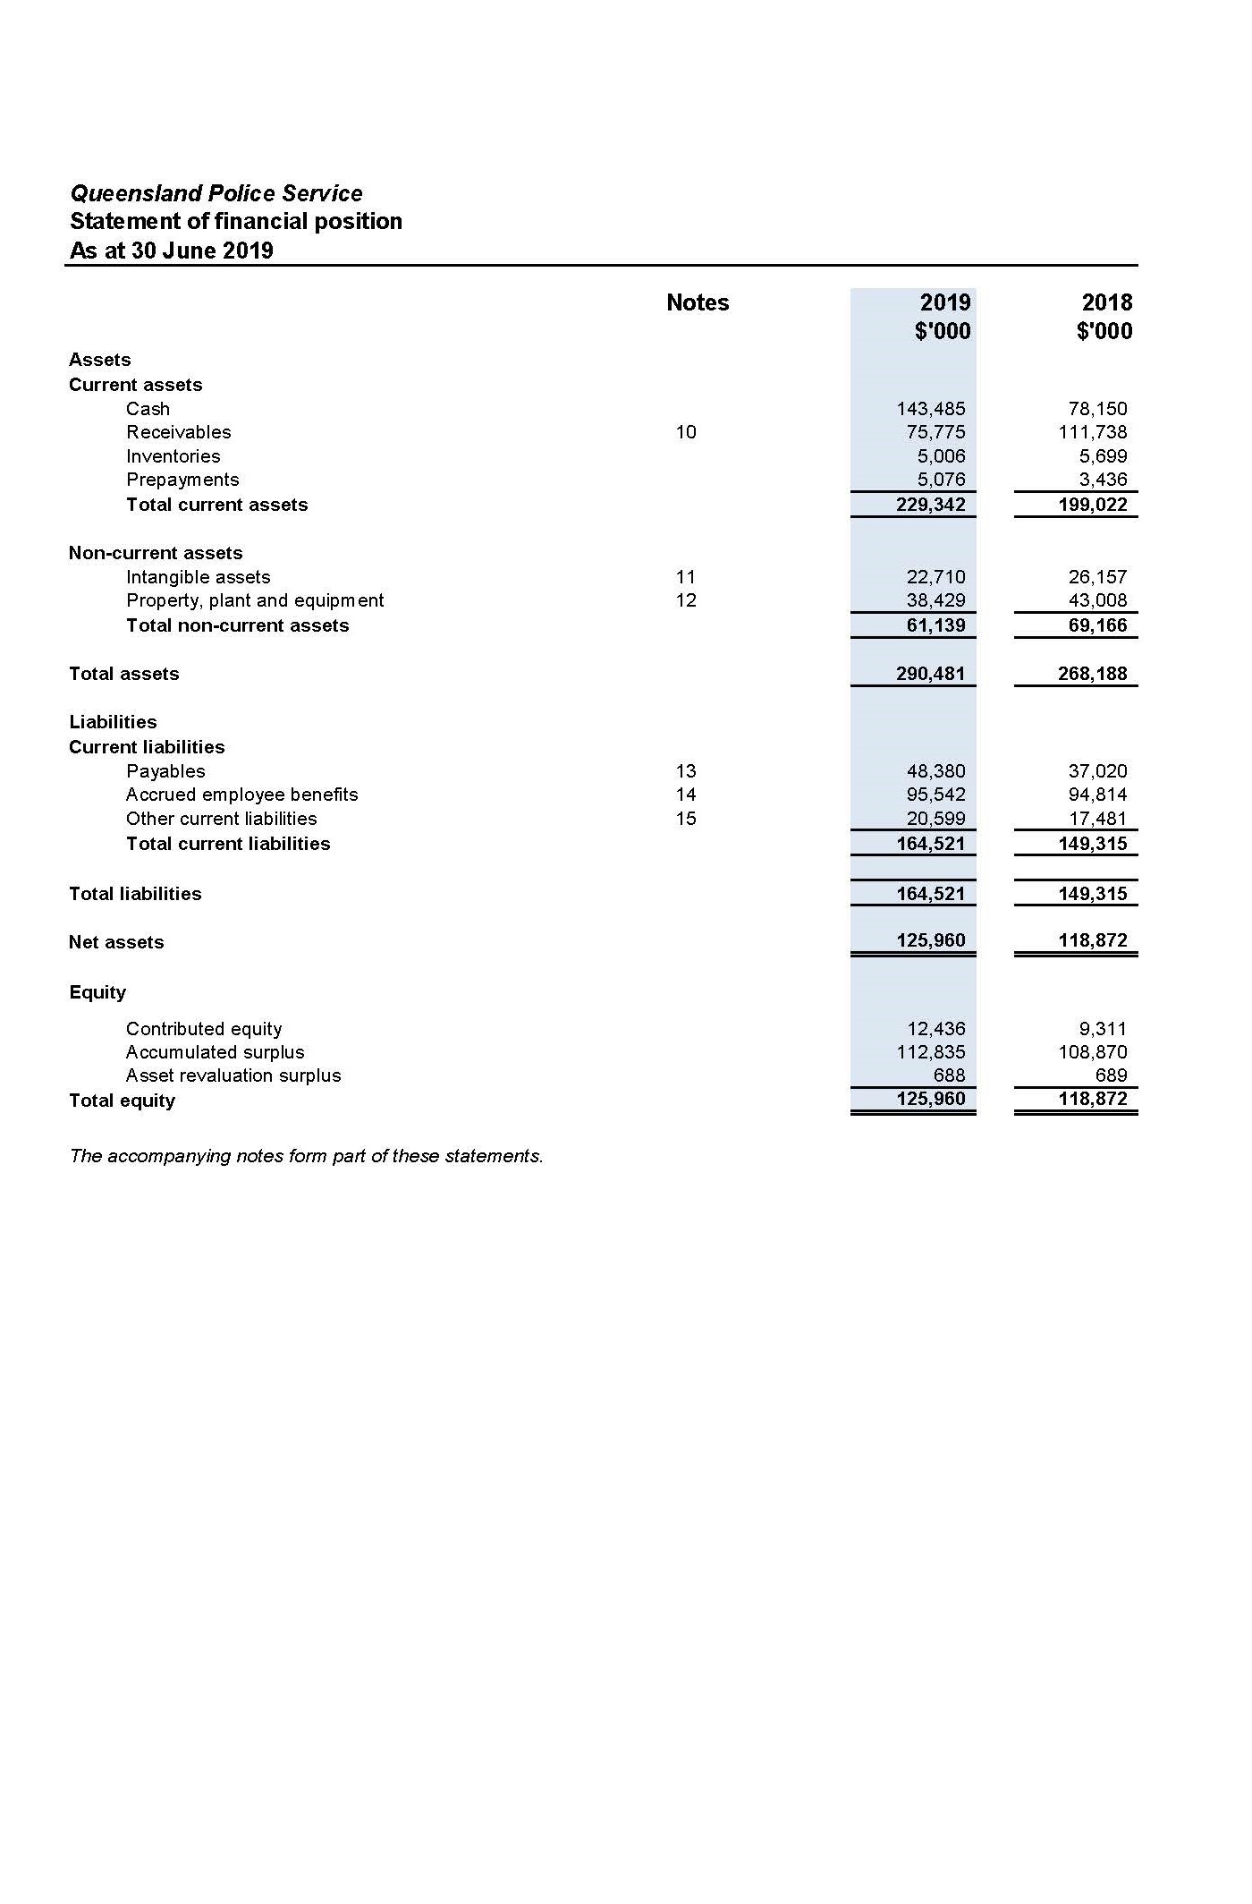

Statement of changes in equity for the year ended
30 June 2019
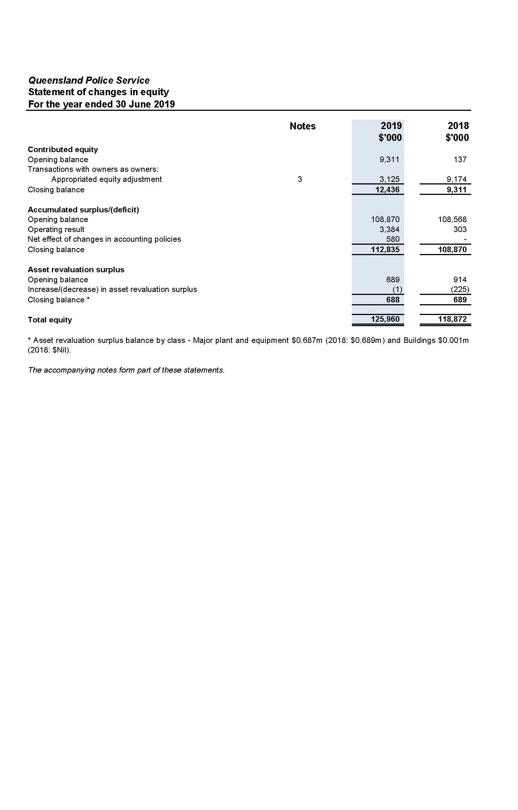

Statement of cash flows for the year ended
30 June 2019
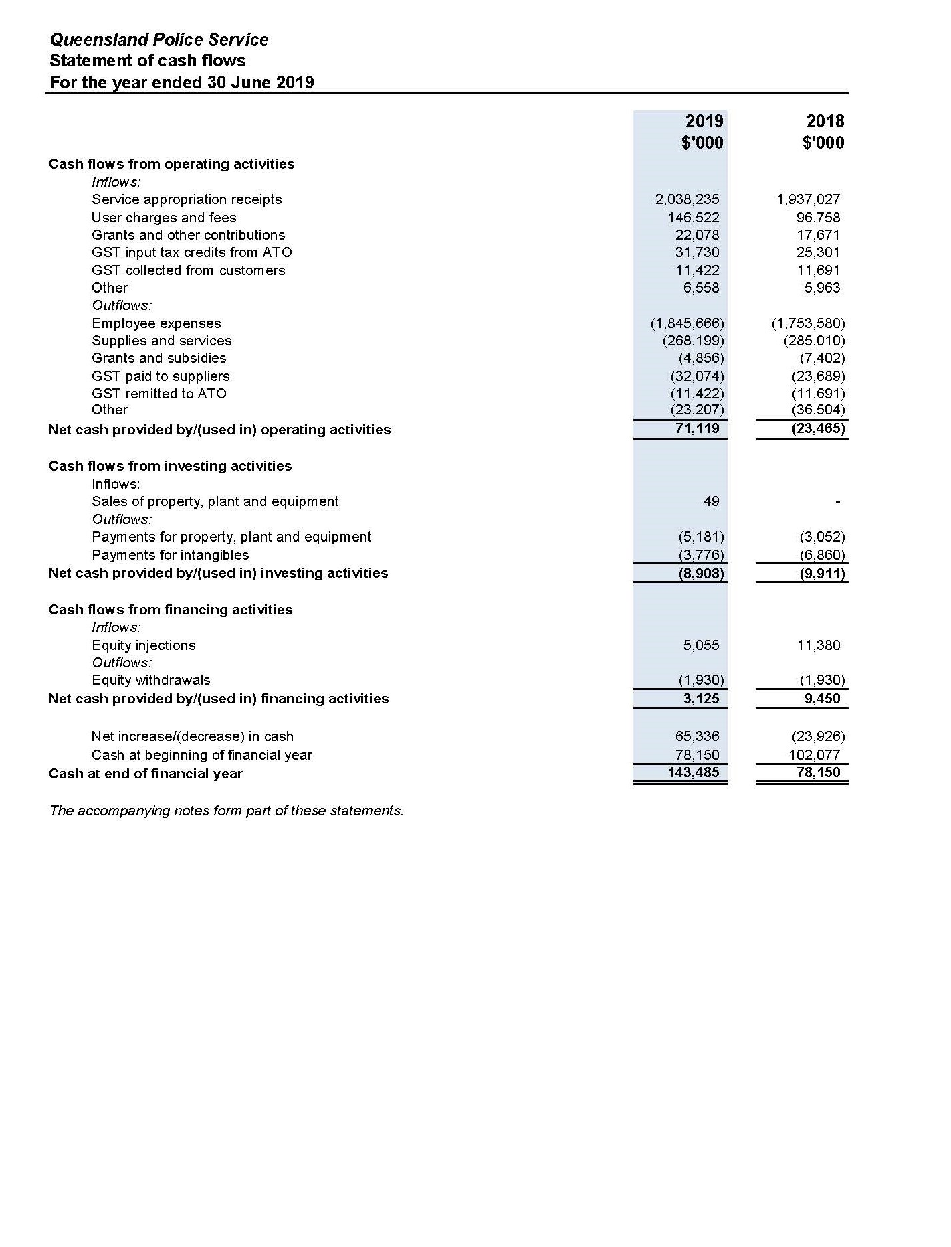

Notes to the statement of cash flows for the year ended
30 June 2019
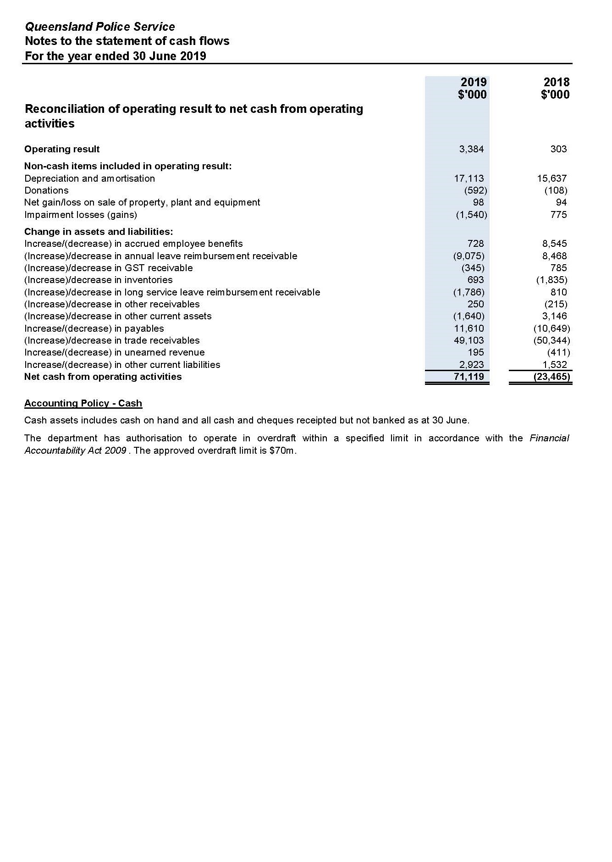

Statement of comprehensive income by major departmental services as at 30 June 2019
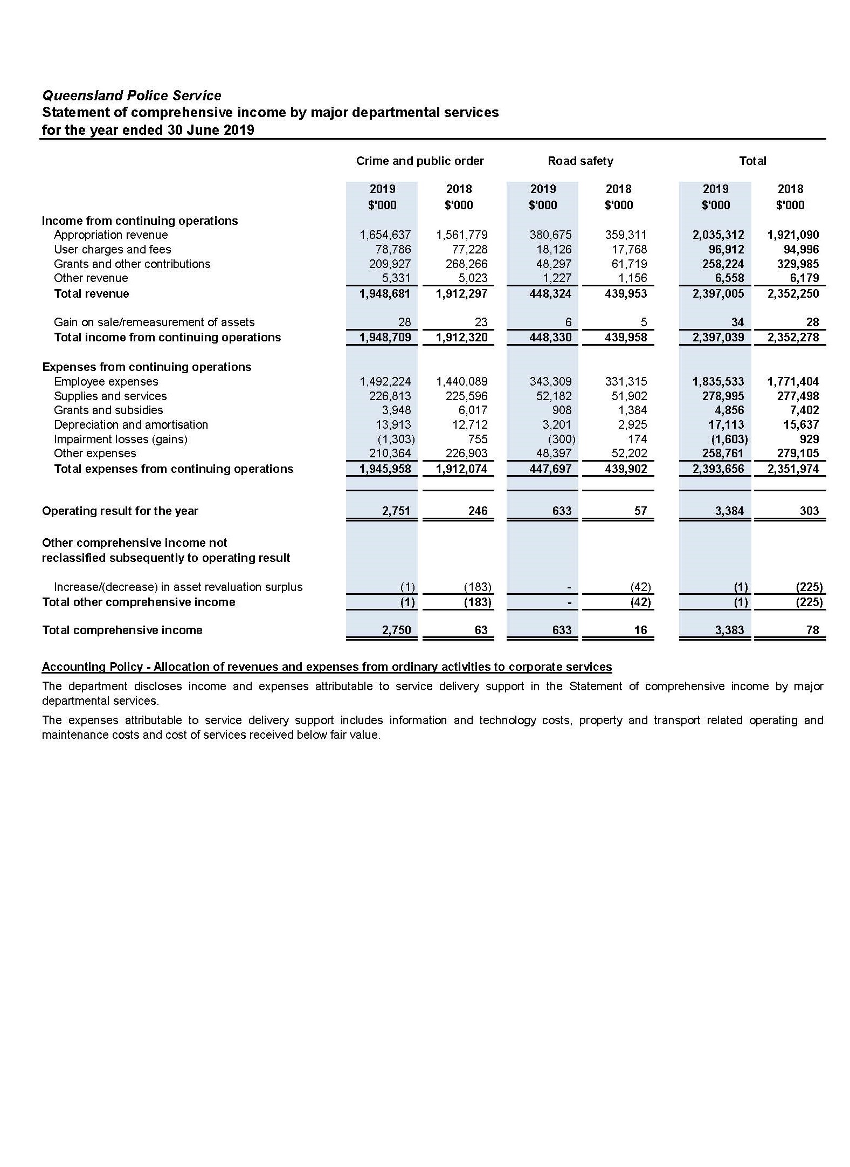

Statement of assets and liabilities by major departmental services as at 30 June 2019
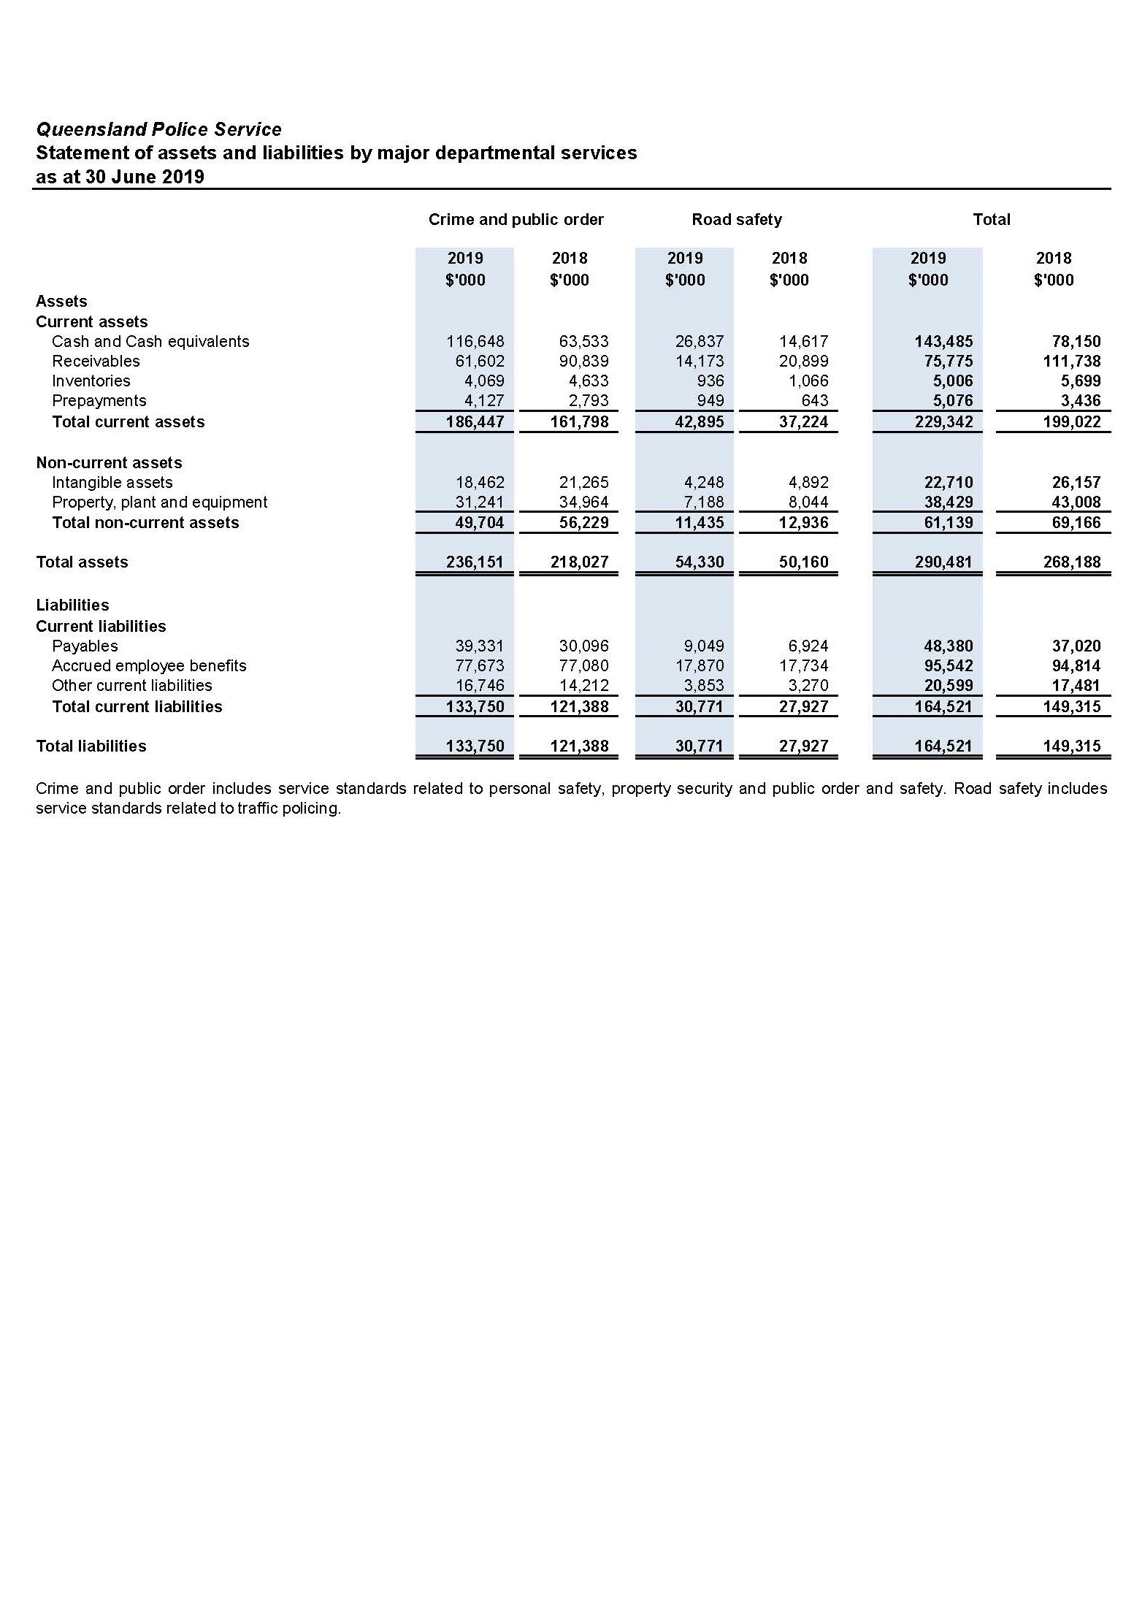

Notes to the financial statements 2018-19
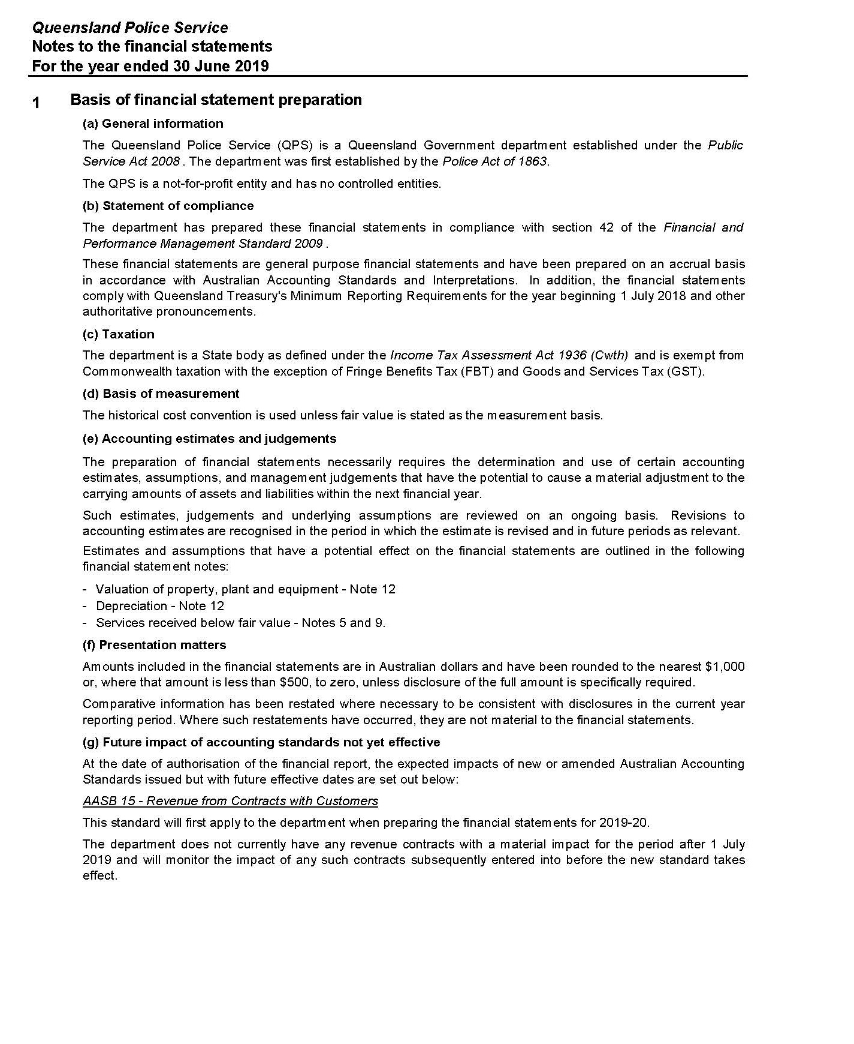

Notes to the financial statements for the year ended
30 June 2019 (cont’d)
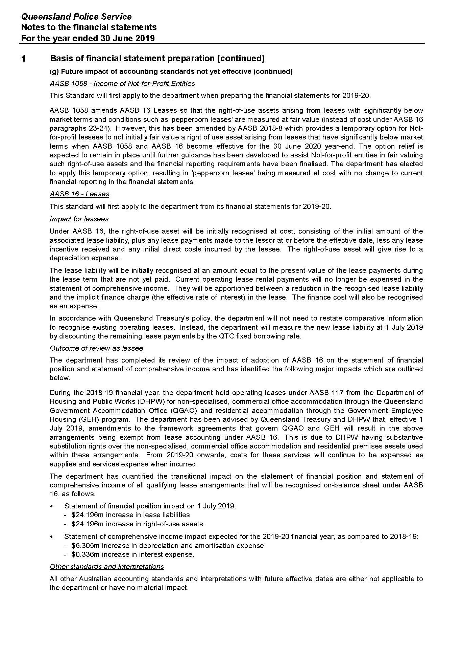
Notes to the financial statements for the year ended
30 June 2019 (cont’d)
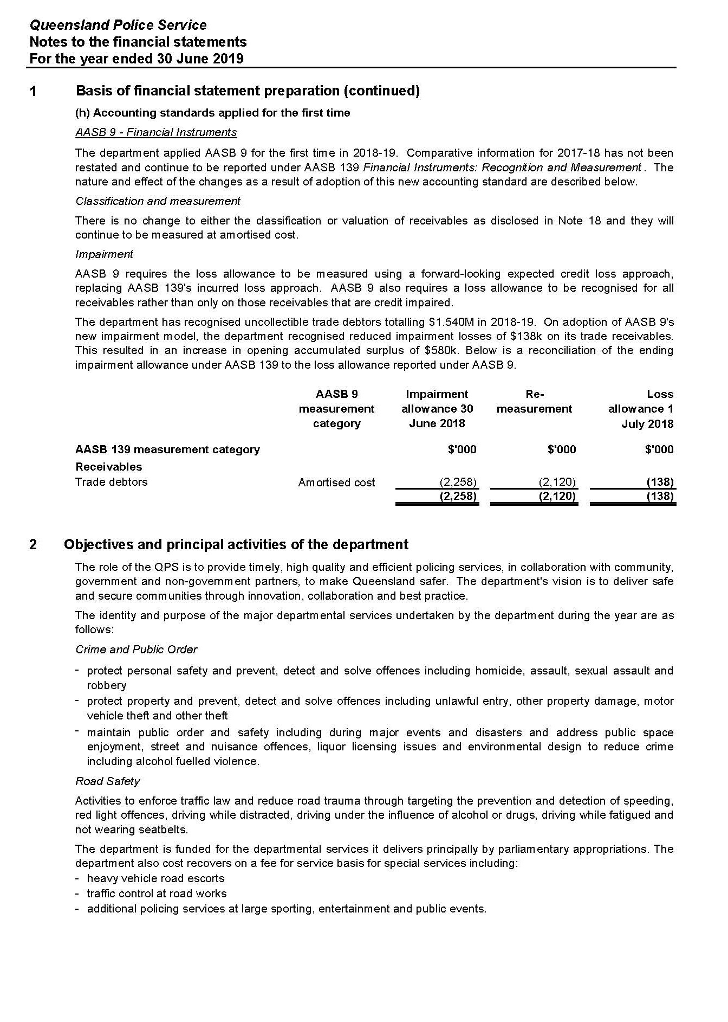
Notes to the financial statements for the year ended
30 June 2019 (cont’d)
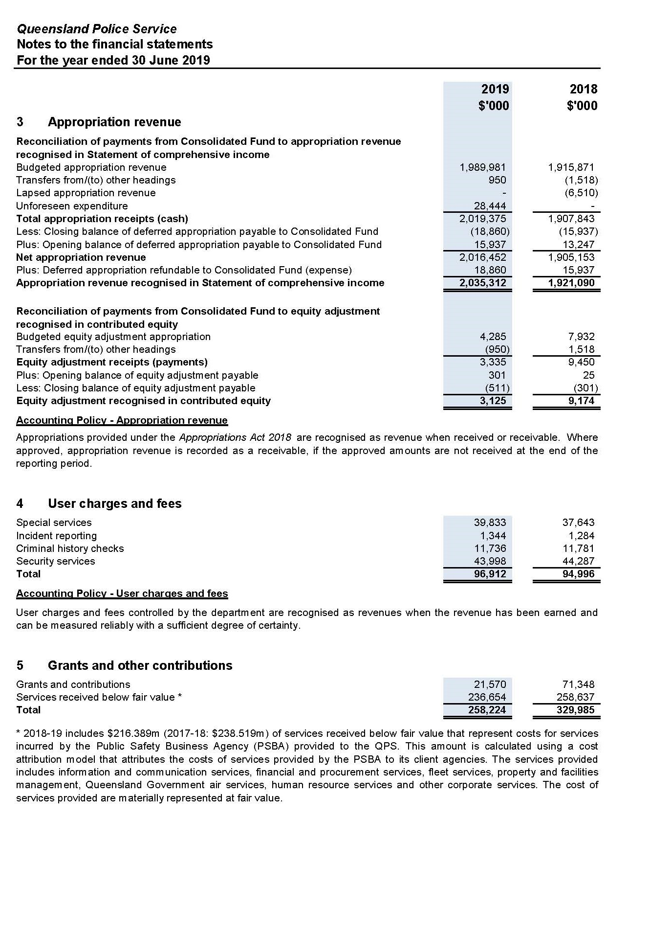
Notes to the financial statements for the year ended
30 June 2019 (cont’d)
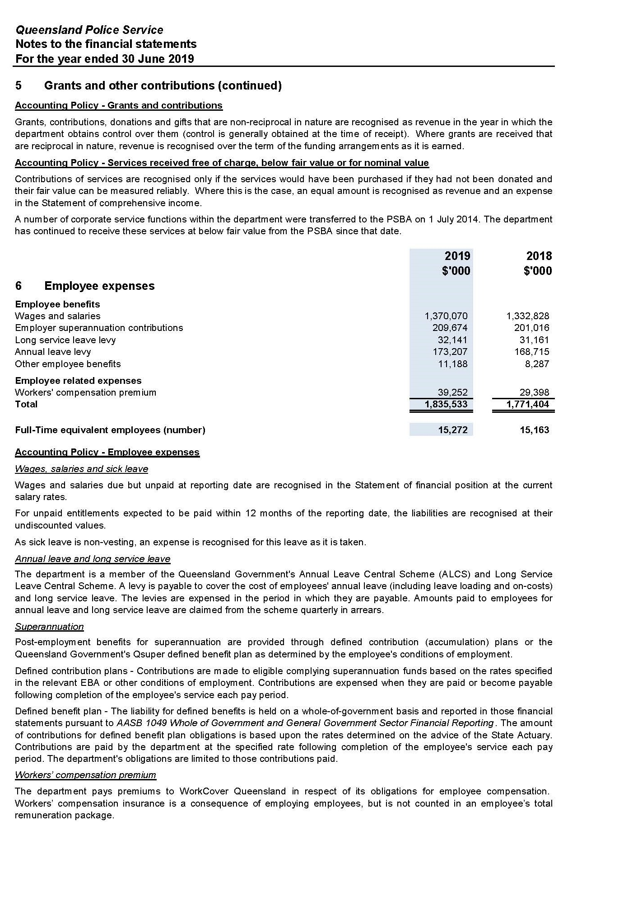
Notes to the financial statements for the year ended
30 June 2019 (cont’d)
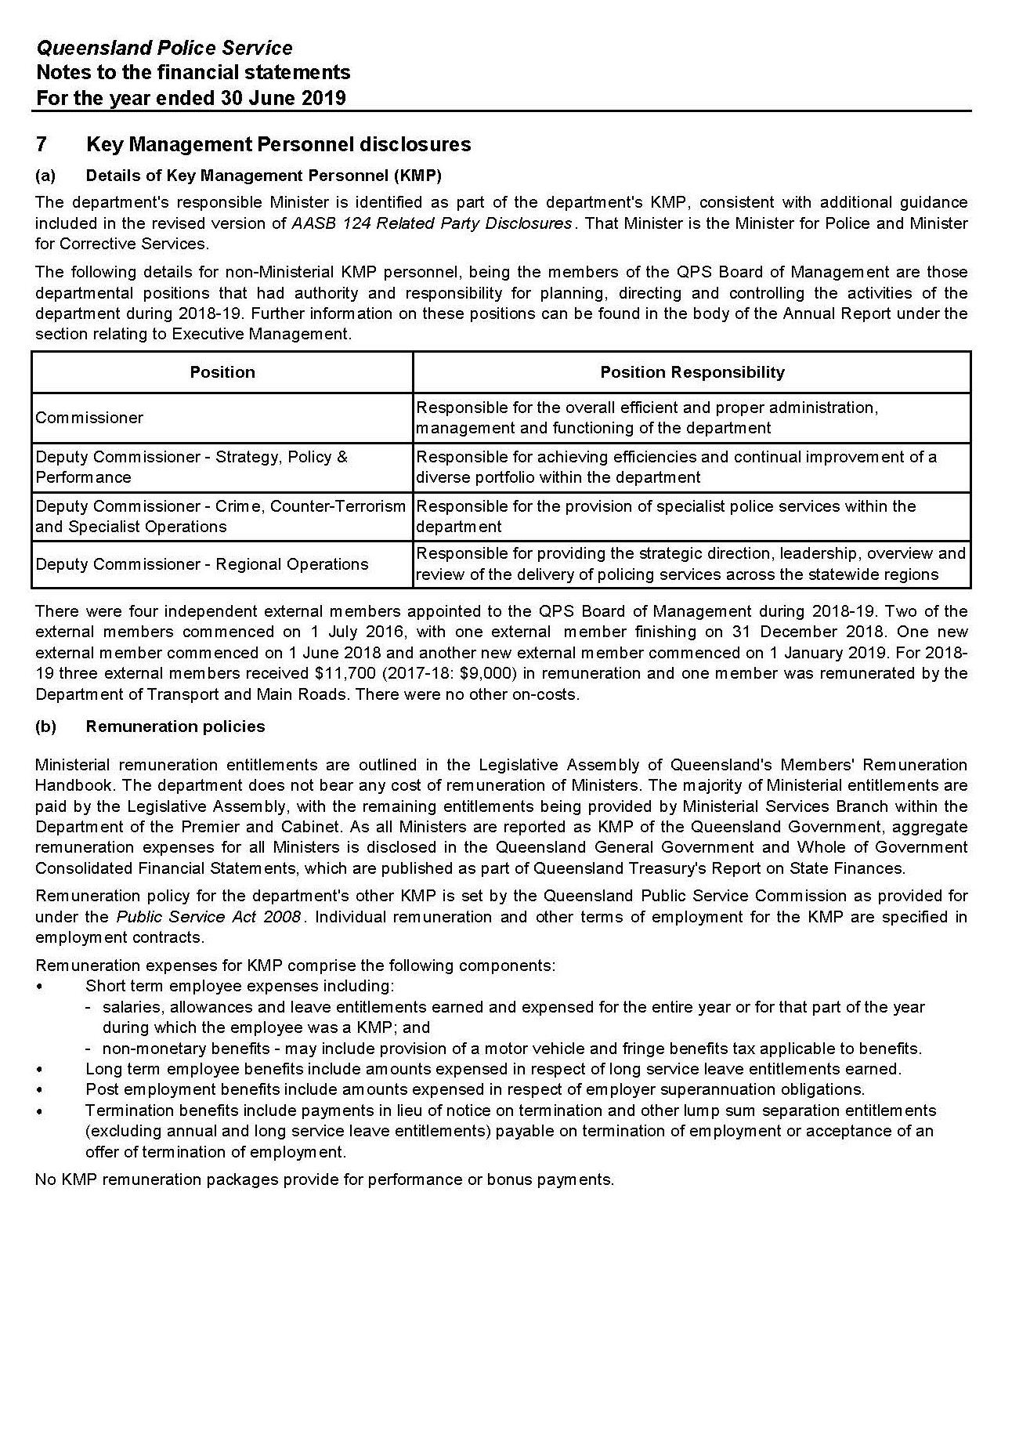

Notes to the financial statements for the year ended
30 June 2019 (cont’d)
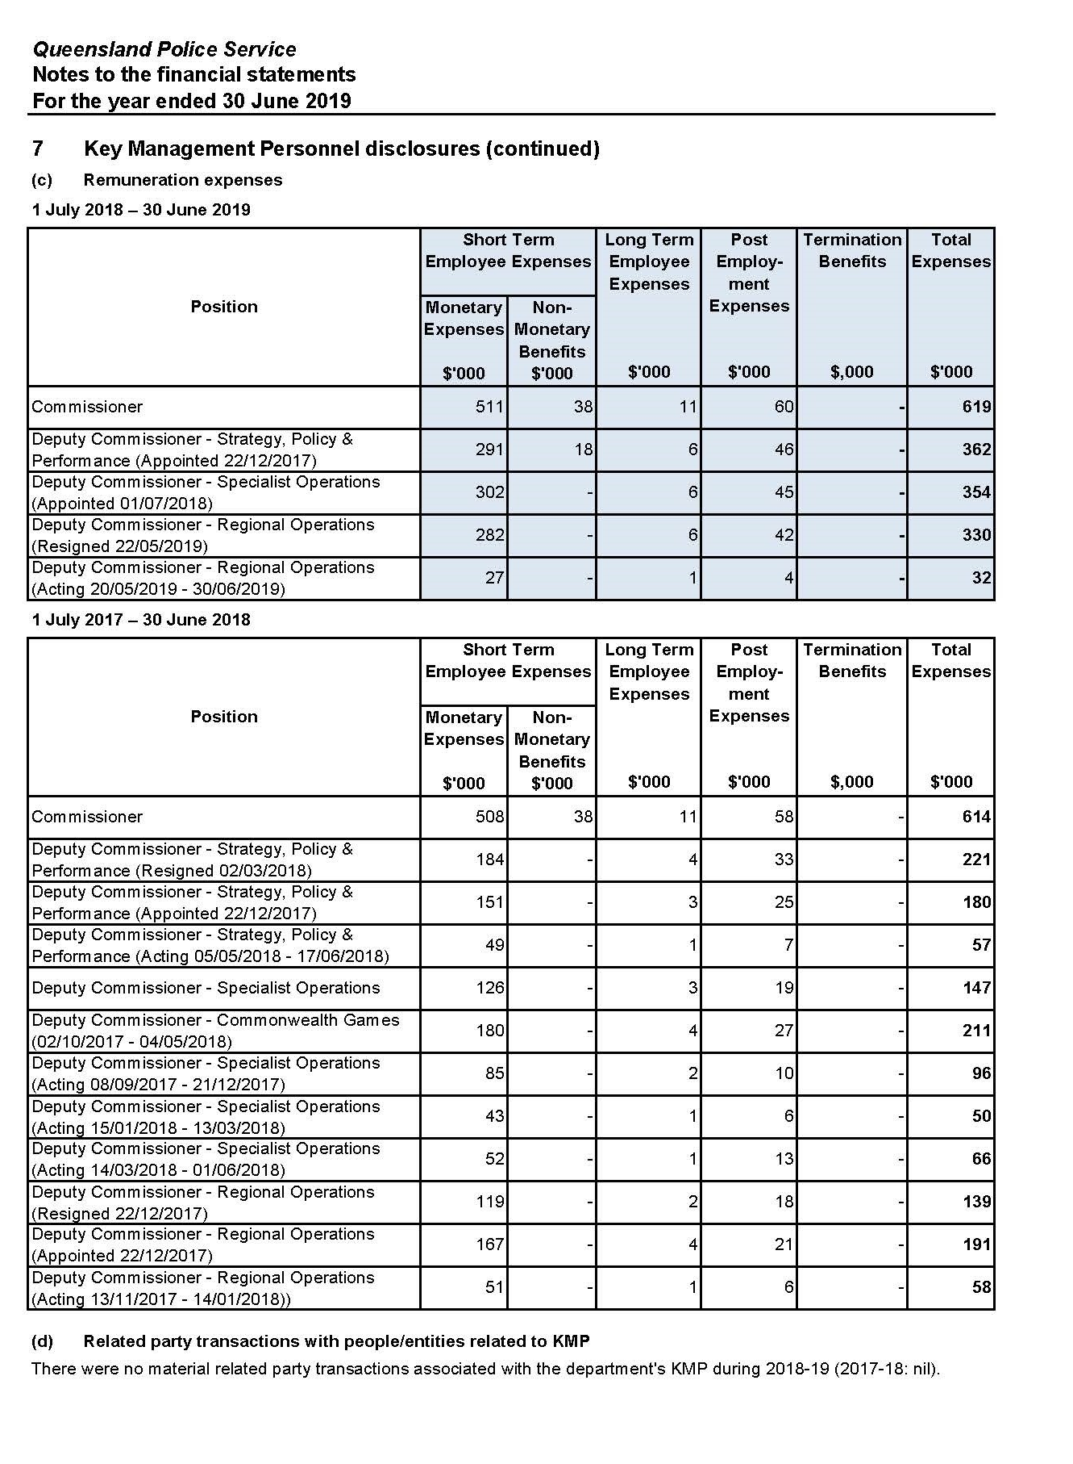

Notes to the financial statements for the year ended
30 June 2019 (cont’d)
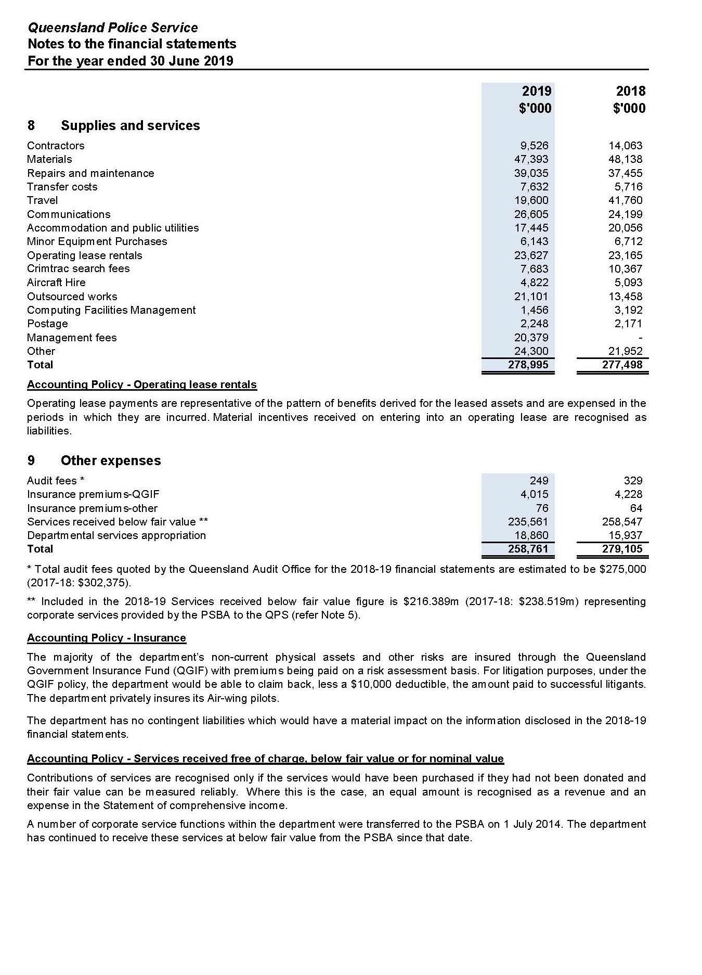

Notes to the financial statements for the year ended
30 June 2019 (cont’d)
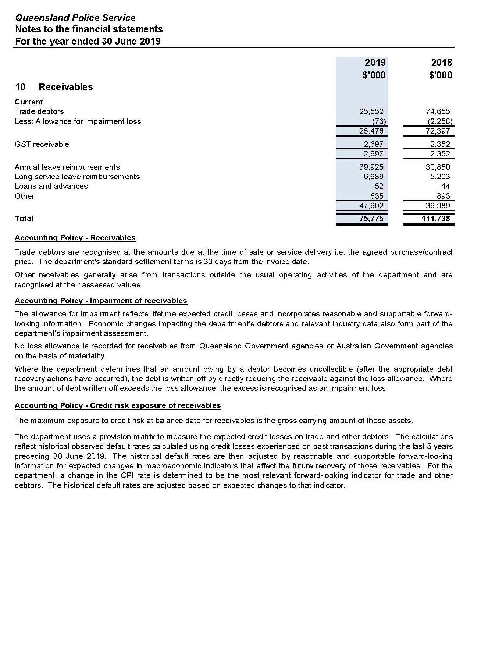

Notes to the financial statements for the year ended
30 June 2019 (cont’d)
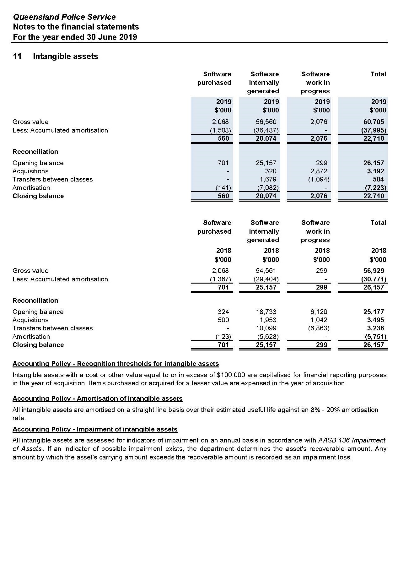

Notes to the financial statements for the year ended
30 June 2019 (cont’d)
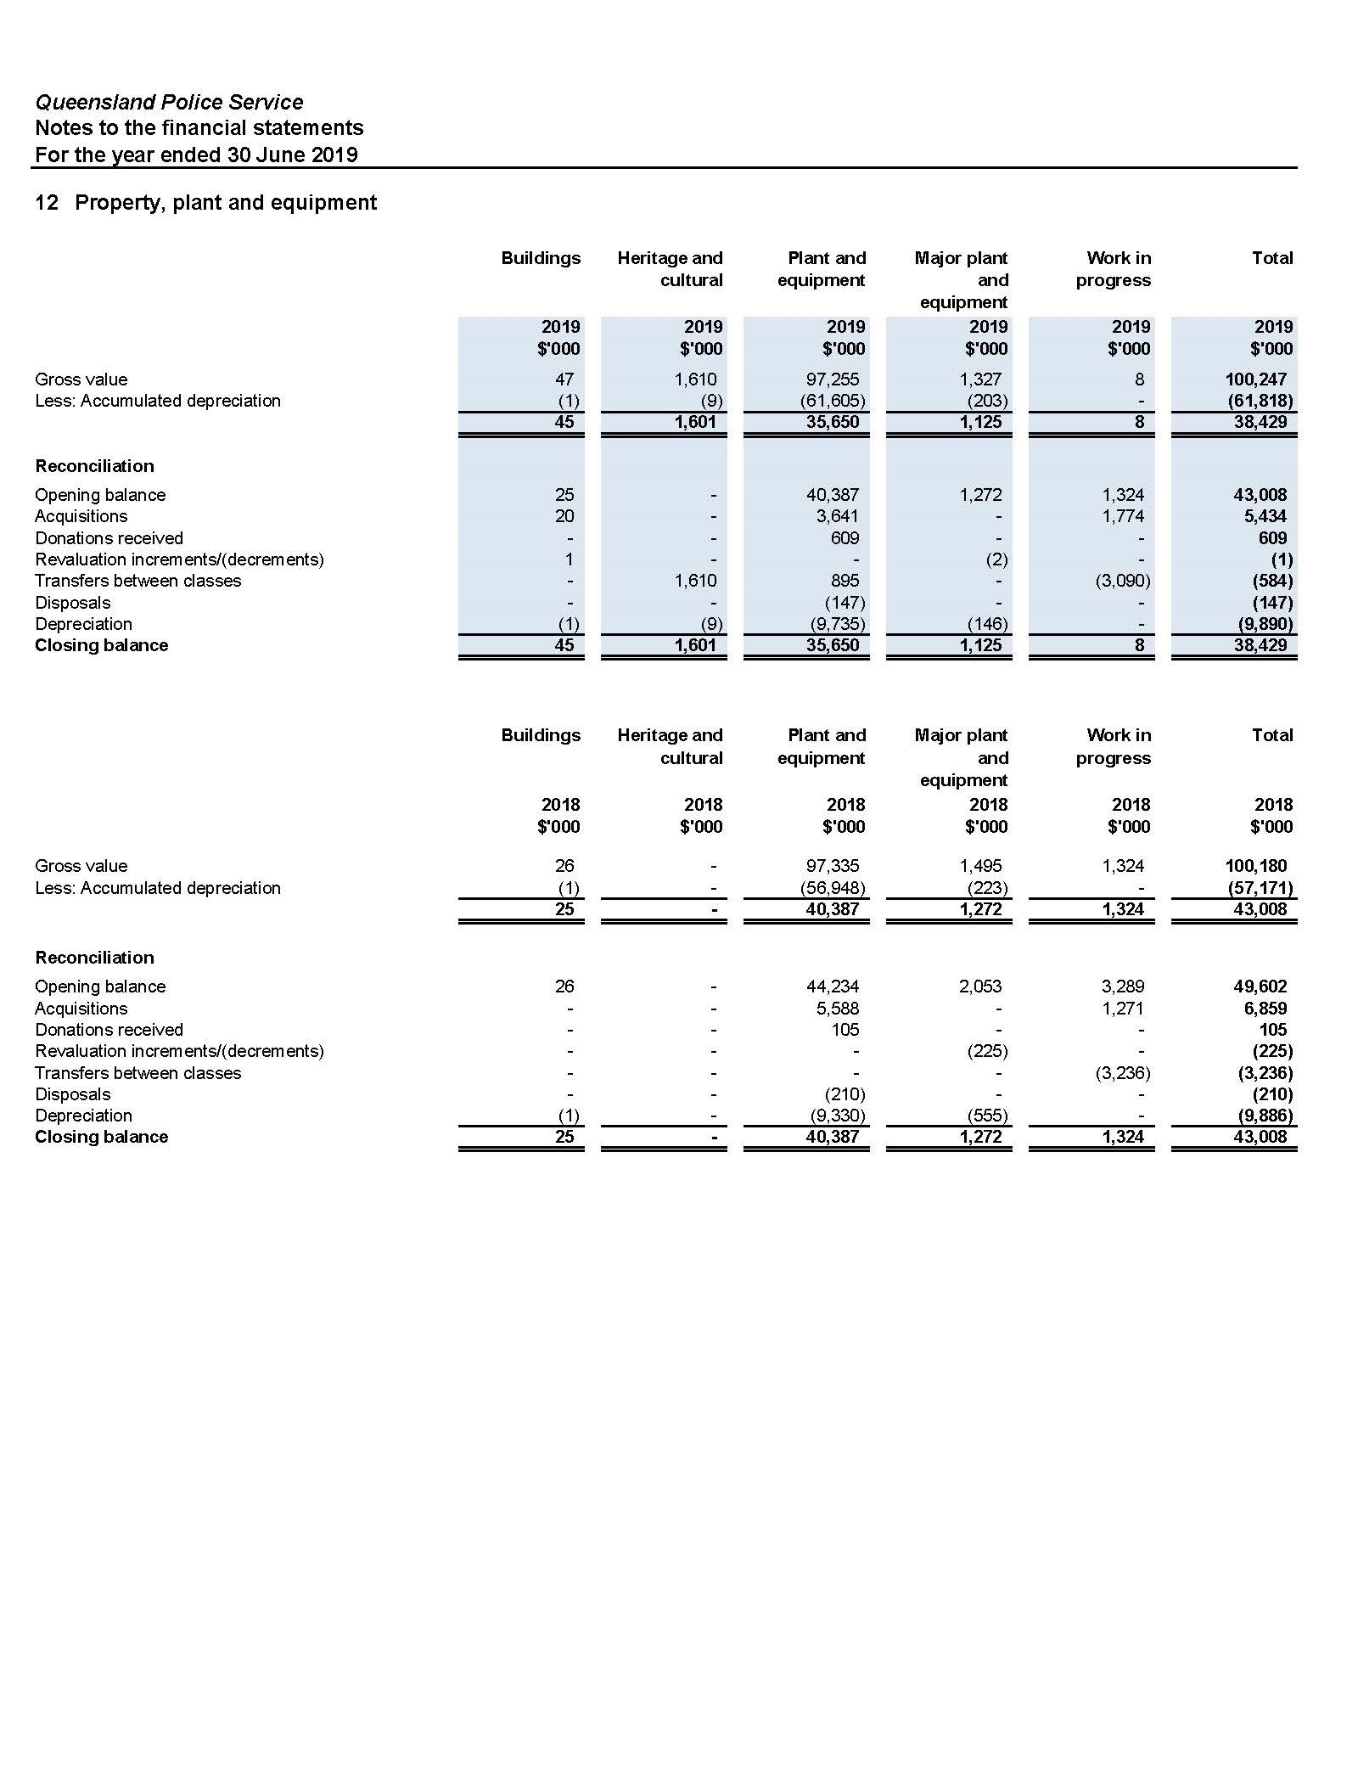

Notes to the financial statements for the year ended
30 June 2019 (cont’d)
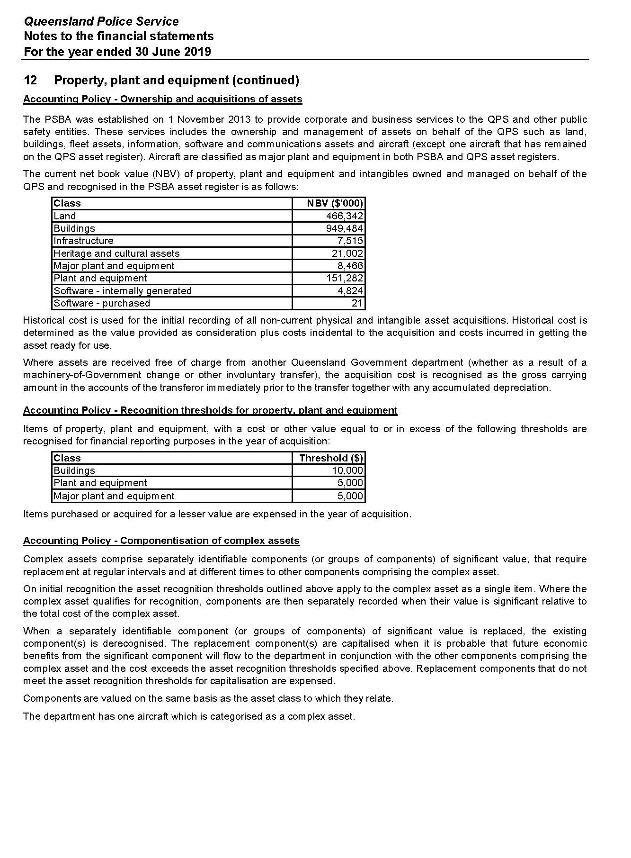

Notes to the financial statements for the year ended
30 June 2019 (cont’d)
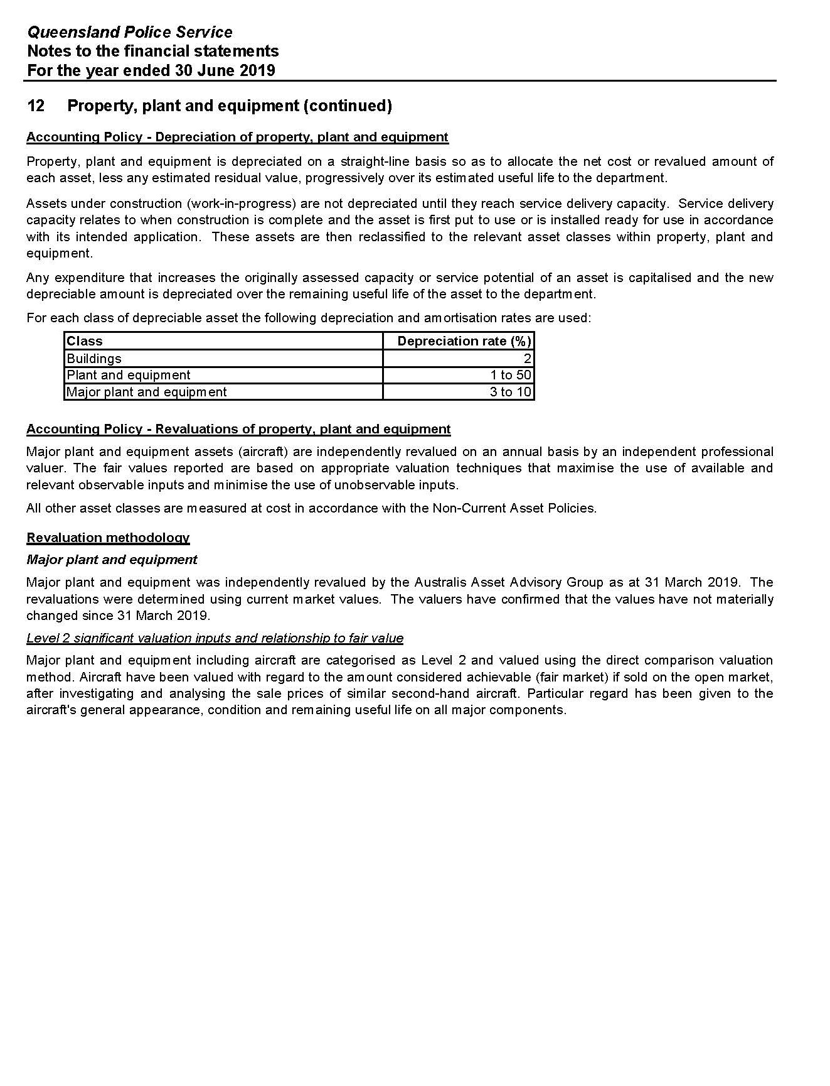

Notes to the financial statements for the year ended
30 June 2019 (cont’d)
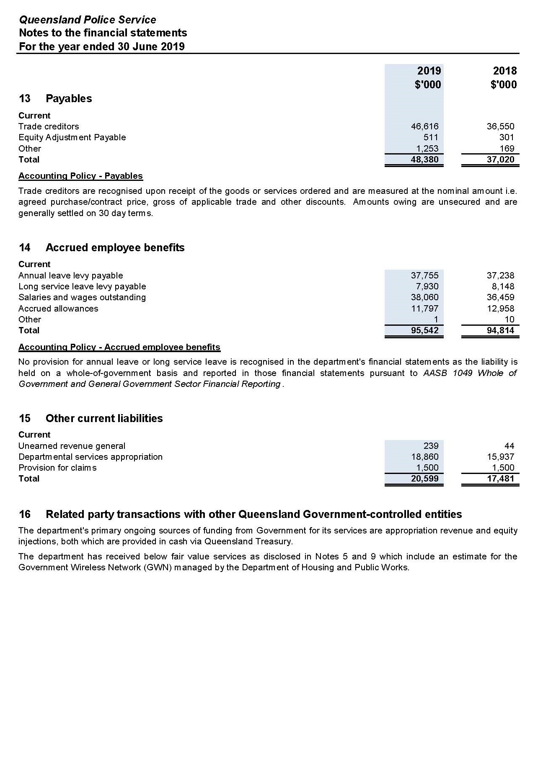

Notes to the financial statements for the year ended
30 June 2019 (cont’d)
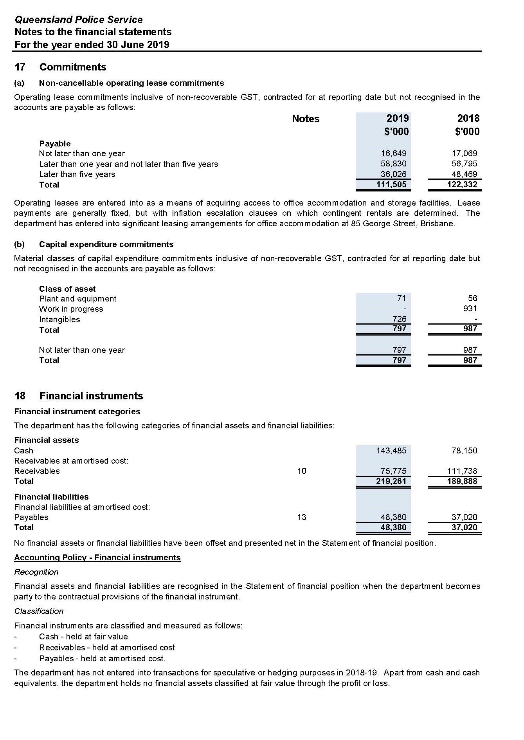
Notes to the financial statements for the year ended
30 June 2019 (cont’d)
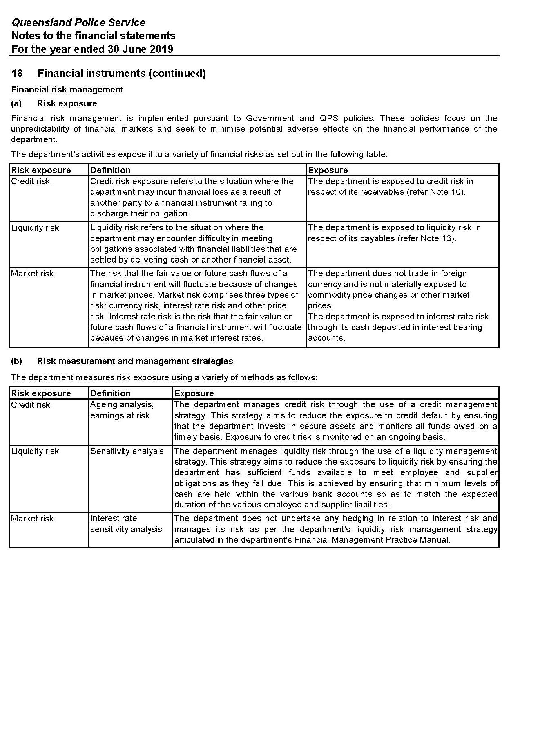

Notes to the financial statements for the year ended
30 June 2019 (cont’d)
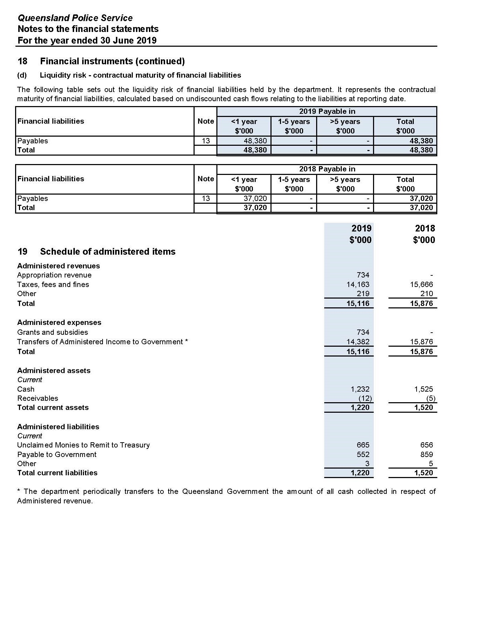

Notes to the financial statements for the year ended
30 June 2019 (cont’d)
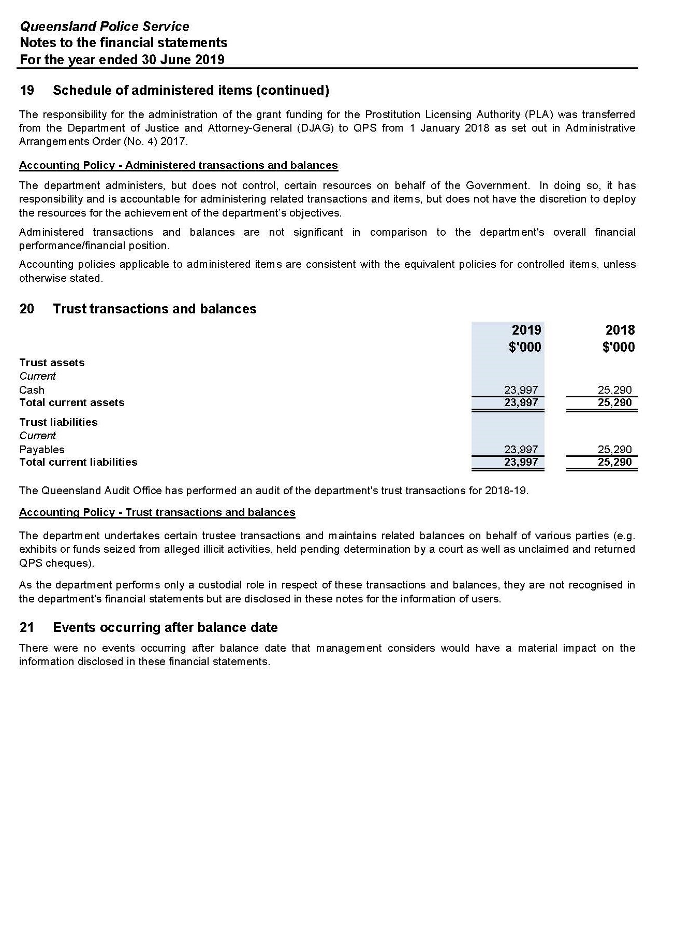
Notes to the financial statements for the year ended
30 June 2019 (cont’d)
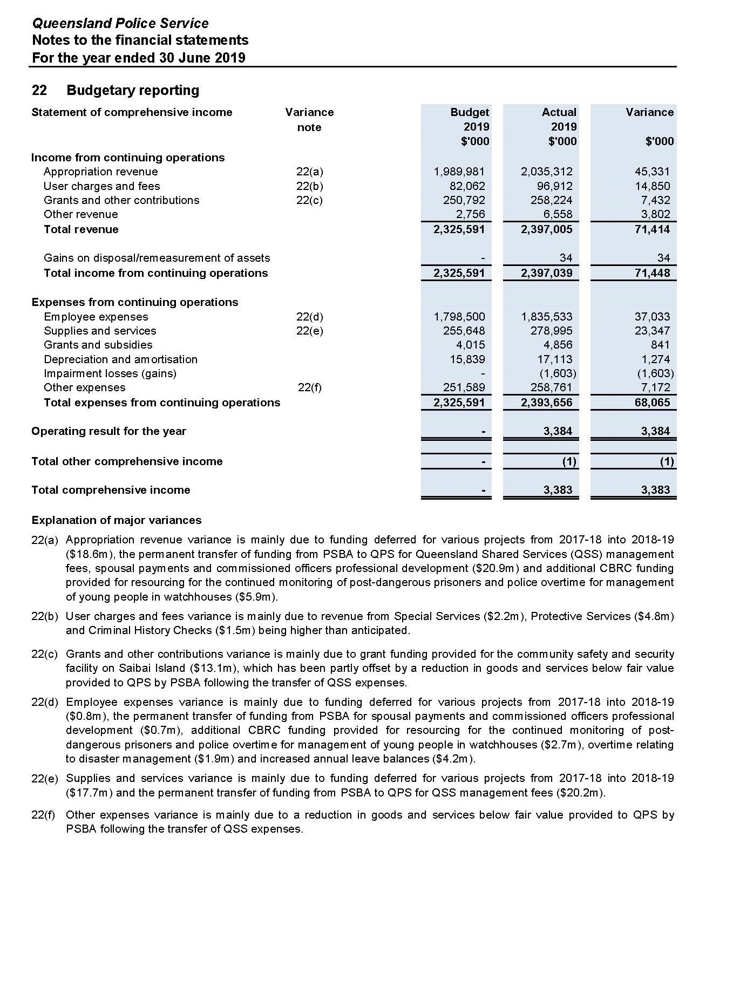

Notes to the financial statements for the year ended
30 June 2019 (cont’d)
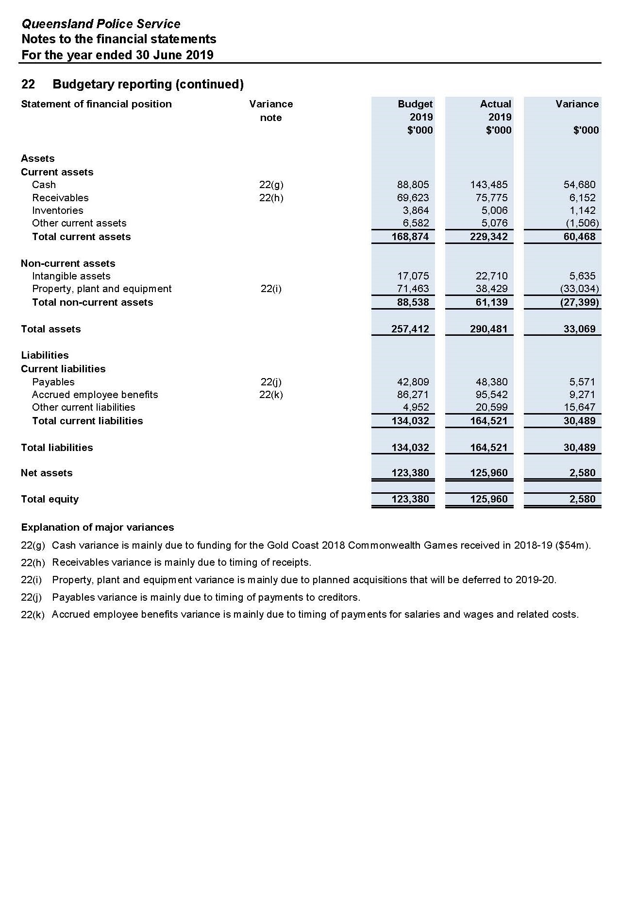
Notes to the financial statements for the year ended
30 June 2019 (cont’d)
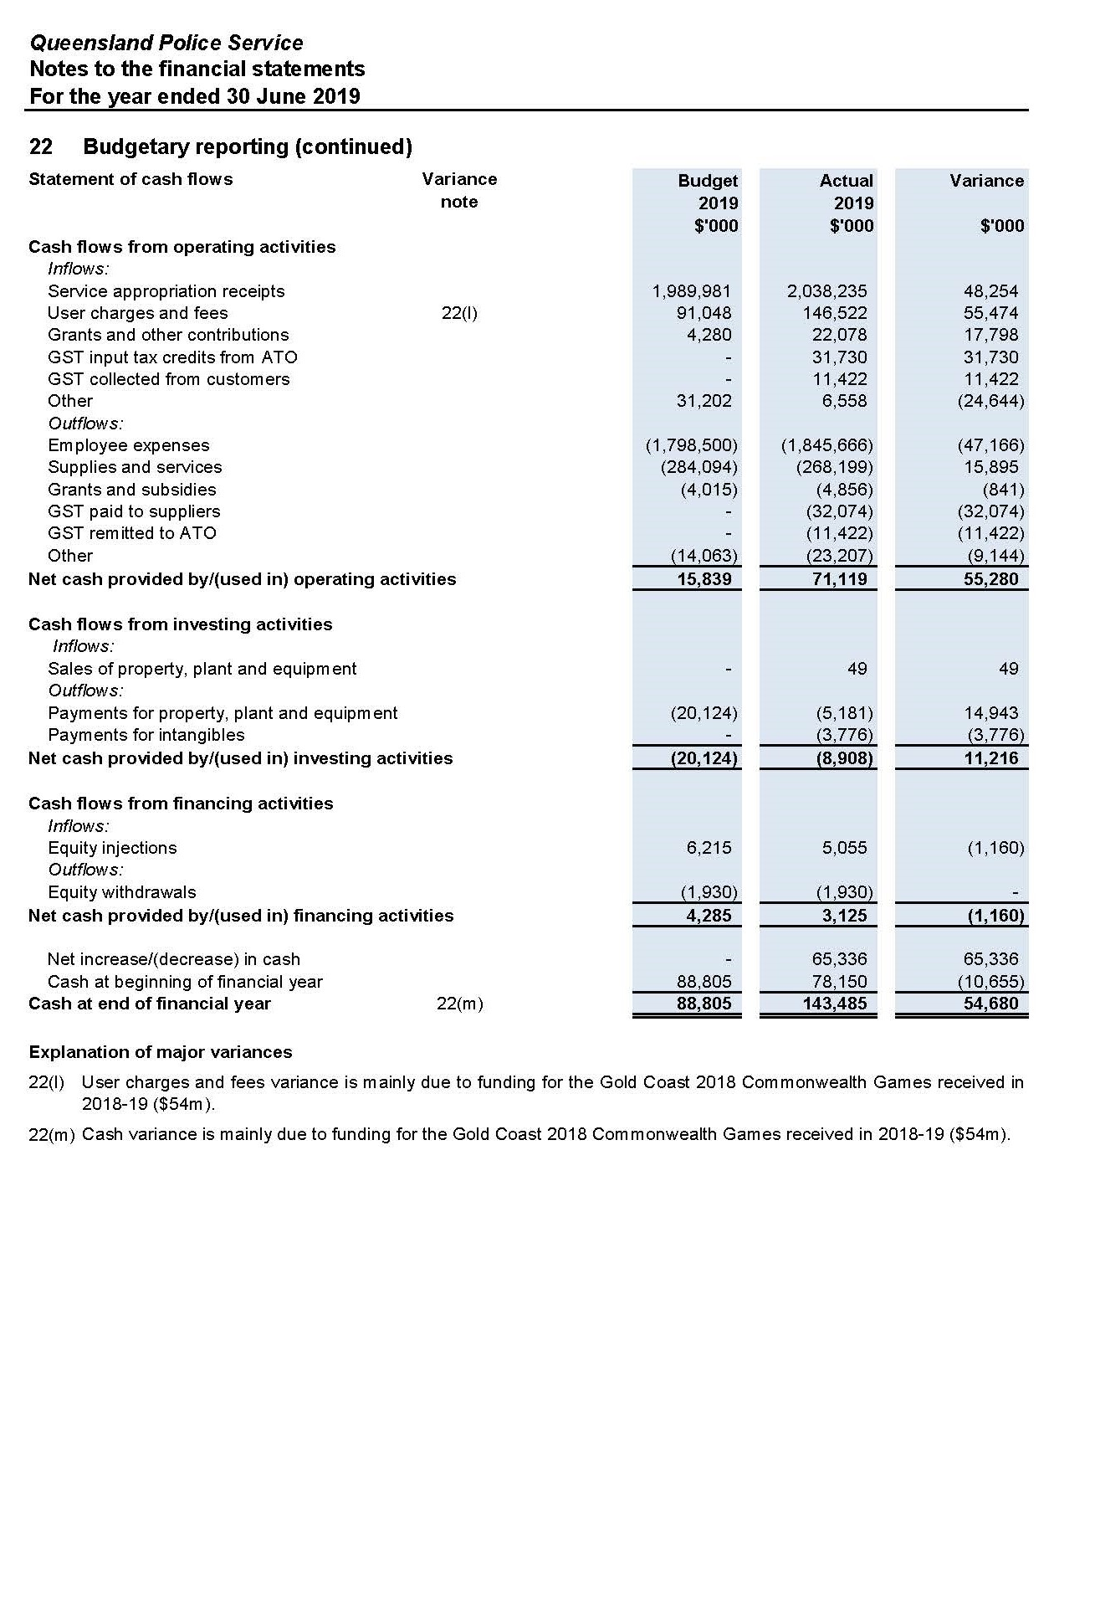
Notes to the financial statements for the year ended
30 June 2019 (cont’d)
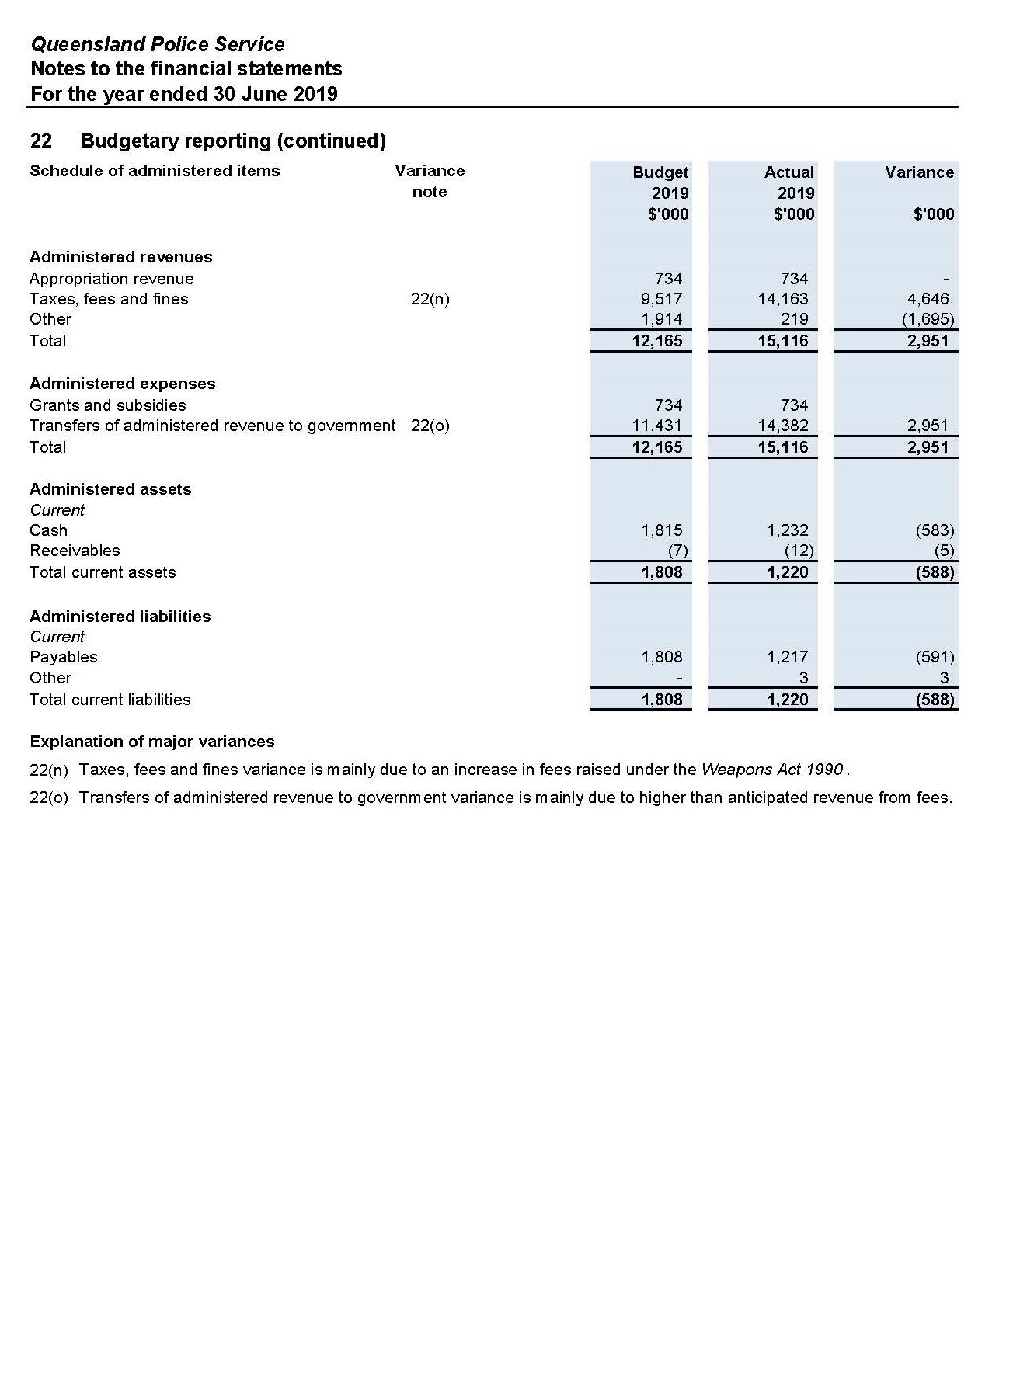

Management Certificate for the year ended 30 June 2019
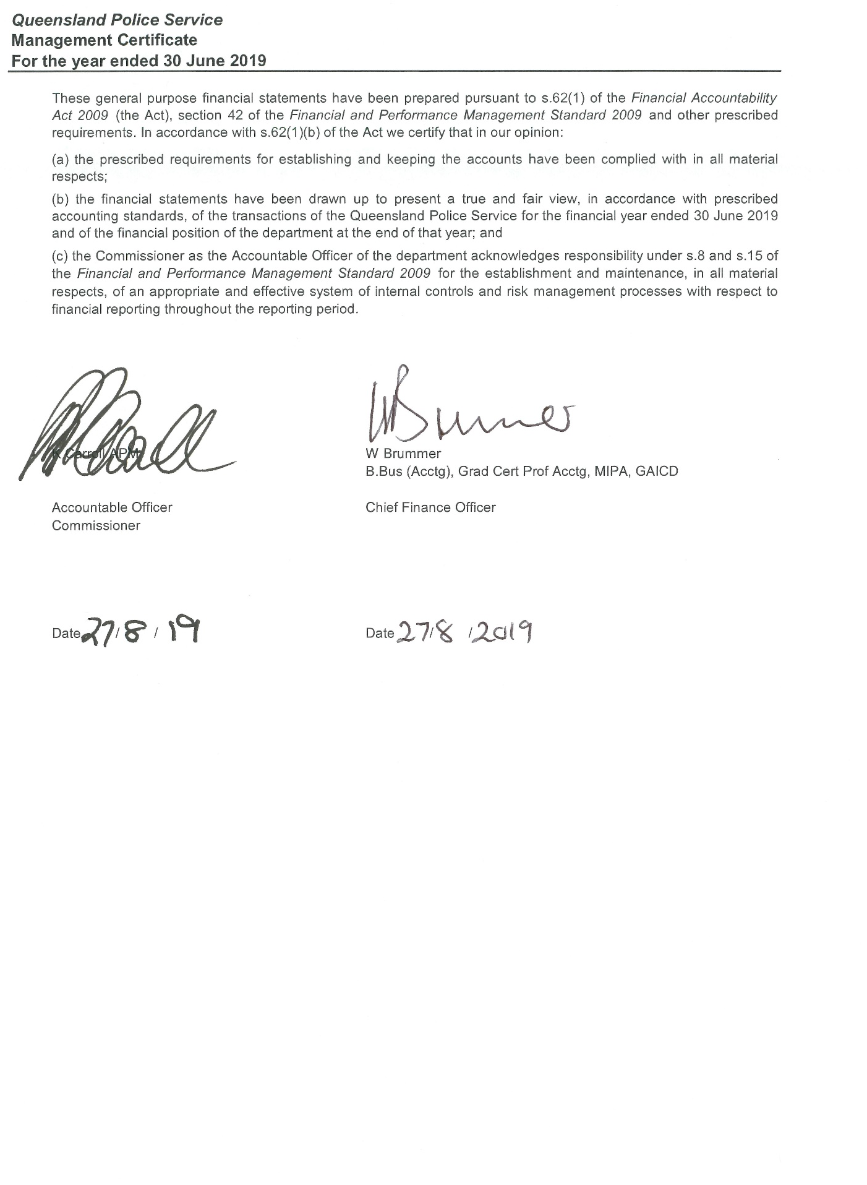

Independent Auditor’s Report
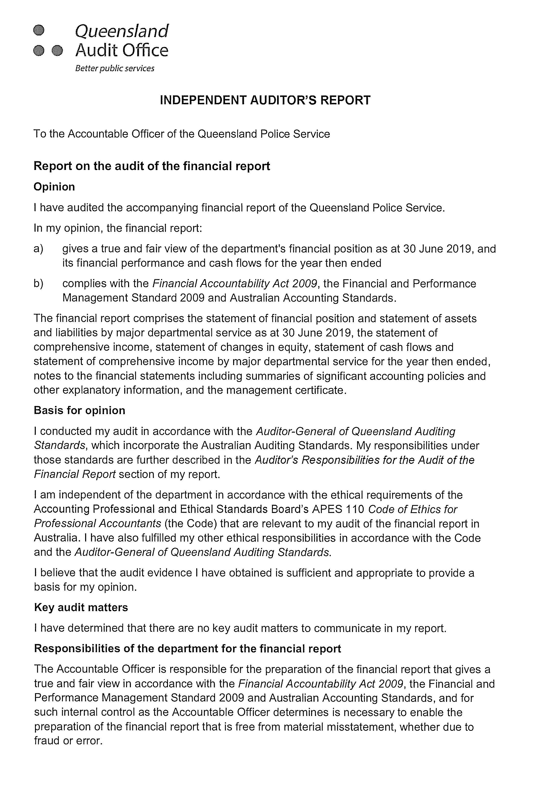
Independent Auditor’s Report (cont’d)
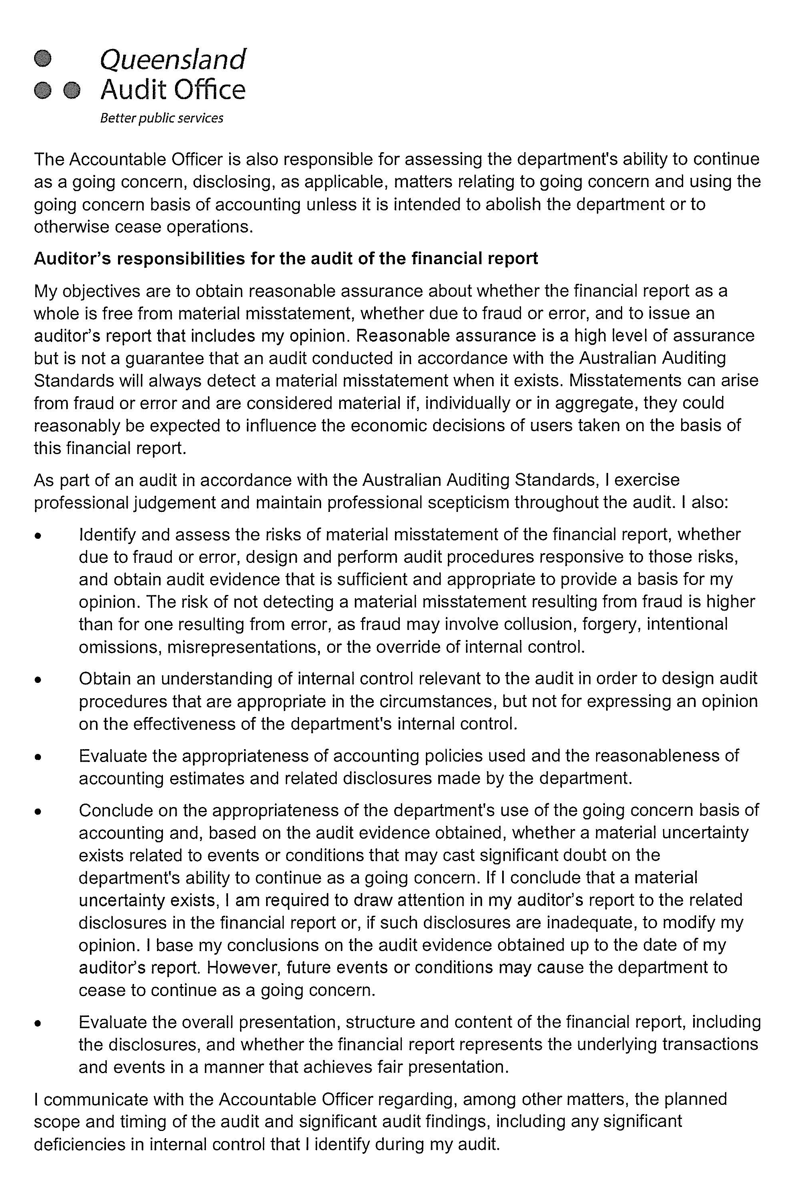

Independent Auditor’s Report (cont’d)
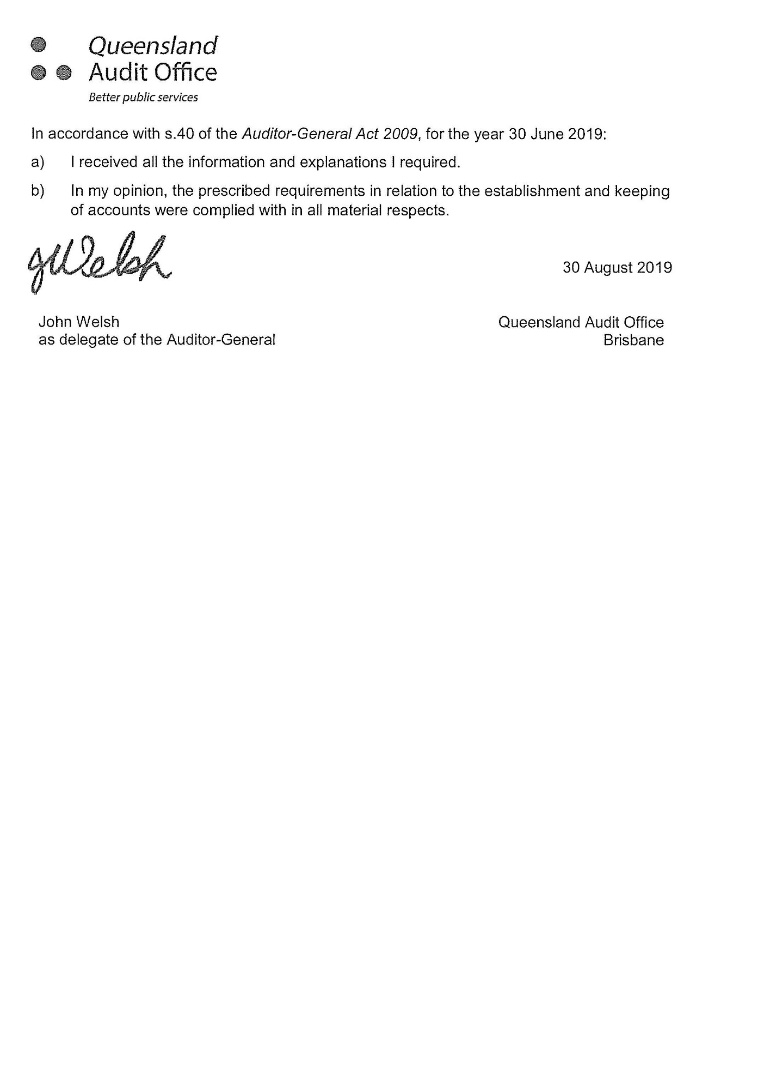

Appendices

Government bodies
Commissioner for Police Service Reviews
Act/instrument | The Commissioner for Police Service Reviews is established under the Police Service Administration Act 1990 and Police Service Administration (Review of Decisions) Regulation 1990.
Functions | The Review Commissioner is responsible for hearing grievances from police officers relating to appointments, promotions, transfers or disciplinary actions made under the Act.  Appeals are heard before a Review Commissioner nominated by the Crime and Corruption Commission yet otherwise independent of the Crime and Corruption Commission and the QPS. Where a matter progresses to a hearing, the Review Commissioner will consider the material presented and prepare written recommendations for the Police Commissioner who will make the final decision. Where the Police Commissioner does not accept the recommendation, reasons must be provided to the Review Commissioner.  The Crime and Corruption Commission provides a secretariat to support the review function.
Further information about the Commissioner for Police Service Reviews is available at www.ccc.qld.gov.au/.
Controlled Operations Committee
Act | The Controlled Operations Committee is established under the Police Powers and Responsibilities Act 2000.
Functions | The Controlled Operations Committee is responsible for considering and making recommendations about applications for an authority, or variation to an authority, to conduct a controlled operation under Chapter 11 of the Police Powers and Responsibilities Act 2000.
Achievements | The committee provides its own annual report after 30 June each year, detailing the work and activities of the QPS under Chapter 11 Controlled operations of the Act for the preceding 12 months.  The committee’s annual report is available online at www.parliament.qld.gov.au/work-of-assembly/tabled-papers.
Financial reporting | Records are inspected by the Chairperson of the Controlled Operations Committee. Transactions of the entity are accounted for in the QPS financial statements which are certified by the Auditor-General of Queensland.

Controlled Operations Committee (cont’d)
Remuneration
Position | Name | Meetings | Approved fee | Approved sub-committee fees | Actual fees received
Independent Member | Judge John Jerrard | 14* | $167.00 |  | $2,338.00
Independent Member | Judge Manus Boyce | 2 | $167.00 |  | $334.00
Chairperson (QPS) | Detective Chief Superintendent Charysse Pond | 5
Acting Chairperson (QPS) | Detective Superintendent Jon Wacker | 4
Acting Chairperson (QPS) | Detective Superintendent Denzil Clark | 1
Acting Chairperson (QPS) | Detective Superintendent Terence Lawrence | 4
Acting Chairperson (QPS) | Detective Superintendent Roger Lowe | 1
Member (CCC) | Allan MacSporran | 9
Acting Member (CCC) | Deborah Holliday | 1
No. of scheduled meetings | 16  (* this figure includes COC annual inspection)
Total out of pocket expenses | N/A

Public Interest Monitor
Act |  | The Public Interest Monitor is appointed under the Police Powers and Responsibilities Act 2000 and the Crime and Misconduct Act 2001.
Functions |  | The Public Interest Monitor has the following functions for surveillance device warrants, retrieval warrants, approvals of the use of surveillance devices under emergency authorisations, and covert search warrants:  - to monitor compliance by police officers with chapter 9 of the Police Powers and Responsibilities Act 2000 (the Act) in relation to matters concerning applications for covert search warrants  - to monitor compliance by law enforcement officers with chapter 13 of the Act in relation to matters concerning applications for surveillance device warrants, retrieval warrants and approvals of the use of surveillance devices under emergency authorisations  - to appear at any hearing of an application to a Supreme Court judge for a warrant or approval mentioned in paragraph a) or b), or to a magistrate for a warrant mentioned in paragraph b), to test the validity of the application, and for that purpose at the hearing, to –  - present questions for the applicant to answer and examine or cross-examine any witness  - make submissions on the appropriateness of granting the application to appear at a consideration of a report made to a Supreme Court judge or a magistrate or given to the monitor and referred to a judge or magistrate under section 357 of the Act  - to appear at a consideration of a report made to a Supreme Court judge or a magistrate or given to the monitor and referred to a judge or magistrate under section 357 of the Act  - to gather statistical information about the use and effectiveness of covert search warrants and surveillance device warrants  - to report as required by this Act on any matter about which this Act expressly requires the Public Interest Monitor to report  - whenever the public interest monitor considers it appropriate  - to give to the Commissioner a report on noncompliance by police officers with chapter 9 of the Act; or  - to give to the chief executive officer of a law enforcement agency a report on noncompliance by law enforcement officers of the law enforcement agency with chapter 13 of the Act.  The Public Interest Monitor also has the following functions:  - under the Criminal Code of the Commonwealth, to exercise the power conferred on the monitor under the following sections –  - section 104.12 (Service, explanation and notification of an interim control order)  - section 104.12A (Election to confirm control order)  - section 104.14 (Confirming an interim control order)  - section 104.18 (Application by the person for a revocation or variation of a control order)  - section 104.17 (Service of a declaration, or a revocation, variation or confirmation of a control order)  - section 104.19 (Application by the Australian Federal Police Commissioner for a revocation or variation of a control order)  - section 104.23 (Application by the Australian Federal Police Commissioner for addition of obligations, prohibitions or restrictions)  - under the Terrorism (Preventative Detention) Act 2005, to exercise the power conferred on the monitor under the following sections –  - section 14 (General provisions that apply if the Public Interest Monitor must be notified about an application to the issuing authority)  - section 73 (Supreme Court hearing and decision)
Public Interest Monitor (cont’d)
Functions (cont’d) |  | - to gather statistical information about the use and effectiveness of control orders and preventative detention orders under the Acts mentioned in paragraphs a) and b)  - whenever the Public Interest Monitor considers it appropriate – to give to the Commissioner a report on noncompliance by police officers with the Terrorism (Preventative Detention) Act 2005.  The Public Interest Monitor is responsible for the recording, reporting and inspection regime for telecommunications interception in accordance with the Telecommunications Interception Act 2009 which enables the use by the QPS and the Crime and Corruption Commission of Commonwealth telecommunications interception powers as a tool for the investigation of serious offences.  The Public Interest Monitor is entitled to appear at the hearing of the application for a telecommunications interception warrant to test the validity of the application and, for that purpose at the hearing, to –  - ask questions of any person giving information to the eligible Judge or nominated Administrative Appeals Tribunal member; and  - make submissions to the eligible Judge or nominated Administrative Appeals Tribunal member about the following maters –  - in relation to an application for a warrant in relation to a telecommunications service  - in relation to an application for a warrant in relation to a person.  In addition, the Public Interest Monitor has record-keeping oversight to ensure eligible authorities keep documents connected with the issue of warrants in accordance with the Telecommunications Interception Act 2009.  As the inspecting entity for the QPS, the Public Interest Monitor:  - must inspect the eligible authority’s records as required under section 23 of the legislation to ascertain the extent of compliance by the authority’s officers  - must report in writing to the Minister about the results of the inspections  may do anything necessary or convenient for the performance of the functions mentioned in (a) and (b).
Achievements |  | The annual report of the Public Interest Monitor is available at www.parliament.qld.gov.au/work-of-assembly/tabled-papers.
Financial reporting |  | Financial transactions made with the Public Interest Monitor are accounted for in the QPS financial statements which are certified by the Auditor-General of Queensland.
Remuneration
Position | Name |  | Meetings | Approved fee | Approved sub-committee fees | Actual fees received
Public Interest Monitor | Peter Lyons |  | 321 | A service fee of $450.00 per hour to a maximum of $2,250.00 per day |  | $281,035.04
Deputy Public Interest Monitor | Patricia Kirkman-Scroope |  | 40 | A service fee of $450.00 per hour to a maximum of $2,250.00 per day |  | $53,841.31
Public Interest Monitor (cont’d)
Deputy Public Interest Monitor | Gail Hartridge |  | 12 | A service fee of $450.00 per hour to a maximum of $2,250.00 per day |  | $15,749.25
No. of scheduled meetings | 373
Total out of pocket expenses | N/A

Acronyms
AO | Administration Officer |  | DCPU | District Crime Prevention Unit
AAC | Adopt-a-Cops |  | DSCG | Drug and Serious Crime Group
ATDP | Advocacy Training and Development Program |  | EOP | Electricity Optimisation Project
ACORN | Australian Crime Online Report Network |  | Edrms | Electronic document and records management system
ANZCTC | Australia-New Zealand Counter-Terrorism Committee |  | ESC | Ethical Standards Command
BYNG | Bowen Youth Network Group |  | ELT | Executive Leadership Team
BYDC | Brisbane Youth Detention Centre |  | ESO | ex-service organisations
CEM | Child exploitation material |  | FND | Far North District
CPOR | Child Protection Offender Register |  | FTO | Field Training Officers
CTU | Child Trauma Unit |  | FCCG | Financial and Cyber Crime Group
CSS | Client Service System |  | FYC | First Year Constable
CTIG | Counter-Terrorism Investigation Group |  | FCU | Forensic Crash Unit
CTIP | Counter-Terrorism Investigations Program |  | FR | Forensic Register
 | Counter-Terrorism Security Coordinator |  | FSG | Forensic Services Group
CCC | Crime and Corruption Commission |  | FCC | Functional Capability Course
CATCH | Crime and Traffic Connecting on Highways |  | GMH | General Motors Holden
CPT | Crowded Places Team |  | Icop | Ideas connecting our people
DoE | Department of Education |  | ICT | Information and Communications Technology
DTMR | Department of Transport and Main Roads |  | ITB | Information Technology Branch
DVA | Department of Veterans’ Affairs |  | IPAA | Institute of Public Administration Australia
DERIE | Digital Electronic Recording of Interviews and Evidence |  | JCAC | Juniper Compliant Assessment Committee
LGBTI | Lesbian, Bisexual, Gay, Transgender, Intersex |  | RPAS | Remotely Piloted Aircraft System
LGBTIQ+ | Lesbian, Bisexual, Gay, Transgender, Intersex, Queer |  | RPC | Road Policing Command
MCC | Mobility Capability Centre |  | SCTN | Security and Counter-Terrorism Network
NAIDOC | National Aboriginal and Islander Day Observance Committee |  | SACP | Sexual Assault Counselling Privilege
NHWQ | Neighbourhood Watch Queensland |  | SCU | Sexual Crimes Unit
OCGG | Organised Crime Gangs Group |  | SERT | Special Emergency Response Team
OMCG | Outlaw Motorcycle Gangs |  | SCC | State Crime Command
PCYC | Police-Citizens Youth Club |  | SDCC | State Disaster Coordination Centre
PFC | Power Factor Correction |  | TPDA | Terrorism (Prevention Detention) Act 2005
P.R.E.P | Primary School Re-Engagement Program |  | VERAS | Victim Engagement and Referral Approach Strategy
PSA A&RC | Public Safety Agencies Audit and Risk Compliance Committee |  | VSM | Volatile Substance Misuse
PSBA | Public Safety Business Agency |  | ViP | Volunteers in Policing
QPRIME | Queensland Police Records Information Management Exchange |  | VPG | Vulnerable Persons Group
QAO | Queensland Audit Office |  | WoG | Whole of government
QFATC | Queensland Fixated Threat Assessment Centre |  | WFQ | Working for Queensland
QPSALS | Queensland Police Security Alert Level System
QPS | Queensland Police Service
QPCYWA | Queensland Police-Citizens Youth Welfare Association
RAPS | Rapid Action and Patrols
RPA | Remotely Piloted Aircraft

Compliance checklist
Summary of requirement |  | Basis for requirement | Annual report reference
Letter of compliance | - A letter of compliance from the accountable officer or statutory body to the relevant Minister/s | ARRs – section 7 | 2
Accessibility | - Table of contents  - Glossary | ARRs – section 9.1 | 3, 132-133
Accessibility | - Public availability | ARRs – section 9.2 | i
Accessibility | - Interpreter service statement | Queensland Government Language Services Policy  ARRs – section 9.3 | i
Accessibility | - Copyright notice | Copyright Act 1968  ARRs – section 9.4 | i
Accessibility | - Information Licensing | QGEA – Information Licensing  ARRs – section 9.5 | i
General information | - Introductory Information | ARRs – section 10.1 | i
General information | - Machinery of Government changes | ARRs – section 10.2, 31 and 32 | (if applicable)
General information | - Agency role and main functions | ARRs – section 10.2 | 9-10, 22, 136
General information | - Operating environment | ARRs – section 10.3 | 13
Non-financial performance | - Government’s objectives for the community | ARRs – section 11.1 | 11-12
Non-financial performance | - Other whole-of-government plans / specific initiatives | ARRs – section 11.2 | 32-67
Non-financial performance | - Agency objectives and performance indicators | ARRs – section 11.3 | 26-31
Non-financial performance | - Agency service areas and service standards | ARRs – section 11.4 | 26-31
Financial performance | - Summary of financial performance | ARRs – section 12.1 | 23-25
Governance – management and structure | - Organisational structure | ARRs – section 13.1 | 19-20
Governance – management and structure | - Executive management | ARRs – section 13.2 | 68-71
Governance – management and structure | - Government bodies (statutory bodies and other entities) | ARRs – section 13.3 | 127-131
Governance – management and structure | - Public Sector Ethics Act 1994 | Public Sector Ethics Act 1994  ARRs – section 13.4 | 79
Governance – management and structure | - Queensland public service values | ARRs – section 13.5 | 9
Governance – risk management and accountability | - Risk management | ARRs – section 14.1 | 80
Governance – risk management and accountability | - Audit committee | ARRs – section 14.2 | 75-76
Governance – risk management and accountability | - Internal audit | ARRs – section 14.3 | 84-85
Governance – risk management and accountability | - External scrutiny | ARRs – section 14.4 | 80-84
Governance – risk management and accountability | - Information systems and recordkeeping | ARRs – section 14.5 | 86
Governance – human resources | - Strategic workforce planning and performance | ARRs – section 15.1 | 87-92
Governance – human resources | - Early retirement, redundancy and retrenchment | Directive No.04/18 Early Retirement, Redundancy and Retrenchment  ARRs – section 15.2 | 92
Open Data | - Statement advising publication of information | ARRs – section 16 | 3
Open Data | - Consultancies | ARRs – section 33.1 | https://data.qld.gov.au
Open Data | - Overseas travel | ARRs – section 33.2 | https://data.qld.gov.au
Open Data | - Queensland Language Services Policy | ARRs – section 33.3 | https://data.qld.gov.au
Financial statements | - Certification of financial statements | FAA – section 62  FPMS – sections 42, 43 and 50  ARRs – section 17.1 | 123
Financial statements | - Independent Auditor’s Report | FAA – section 62  FPMS – section 50  ARRs – section 17.2 | 124-126

FAA Financial Accountability Act 2009
FPMS Financial and Performance Management Standard 2009
ARRs Annual report requirements for Queensland Government agencies

Contacts and key locations
Queensland Police Headquarters | 200 Roma Street  Brisbane Qld 4000 | GPO Box 1440  Brisbane Qld 4001 | (07) 3364 6464
Central Region | Rockhampton Police Complex  161 Bolsover Street  Rockhampton Qld 4700 | PO Box 221  Rockhampton Qld 4700 | (07) 4932 3400
Brisbane Region | 20 Pickering Street  Alderley Qld 4051 | GPO Box 1440  Brisbane Qld 4001 | (07) 3354 5005
Northern Region | Mundingburra Police Complex  244-246 Charters Towers Road  Hermit Park  Townsville Qld 4812 | PO Box 3737  Hermit Park Qld 4812 | (07) 4726 8777
South Eastern Region | Surfers Paradise Police Complex  68 Ferny Avenue  Surfers Paradise Qld 4217 | PO Box 561  Surfers Paradise Qld 4217 | (07) 5570 7924
Southern Region | 52 Neil Street  Toowoomba Qld 4350 | PO Box 144  Toowoomba Qld 4350 | (07) 4631 6501
QPS stations are located throughout Queensland. You can locate or contact your nearest station by calling the regional office or 13 QGOV (13 74 68). Alternatively refer to the online station locator accessible at www.police.qld.gov.au/apps/stationlocator/.



